Diagnostic Dilemma of a Diaphragmatic Hernia - A case report

Authors: Salman Yahya, Sonia Zafar
Department of Anesthesia and Pain Management
Shaukat Khanum Memorial Cancer hospital and Research Centre, Lahore.
Hafsa S Babar
Department of Radiology
Shaukat Khanum Memorial Cancer hospital and Research Centre, Lahore.

Abstract

Authors: Yahya S, Zafar S, Babar H S.
Diaphragmatic hernia post esophagectomy is a rare complication but a reality in its existence. It is typically difficult to diagnose but highly depends on keeping high index of suspicion. In our case report, the young male who underwent esophagectomy for esophageal carcinoma, remained disease free and stable in his 9 months follow up, suddenly presented in the emergency department with the symptoms of shortness of breath, chest pain, vomiting and tachycardia. The case was typically complicated by the initial treatment given for acute ischemia and cardiogenic shock. Radiological findings proved to be helpful and turning point in the diagnosis and overall management.
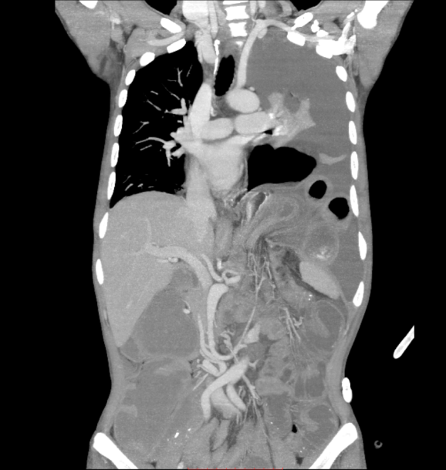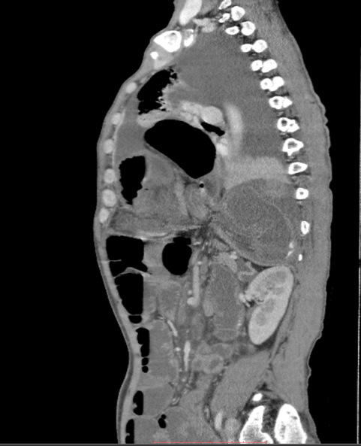
Key words:
Esophagectomy, Diaphragmatic hernia, Diagnostic dilemma

Autobiography:

I’m Dr. Salman Yahya, Currently working as Registrar Anaesthesia and Critical Care. I have completed my Post graduate fellowship training from college of Physicians and Surgeons Pakistan. I did my four years of residency in Shaukat Khanum Memorial cancer hospital and Research Centre, Lahore. I have been able publish 3 studies so far in different national and international journals and have also presented my research in multiple international conferences.



Email ID: khattakyahya@gmail.com

Looking forward for an opportunity to present my paper in the EuroSciCon in Tokyo, Japan.
Regards.

Dr. Salman Yahya
khattakyahya@gmail.com
00 92 306 4469999

