An analysis of the influence of preparation conditions on the development of the porous structure of the carbonaceous materials obtained from polymers
Mirosław Kwiatkowski, Marcin Starościak

AGH University of Science and Technology, Poland

Abstract:
The work presents the original results of a research into analysing the porous structure of carbonaceous materials obtained from polymers by chemical activation. The calculations were carried out with the use of the procedure of the fast multivariate identification of adsorption systems with implemented new numerical models of the adsorption on heterogeneous surfaces. The proposed methods were employed to evaluate the impact of the impregnation ratio on the microporous structure of the obtained materials. The used models can be well fitted to the experimental data in a wide range of relative pressure, giving reliable information on the microporous structure, mechanisms of the adsorbate molecules clusterisation and energy distribution on the first adsorbed layer.
The new numerical models with the fast multivariate procedure of the fitting of theoretical models to empirical data yield a broader range of highly reliable information on the analysed structure and consequently constitute an alternative to the popular simple and most sophisticated method of the description of the activated carbons microporous structure.

Keywords: Adsorption, Numerical Methods, Micropores, Activation.

Acknowledgments: The research was led within the subvention from the Polish Ministry of Science and Higher Education for the AGH University of Science and Technology in Krakow.

Professional Biography:
Dr. hab. eng. Mirosław Kwiatkowski in 2004 obtained Ph.D. degree at the AGH University of Science and Technology in Kraków (Poland), and in 2018 D.Sc. degree at the Wrocław University of Technology (Poland). In addition, he obtained a certificate of completion of postgraduate studies: Professional Research and Development Project Manager at the Krakow University of Agriculture (Poland), Research and Development Project Manager at the University of Economics and Innovation in Lublin (Poland), and Electrical Energy Markets at the AGH University of Science and Technology in Krakow (Poland). His published work includes more than 45 papers in reputable international journals and 90 conference proceedings. He is the editor in chief of The International Journal of System Modeling and Simulation (United Arab Emirates), an associate editor of Micro & Nano Letters Journal (United Kingdom) and a member of the organizing committees international conferences. Dr. hab. eng. Mirosław Kwiatkowski is also a reviewer in a most reputable scientific journals.
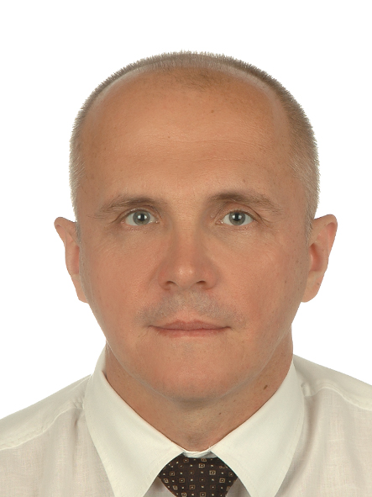
Email Id: kwiatkow@agh.edu.pl

