Abstract Title: Computational and Empiric Considerations Regarding the Electrocatalytic Reduction of CO2 by Water Soluble Cobalt Porphyrins

Y. Ben-Eliyahu1,2, Y. Bochlin1, S. Kozuch3, E. Korin1, A. Bettelheim

¹ Chemical Engineering Department, Ben-Gurion University of the Negev, Beer-Sheva, 84105, Israel
² Chemistry Department, Nuclear Research Center Negev, POB 9001, Beer-Sheva, Israel
³ Chemistry Department, Ben-Gurion University of the Negev, Beer-Sheva, 84105, Israel

Abstract
The electrochemical reduction of CO2 offers one of the possible solutions to current energy and sustainability issues since it can sequester carbon from the atmosphere and can be used to produce fuels and useful chemicals. In this respect, some metalloporphyrins have been reported to catalyze the electroreduction of CO2. However, key issues still remain in regard to the elucidation of the effect of the porphyrin structure on the reaction mechanism and catalyst activity. An essential and necessary stage in the proposed mechanism for the catalytic reduction of CO2 by the Co(II)/Co(I) porphyrin redox couple is the formation of an intermediate Co(II)porphyrin-CO2.- complex. In an attempt to examine the effect of positively and negatively charged porphyrin substituents on the catalytic activity, we report here on a combined DFT and empirical study regarding the electrochemical reduction of CO2 in the presence of the Cobalt(II) 5,10,15,20-(tetra-N-methyl-4-pyridyl) porphyrin - Co(II)TMPyP and Cobalt(II) 5,10,15,20-(tetra-4-sulfonatophenyl) porphyrin – Co(II)TPPS complexes, with charges of +4 and -4, respectively. The lower catalytic activity of the CoTPPS complex as compared to that of CoTMPyP, both dissolved in aqueous alkaline solutions, as demonstrated by cyclic voltammetry experiments, are in agreement with the DFT study. Coulombic interactions seem to dictate the cobalt-carbon bond length and strength in the porphyrin-CO2 intermediate, and consequently have an impact on its stability and on the overall catalytic activity towards CO2 reduction.

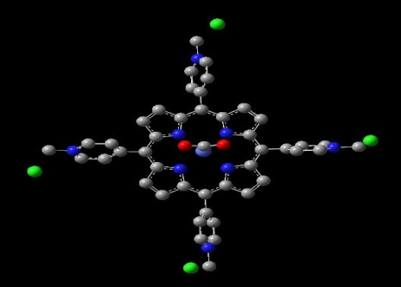
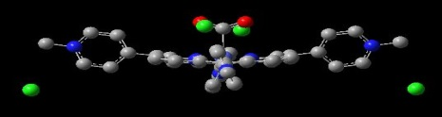
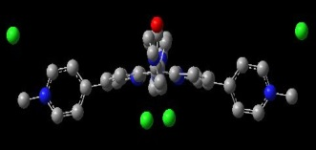
Calculated CoTMPyP-CO₂ complex, top and side views

Keywords— Metalloporphyrins, catalytic electroreduction, CoTPPS, CoTMPyP

Professional Biography (100-150 words)

Yeshayahu got all his degrees in Chemistry from the Hebrew University of Jerusalem.
The Msc and PhD theses were done under the supervision of the late Prof. Yehuda Haas from the Physical Chemistry Department.
He is working in the NRCN since 1995 in the department of Chemistry.
Between the years 2010-2013 he served as the head of Department of Chemistry in NRCN
From 2013-2018 he served as the Head of Nuclear Engineering Department in the IAEC.
Now he is on Sabbatical in the department of Chemical Engineering in Ben-Gurion University of the Negev in ISRAEL.


Paste your Photograph here

Email Id:

Any Comments:

