Abstract Template
Temperature- and pH-responsive double hydrophilic betaine copolymer: synthesis and investigation of the behaviour
Jongmin Lim¹, Hideki Matsuoka¹ and Yoshiyuki Saruwatari²

¹ Kyoto University, Japan
²Osaka Organic Chemical Industry, Japan

Abstract (not more than 300 words)

The polycarboxybetaine-polysulfobetaine double hydrophilic block copolymer, poly(2-((2-(methacryloyloxy)ethyl)dimethylammonio)acetate)-b-poly(3-((2-(methacryloyloxy)ethyl)di-
methylammonio)propane-1-sulfonate) (PGLBT-b-PSPE), was synthesized by reversible addition-fragmentation chain transfer (RAFT) polymerization. The block copolymer was designed for responding to both temperature and pH. The temperature dependent behaviours in aqueous solution of PGLBT-b-PSPEs were revealed by observing transmittance variation at λ=400 nm. The transmittance of solutions were gradually increase/decreased over 20ºC, unlike polysulfobetaine homopolymers or other temperature-responsive nonionic polymers that usually show abrupt transition within only a few ºC. Dynamic light scattering studies at transparent or translucent state elucidated that the block copolymer chains created monodisperse particles (hydrodynamic radius R_{h} = 40-60 nm, depended on the chain length) although the both are hydrophilic components, and the particles turned into individual chains when the solution was transparent. At the intermediate temperature, highly expanded particles and unimer-like small particles were detected simultaneously. (Fig. 1) ¹H NMR measurement showed disappearances of some signals of PSPE at low temperatures and reappearances by temperature increase, which suggested that the UCST-type PSPE segments aggregate each other to form core and the PGLBT segments form corona on the particle surface. Consequently, PGLBT-b-PSPE forms polymeric micelles below certain temperature then gradually disassembled upon heating, and eventually turned into single chains while the transmittance rises to almost 100%. The structure of particles was identified by comparing radius of gyration to hydrodynamic radius, R_{g}/R_{h}. In micellar region, the shape factor was approximately 0.77 which anticipates spherical particles, and closed to unity just before disassociation, which implies hollow or anisotropic structure. Particle images obtained by TEM met in a good agreement with the light scattering results. Under acidic (pH ~2) condition, zeta potentials of the particle surface turned into positive from near neutral by protonation of carboxylate unit on PGLBT chains, and large aggregates made the solution more turbid.

Keywords— double hydrophilic block copolymers, polybetaines, polymer self-assembly, stimuli-responsive polymers
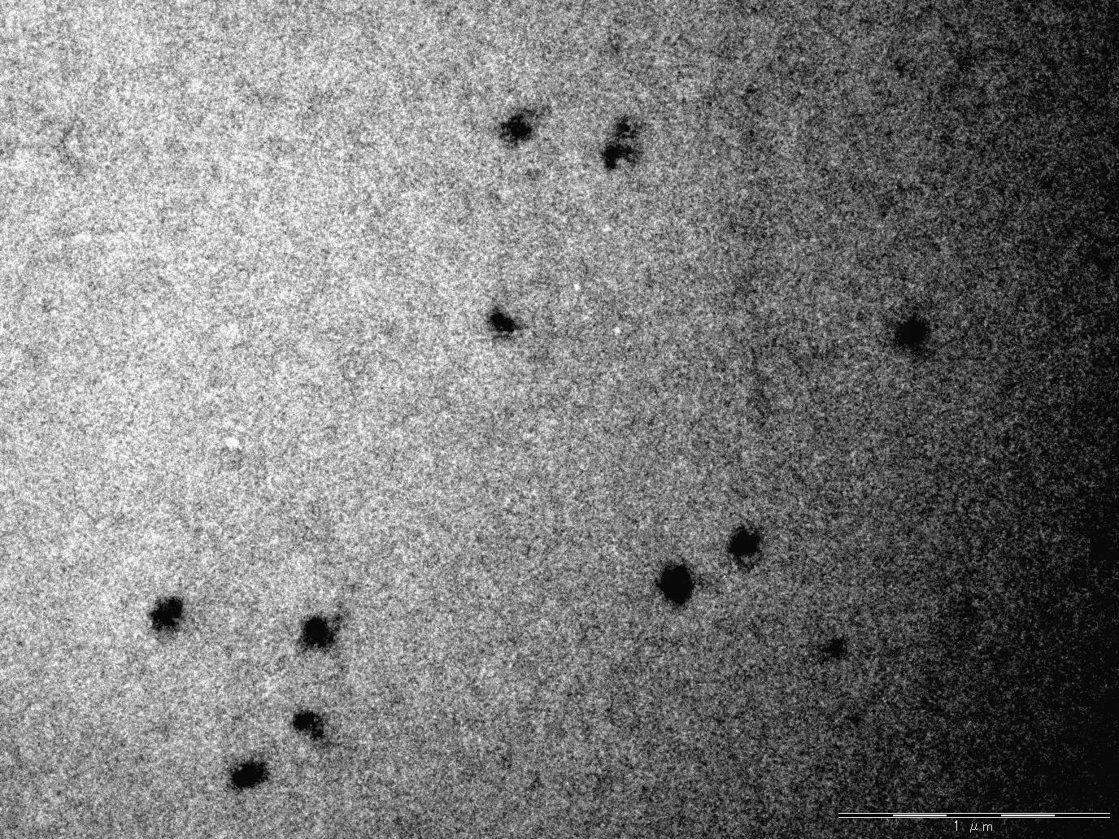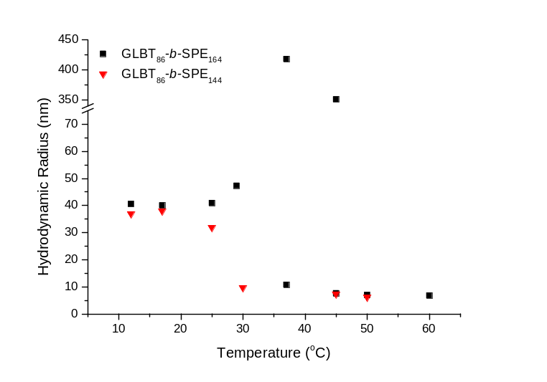
intermediates
unimers
~ 6.8 nm
micelles
~ 40 nm
Figure 1. (left) Variations of hydrodynamic radii of GLBT₈₆ derivative PGLBT-b-PSPEs (right) TEM image of GLBT₈₆-b-SPE₁₆₄ (scale bar: 1μm)

Professional Biography (100-150 words)

Jongmin Lim is pursuing his PhD degree at Kyoto University under the supervision of Prof. Hideki Matsuoka. His current research interests focus on the synthesis and characterizing stimuli-responsive double betaine block copolymers. He received his MS degree in chemical engineering (2011) from KAIST, South Korea under the guidance of Prof. Bumjoon J. Kim before working several years at LG Household & Health Care.

Paste your Photograph here

Email Id: lim.jongmin.33a@st.kyoto-u.ac.jp

Any Comments:

