Abstract Title: Water-borne topcoats,
It’s the final flow that makes the coating shine.

B. Reuvers and A. Veurink

¹ First Author Affiliation (DSM Resins)
²Second Author Affiliation (DSM Resins)

Abstract

How to achieve a high-gloss surface for a water-borne coating drying on top of an uneven substrate? To answer this question, we examined the gloss level of dried topcoats, as a function of a series variables both related to the substrate (: topography) and the topcoat (: volume fraction non-volatile components, film thickness, viscosity of the emulsified binder and rate of X-linking). To reveal the basic mechanisms underlying gloss development, we monitored the evolution of the surface topography of drying topcoats, using a white light interferometer. The study revealed the existence of two distinct different stages in the evolution of the surface topography. Firstly, the glossy wet film surface becomes uneven due to (damped) telegraphing of the substrate unevenness, driven by evaporation of water. This process is accompanied by loss of gloss. After coalescence of the emulsified binder particles subsequently, the telegraphed unevenness levels out driven by pressure gradients. This process results into gloss recovery. Full gloss recovery is promoted by low viscosity of the emulsified binder, high film thickness and slow X-linking.

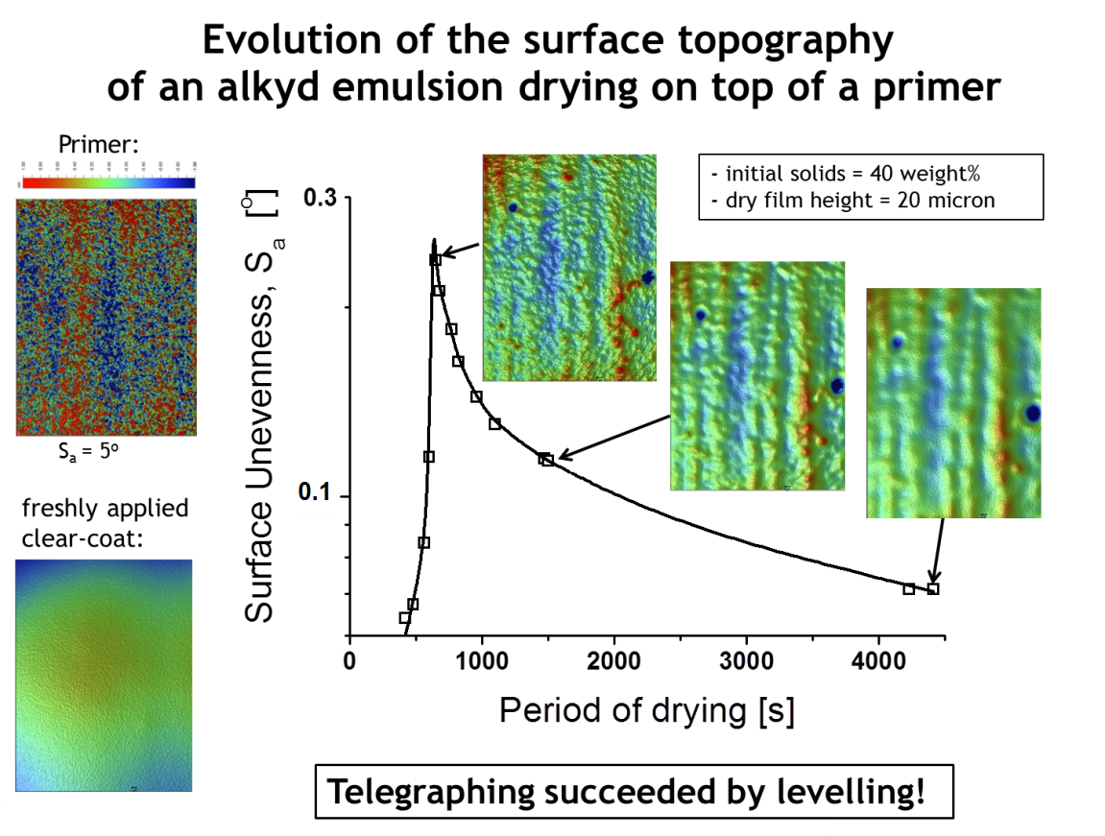

Keywords— Gloss, telegraphing, surface topography, water-borne topcoat.

Professional Biography (100-150 words)

Bart Reuvers has completed his PhD at the age of 30 years from Twente University. For 20 years he worked as physical chemist at Akzo Nobel Coatings. Currently, he is working as senior scientist at DSM Resins in the field of rheology. He has published more than 10 papers in reputed journals.



Email Id: bart.reuvers@DSM.com

