Title: Does dermoscopy affect help-seeking behaviours for patients with sexually transmitted infections diagnosed with dermoscopy in primary care settings? – the first case-control study
Antonio Chuh¹⁻³, Vijay Zawar³⁻⁵, Regina Fölster-Holst^{3,6}
¹ Department of Family Medicine and Primary Care, The University of Hong Kong
² JC School of Public Health and Primary Care, The Chinese University of Hong Kong
³ Hong Kong Society of Primary Care Dermoscopy
⁴ Skin Diseases Centre, Nashik, India
⁵ Department of Dermatology, Dr Vasantrao Pawar Medical College, Nashik, India
⁶ Dermatologie, Venerologie und Allergologie, Universitätsklinikum Schleswig-Holstein, Campus Kiel, Germany

Abstract (300 word limit)
Statement of the Problem: Help-seeking behaviours of patients with sexually-transmitted infections are crucial in treating and preventing spread of these infections. We have reported the roles of dermoscopy in diagnosing these diseases (1-5). We subsequently noted changes in the behaviours of patients upon making diagnoses complemented by dermoscopy. Aim: To investigate whether incorporating dermoscopy in diagnosing sexually-transmitted infections would affect help-seeking behaviours of patients. Methodology & Theoretical Orientation: Our settings were two primary care surgeries served by a general practitioner with special interests in skin diseases and sexually-transmitting infections. For patients with sexually-transmitted infections, we always recommended them to investigate for other sexually-transmitted infections (costs covered by the patients), attend follow-up, and bring their sexual partners for investigations and treatments as necessary. We retrieved records of 72 patients with these infections diagnosed complemented by dermoscopy over a three-month period as study subjects. The commonest diseases were genital herpes simplex virus (33; 49%) and genital human papillomavirus (32; 44%) infections. For each study subject, we retrieved the record of a sex-and-age (± five years) pair-matched patient most recently diagnosed to have the same infection before we started to apply dermoscopy as control subjects. We found that (1) study subjects were significantly more willing to investigate for other sexually-transmitted infections (RR:1.66, 95%CI:1.27-2.16); (2) study subjects were significantly more likely to attend follow-up (RR:1.84, 95%CI:1.37-2.46), (3) study subjects were significantly more likely to have brought sexual partners for further investigations (RR:3.17, 95%CI:1.34-7.47); and (4) significantly more study subjects followed all three recommendations (RR:3.8, 95%CI:1.50-9.63). Conclusion & Significance: Incorporating dermoscopy in diagnosing sexually-transmitted infections might optimise help-seeking behaviours of patients in primary care settings. Such could elevate the standards of managements and efficacies of contact tracing. However, whether these changes are sustainable and whether our findings are generalisable to other clinical settings are unknown.

(Word count of text: 300)

Image

Genital warts as portrayed by dermoscopy with cross-polarisation. Starring images like this might alter the attitudes and behaviours of some patients.
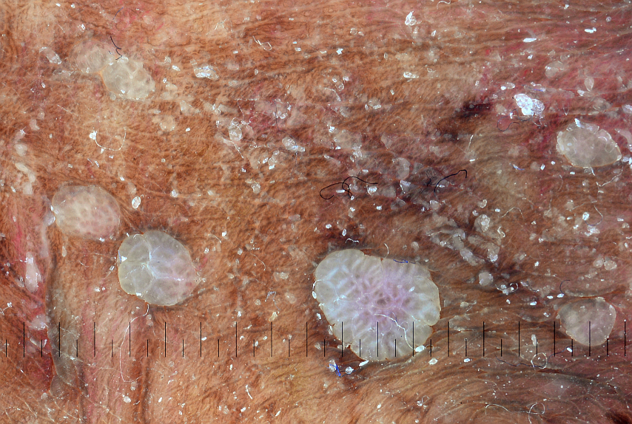
Recent publications (minimum 5)
1. Chuh A, Zawar V, Ooi C, Lee A (2018). A case-control study on the roles of dermoscopy in infectious diseases affecting the skin Part I – Viral and bacterial infections. Skinmed; 16: 247-54.
2. Chuh A, Zawar V, Ooi C, Lee A (2018). A case-control study on the roles of dermoscopy in infectious diseases affecting the skin Part II – Mycologic infections and ectoparasitic infestations. Skinmed; 16 (in press).
3. Chuh A, Zawar V, Fölster-Holst R, Lee A (2018). A novel, inexpensive, portable, and wireless dermoscopic unit and qualitative demonstrations on the versatility of the device. J Med Sc Tech; 6: 8-16.
4. Chuh A (2017). Roles of epiluminescence dermoscopy beyond the diagnoses of cutaneous malignancies and other skin diseases. Int J Trop Dis Health; 24: 1-10.
5. Chuh A, Lee A, Wong W, Ooi C, Zawar V (2007). Diagnosis of pediculosis pubis – a novel application of digital epiluminescence dermatoscopy. J Eur Acad Dermatol Venereol; 21: 837-8.

Antonio Chuh is a family physician with a special interest in dermoscopy. He is an Honorary Clinical Associate Professor in the Department of Family Medicine and Primary Care in the University of Hong Kong. He is also the Founding President of the Hong Kong Society of Primary Care Dermoscopy.
Zawar V is a Consultant Dermatologist, Skin Diseases Centre, Nashik, India, and a Professor, Department of Dermatology, Dr Vasantrao Pawar Medical College, Nashik, India
Prof Dr Regina Fölster-Holst is Professor, Department for Dermatology, Venereology and Allergology at the Universitätsklinikum Schleswig-Holstein, Campus Kiel, Germany. She was the president of the Society for Pediatric Dermatology from May 2016-June 2018 and is now the Past President of the Society. In addition, she is a member of diverse societies and since 2017 the vice president of the European Society for Educational Crisis. Her scientific focuses are paediatric dermatology, parasitoses, and atopic dermatitis. (Word count: 150)
Email: antonio.chuh@yahoo.com.hk

Oral or Poster or Workshop: Oral
Notes/Comments: Please list me as a Plenary Speaker.

