Impact of quality control standardization parameters on some potential folklore medicinal plants from North Eastern India.
Dr. Damiki Laloo
M.Pharm., Ph.D, PGDS.
Girijananda Chowdhury Institute of Pharmaceutical Science, Assam, India.

Abstract
Statement of the Problem: The tribal people of Northeastern regions of India (NER) harbor potential medicinal plants which are used ethno-medicinally to treat majority of the disease ailments including ulcer, diarrhea, diabetes, wounds, arthritis, fever and cancer etc. Some potentially active medicinal herbs which are highly used include Potentilla fulgens, Potentilla mooniana, Eriosema chinense, Caesalpinia digyna and Houttuynia cordata. However, due to lack of scientific research and validation, problem arises mainly in their standardization process. Hence to overcome such technical gaps between the traditional and modern science, the present investigation aimed to scientifically validate the traditional claims of such potential herbs on the basis of pharmacognostical, ethnopharmacological, phytochemical and molecular aspects.
Methodology & Theoretical Orientation: The pharmacognostical evaluation was performed as per the standard guidelines provided in Indian Herbal Pharmacopoeia (2002) and World Health Organization (2002). Chemical standardization was evaluated involving phytochemical screening, TLC, quantification of phytochemicals followed by isolation and characterization of the active constituents. Pharmacological evaluation with possible mechanism of action was tested for antiulcer, antidiabetic, anti-diarrhoeal and wound healing activity incorporating in vivo experimental animal models. In silico molecular docking standardization was also incorporated between the active constituents versus the targeted proteins of interest.
Findings: All the five tested herbs showed significant (p<0.05) potential effects which includes antiulcer activity (P. fulgens, P.mooniana); antidiabetic (Houttuynia cordata, Caesalpinia digyna); antidiarrhoeal (Eriosema chinense) and wound healing activity (P.fulgens). Their chemical standardization was done using HPLC and HPTLC techniques. Pharmacognostical standardization showed important diagnostic characters for morphological, histological and physiochemical parameters. Molecular docking studies showed probable aspects of binding mechanism between the active constituents with the particular proteins.
Conclusion & Significance: In conclusion, the present findings provide scientific information to develop a standard herbal monograph and to achieve standard quality, purity and efficacy of the herbal medicines.

Image
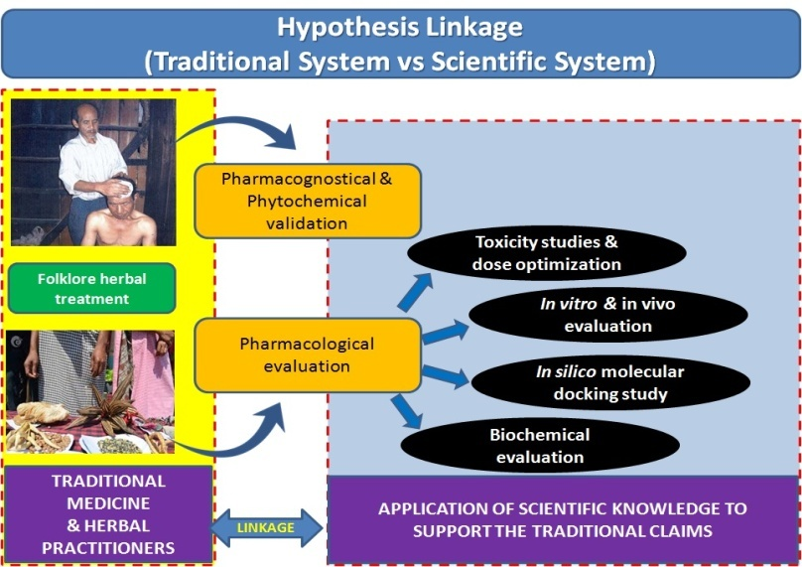
Recent Publications
- Prasad SK, Parmar K, Danta CC, Laloo D, Hemalatha S (2017). Antidiarrhoeal activity of eriosematin E isolated from the roots of Eriosema chinense Vogel. Phytomedicine 24: 127-133.
- Kundu A, Ghosh A, Singh NK, Singh GK, Seth A, Maurya SK, Hemalatha S, Laloo D (2016). Wound healing activity of the ethanol root extract and polyphenolic rich fraction from Potentilla fulgens. Pharmaceutical Biology 54:2383-2393.
- Laloo D, Prasad SK, Sairam S, Hemalatha S (2014). Gastroprotective activity of polyphenolic-rich extract of Potentilla mooniana. Pharmaceutical biology 52: 1532-1542.
- Prasad SK, Laloo D, Sahu AN, Nath G, Hemalatha S (2014). Cryptocoryne spiralis, a substitute of Aconitum heterophyllum in the treatment of diarrhea. Journal of Pharmacy and Pharmacology 66:1808-1817.
- Laloo D, Prasad SK, Sairam K, Hemalatha S (2013). Gastro protective activity of ethanolic root extract of Potentilla fulgens Wall. ex Hook. Journal of Ethnopharmacology 146: 505-514.
- Laloo D, Kumar M, Prasad SK, Hemalatha S (2013). Quality control standardization of the roots of Potentilla fulgens Wall.: A potent medicinal plants of the Western Himalayas and Northeastern India. Pharmacognosy Journal 5: 97-103.
- Prasad SK, Laloo D, Kumar M, Hemalatha S (2013). Antidiarrhoeal Evaluation of Root Extract, Its Bioactive Fraction, and Lupinifolin Isolated from Eriosema chinense. Planta medica 79: 1620-1627.
- Kumar R, Patel DK, Prasad SK, Laloo D, Krishnamurthy S, Hemalatha S (2012). Type 2 antidiabetic activity of bergenin from the roots of Caesalpinia digyna Rottler. Fitoterapia 83: 395-401.

Biography
Dr. Damiki Laloo is a young research scientist and academician from India who is expertise in ethnopharmacology, pharmacognosy and phytochemistry. He is an experience fellow who had spent his entire research career working with traditional medicinal practitioners and indigenous healers of the North Eastern India. He had made research validation easy by extracting the information of ethnic claims on traditional healing process and proving their activity with the help of validated scientific methodologies. Based on his research activities he had published many research articles in peer reviewed International Journals and is also serving as an eminent reviewer for many International publishers including Elsevier, Informa healthcare, Spinger, Thieme etc. He has been a keynote speaker in various national and international conferences specialized in medical backgrounds including peptic ulcer, diabetes, wound healing, diarrhea, epilepsy, and recently his project area is aiming at gastric and oral cancer.
Email: damiki.laloo@gmail.com; dlaloo.rs.phe@itbhu.ac.in

