Comparative chemical analyses of seven endemic Greek Citrus hybrids

Eleni Anastasopoulou, MSc, Div. of Pharmacognosy and Chemistry of Natural Products, Dept. of Pharmacy, National & Kapodistrian University of Athens, GR

Konstantia Graikou, Dr., Div. of Pharmacognosy and Chemistry of Natural Products, Dept. of Pharmacy, National & Kapodistrian University of Athens, Greece

Ioanna Chinou, Chair of the Monographs and List Working party of HMPC at European Medicines Agency (EMA), Div. of Pharmacognosy and Chemistry of Natural Products, Dept. of Pharmacy, National & Kapodistrian University of Athens, Greece

Abstract
In the framework of our studies on Greek Citrus hybrids, we report here the chemical analyses of the oils from cold pressed peels of one grapefruit [Citrus paradisi cv Star Ruby x Citrus aurantium], four oranges [Citrus sinensis cv Newhall x citrumelo, C. sinensis cv Newhall x trifoliata, C. sinensis cv Valencia Porou x citrumelo, C. sinensis cv Valencia Porou x trifoliata], one pomelo [C. grandis cv Cuban shaddock x trifoliata] and one mandarin [Citrus reticulata cv Tangelo Minneola x trifoliata].
All volatiles have been analyzed through GC-MS and forty-five constituents were identified: terpenes (94%-99%), among which monoterpenes (88-98%) with limonene as the most abundant (80-95%). It is noteworthy the detection of the sesquiterpene nootkatone (3.76%) in the essential oil of Citrus paradise, which is well known to inhibit acetylcholinesterase [1] while is the most expensive and valuable component of all Citrus [2].
The essential oils of all six among studied Citrus leaves showed a different chemical profil in comparison with their peels content, as sabinene is considered (0.6%-78.5%) as the main component, which is in accordance with literature, while only in mandarin (Citrus reticulata) was absent. Moreover, alkanes are identified in high percentages in all Citrus samples.
Furthermore, six polymethoxyflavones were isolated and structurally determined by NMR spectroscopy, from the peels of C. sinensis cv Valencia Porou x citrumelo and Citrus reticulata respectively. Their structures were identified as: 3',4',5,6,7-pentamethoxyflavone (sinensetin), 3',4',5,6,7,8-hexamethoxyflavone (nobiletin), 3',4',3,5,6,7-hexamethoxyflavone, 4',5,6,7-tetramethoxyflavone, 3,5,6,7,8,3’,4’-heptamethoxyflavone (3-methoxy-nobiletin) and 4’,5,6,7,8-pentamethoxyflavone (tangeretin), together with the fatty acid linoleic acid. All the above isolated polymethoxyflavones are among appreciated chemotoxonomic markers in Citrus genus showing also strong bioactivities (antioxidant, anti-inflammatory, antibacterial, cytotoxic) [3], [4], [5].
Image
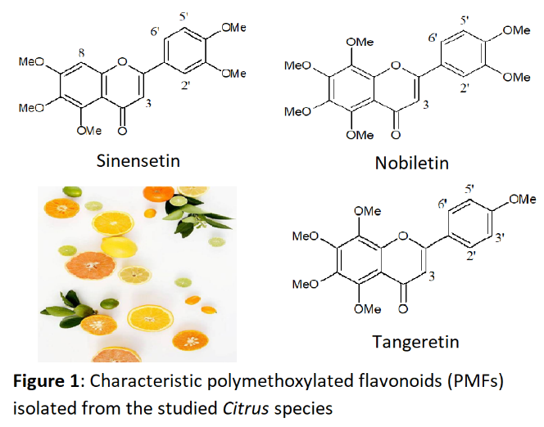
Recent Publications
1 Miyazawa, M, Okuno Y, Fukuyama M, Nakamura S, Kosaka H (1999). Antimutagenic activity of polymethoxyflavonoids from Citrus aurantium. Journal of Agricultural and Food Chemistry 47:5239–5244.
2 Furusawa, M, Hashimo T, Noma Y, Asakawa Y (2005). Highly efficient production of nootkatone, the grapefruit aroma from valencene, by biotransformation. Chemical and Pharmaceutical Bulletin 53(11): 1513–1514.
3 Gosslau, A, Chen KY, Ho CT, Li S (2014). Anti-Inflammatory effects of characterized orange peel extracts enriched with bioactive polymethoxyflavones. Food Science and Human Wellness 3:26–35.
4 Borah, N, Gunawardana S, Torres H, McDonnell S, Van Slambrouck S (2017). 5,6,7,3’,4’,5’-Hexamethoxyflavone inhibits growth of triplenegative breast cancer cells via suppression of MAPK and Akt signaling pathways and arresting cell cycle. International Journal of Oncology 51(6):1685–1693.
5 Lai HC, Wu MJ, Chen PY, Sheu TT, Chiu SP, Lin MH, Ho CT, Yen JH. (2011). Neurotrophic effect of Citrus 5-Hydroxy-3,6,7,8,3′,4′-Hexamethoxyflavone: promotion of neurite outgrowth via cAMP/PKA/CREB pathway in PC12 Cells. PLoS One 6(11).

Biography
Eleni Anastasopoulou has graduated from the Faculty of Agriculture, at the Department of Food Science and Technology, Aristotle University of Thessaloniki (GR). Throughout her studies, she appreciated the value of natural products, therefore during her research thesis, she optimized a green extraction method for the recovery of polyphenols from olive leaf using cyclodextrins and glycerin as co-solvents. Furthermore, she participated in the creation of an innovative yoghurt product, on the Greek competition Ecotrophelia 2016. Finally, she continued her postgraduate studies in the Div. of Pharmacognosy and Chemistry of Natural Products, Dept. of Pharmacy, National & Kapodistrian University of Athens. In the framework of her dissertation on essential oils, she had the opportunity to learn the analytical methods on the isolation, development, production and control of bioactive natural products.
Email: eeanasta@gmail.com

