Enzyme Inhibitory Activities of Nymphaea alba fruit extracts
Mihaela Cudălbeanu¹, Ioana O. Ghinea¹, Anna Cazanevscaia¹, Bianca Furdui¹ and Rodica M. Dinica^{1*}

¹“Dunarea de Jos” University of Galati, Department of Chemistry, Physics and Environment, Domneasca Street 47, 800008,
Galati, Romania, *correspondence to: rodica.dinica@ugal.ro

Abstract (300 word limit)

Statement of the Problem: In the developing countries the diabetes and also the hyperuricemia can cause many problems for people's health and has shown an increasing trend among the urban population. The studies published before reported that the alcoholic extracts of Nymphaea alba from the Danube Delta Biosphere Reserve have bioactive compounds like polyphenols and flavonoids. The Nymphaea alba fruit extracts were investigated further to determine their therapeutic potential to inhibit key enzymes involved in carbohydrate metabolism or in the catabolism of purines. Methodology & Theoretical Orientation: The evaluation of enzyme inhibitory activity of alcoholic extracts of Nymphaea alba fruits was carried out against α-amylase and xanthine oxidase. It is known that polyphenols readily complex with protein and as a result, often, there is an inhibition of enzyme activity. Enzyme inhibitory activities of the extracts from Nymphaea alba fruits were assayed in vitro. Findings: The results indicate that the evaluated alcoholic extracts were exerted higher inhibitory activity against both α-amylase and xanthine oxidase enzymes, having the highest xanthine oxidase inhibitory activity (IC50 = 160 µg/mL), and also α-amylase highest inhibitory activity (IC50 = 4 mg/mL). Conclusion & Significance: The obtained results suggest that the Nymphaea alba fruit extracts have the major components inhibiting the α-amylase and xanthine oxidase activity in vitro.
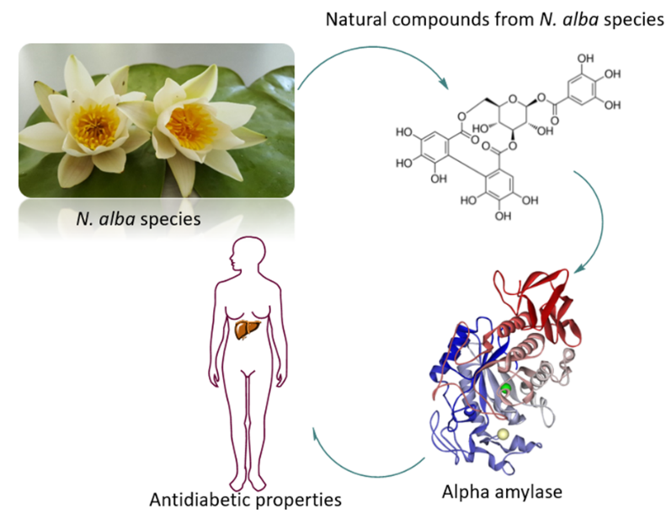

Figure 1. The bioactive compounds from the Nymphaea alba species have properties for inhibiting the α-amylase enzyme.
Recent Publications (minimum 5)
- Cudalbeanu, M.; Ghinea, I. O.; Furdui, B.; Dah-Nouvlessounon, D.; Raclea, R.; Costache, T.; Cucolea, I. E.; Urlan F.; Dinica, R. M. Exploring New Antioxidant and Mineral Compounds from Nymphaea alba Wild-Grown in Danube Delta Biosphere. Molecules. 2018, 23, 1247; doi:10.3390/molecules23061247.
- Liu, K.; Wang, W.; Guo, B.H.; Liu, Y.; Liu, X.-H.; Yao, H.-L.; Cheng, K. Chemical Evidence for Potent Xanthine Oxidase Inhibitory Activity of Ethyl Acetate Extract of Citrus aurantium L. Dried Immature Fruits. Molecules. 2016, 21, 302; doi:10.3390/molecules21030302.
- Dicko, M.H.; Hilhorst, R.; Gruppen, H.; Traore, A.S.; Laane, C.; van Berkel, W.J.H.; Voragen, A.G.J. Comparison of Content in Phenolic Compounds, Polyphenol Oxidase, and Peroxidase in Grains of Fifty Sorghum Varieties from Burkina Faso. J. Agric. Food Chem. 2002, 50, 3780–3788.
- Nirmali Wickramaratne, M.; Punchihewa, J. C.; Wickramaratne, D. B. M. In-vitro alpha amylase inhibitory activity of the leaf extracts of Adenanthera pavonina. BMC Complementary and Alternative Medicine. 2016, 16, 466, doi 10.1186/s12906-016-1452-y.
- Li, Y.; Wan, Y.; Li, R.; Xu L.; Xie, M.; Fu, G. Solvent extraction of caffeoylquinic acids from Artemisia selengensis Turcz leaves and their in vitro inhibitory activities on xanthine oxidase. Industrial Crops & Products. 2018, 118, 296–301.

Photograph

Biography (150 word limit)
Miss Mihaela Cudalbeanu has her expertise in evaluation and investigation of plant extracts. She is PhD students in chemistry and she has abilities in separations and chromatographic analysis of the different fractions obtained from the vegetal extracts. She has also competences in the analysis of bioactive compounds, antioxidant activity, antimicrobials and in cytotoxicity studies.
Email: mihaela.cudalbeanu@ugal.ro

Notes/Comments:
Thank you very much for your valuable time!

