Traditional Chinese Medicines and Natural Bioactive Compounds for the Treatment of Stroke: Prospective Molecular Targets

JAYAKUMAR, T and JOEN-RONG SHEU

Graduate Institute of Medical Sciences, Taipei Medical University, 250Wu-Hsing Street, Taipei 110, Taiwan

Stroke is an important cause of mortality and morbidity worldwide but effective therapeutic strategy for the prevention of brain injury in patients with cerebral ischemia is lacking. Although tissue plasminogen activator (tPA) has been used to treat stroke patients, this therapeutic strategy is confronted with ill side effects and is limited to patients within 3 hours of a stroke. Due to the complexity of the events and the disappointing results from single agent trials, the combination of thrombolytic therapy and effective neural protection therapy may be an alternative strategy for patients with cerebral ischemia. Chinese medicine is the most widely practiced form of herbalism worldwide, as it is a sophisticated system of medical theory and practice that is specifically different from Western medicine. Most traditional therapeutic formulations consist of a combination of several drugs. The combination of multiple drugs is thought to maximize therapeutic efﬁcacy by facilitating synergistic actions and preventing possible adverse effects while at the same time marking at multiple targets. Chinese medicine has been labeled in ancient medicine systems as a treatment for various diseases associated with stroke. The following novel bioactive compounds of plant origin xanthohumol, puerarin, hinokitiol and andrographolide have been reported to have neuroprotective effects. Therefore, this subject may provide a positive contribution to better understand the therapeutic value of various traditional Chinese medicines and natural bioactive compounds in ischemic stroke and to support further clinical evaluation.
KEY WORDS: Traditional Chinese medicines; Natural bioactive compounds;
Xanthohumol; Andrographolide; Stroke; Molecular targets
Image
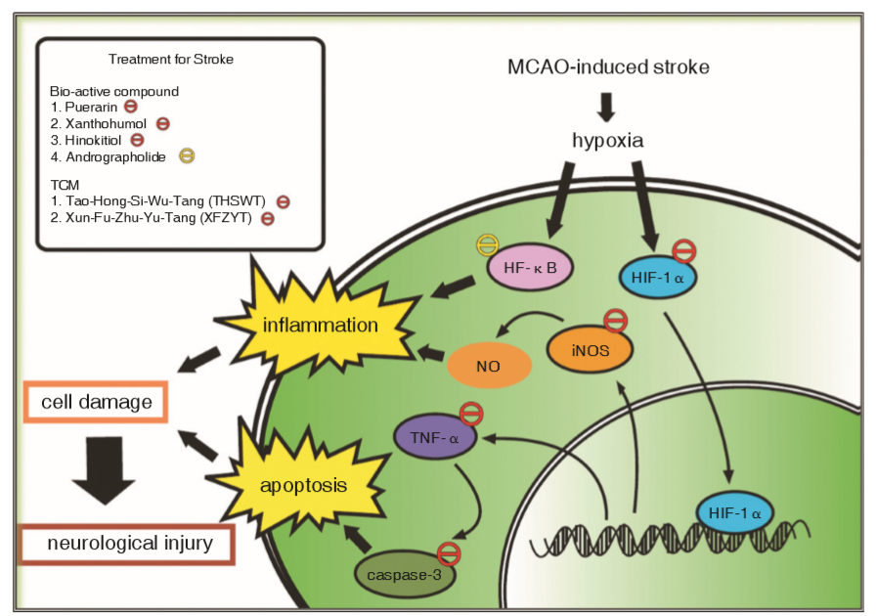

Figure.1 Potential Effects of CM and Bioactive Compounds on MCAO-Induced Stroke
Model

Description: MCAO inducing a release of transcription factor HIF-1α. HIF-1α translocates into the nucleus in activating genes of iNOS, TNF-α and casapase-3. iNOS may contribute to enhance the inﬂammatory responses by elevating nitric oxide (NO). TNF-α, it shows to be involved in apoptosis through the activation of downstream caspases-3, and subsequently induces cell death and neurological injury. TCM and their products inhibit these signaling molecules, followed by the inhibition of apoptosis and inﬂammation and ultimately inhibit the neurological injury.

Recent Publications:
- Jayakumar T, Liu CH, Wu CY, Lee TY, Manubolu M, Hsieh CY, Yang CH, Sheu JR. Hinokitiol inhibits migration of A549 lung cancer cells via suppressing MMPs and inducing antioxidant enzymes and apoptosis. International Journal of Molecular Sciences, 2018, 18(2545), 1-12.

- Hsia CH, Jayakumar T#, Sheu JR, Tsao SY, Velusamy M, Hsia CW, Chou DS, Chang CC, Chung CL, Khamrang T, Lin KC. Structure-Antiplatelet Activity Relationships of Novel Ruthenium (II) Complexes: Investigation of Its Molecular Targets. Molecules, 2018, 22.

- Yang CH, Yen TL, Hsu CY, Thomas PA, Sheu JR, Jayakumar T*. Multi-targeting andrographolide, a Novel NF-κB Inhibitor, as potential therapeutic agent for stroke. International Journal of Molecular Sciences. 2017, 18:1-14.

- Jayakumar T, Yang CH, Geraldine P, Yen TL, Sheu JR. The pharmacodynamics of antiplatelet compounds in thrombosis treatment. Expert Opinion on Drug Metabolism and Toxicology 2016, 1-18.

- Hsu LW, Shiao WC, Chang NC, Yu MC, Yen TL, Thomas PA, Jayakumar T*, Sheu JR. The neuroprotective effects of Tao-Ren-Cheng-Qi Tang against embolic stroke in rats. Chinese Medicine-UK, 2017, 12:7, 1-8.

Biography
Dr. Thanasekaran Jayakumar has been initiated research work at Bharathidasan University, India for his PhD degree. Where he investigated the antioxidant effect of an edible mushroom Pleurotus ostreatus against the acute (CCl₄-induced) and chronic (age-related) state of oxidative stress in rat model. What is unique of this research is he has done several publications from Food and Chemical Toxicology, Experimental Gerontology, Chemico Biological Interactions, Innovative Food Science and Emerging Technology, Food Research International, Journal of Medicinal Food, Chinese Journal of Integrative Medicine and Pharmaceutical Biology.
Currently, he is working as Scientist in Taipei Medical University. He has taken several natural plant sources or their compounds such as mushroom Pleurotus ostreatus, brazilin, green tea catechins, hinokitiol, okadai acid, vitamin E derivatives, andrograppholide, sulforaphane etc., to analyze their effects on chondroprotection, cardiovascular disease, cancer, platelets inhibition, immunomodulatory effects etc., He has been published nearly 75 research papers including 9 major reviews. He has been rewarded outstanding scientist and few research awards.

