Nanoliposome-encapsulated lycopene ameliorates methotrexate-induced hepatotoxicity
Nenad Stojiljković, Prof, PhD, Faculty of Medicine, University of Nis; Sonja Ilić, MD, PhD, Faculty of Medicine, University of Nis; Nikola Stojanović, MD, Faculty of Medicine, University of Nis; Milan Stoiljković, MD, PhD, Faculty of Medicine, University of Nis; Slavica Stojnev, MD, Faculty of Medicine, University of Nis.

Abstract
Introduction: Nanoliposomes have the potential to increase bioavailability, stability, improve time-controlled drug releasing, enable cell-specific targeting and decrease adverse effects of drugs [1]. In this study, we evaluated the potential protective effect of lycopene, a potent antioxidant carotenoid [2], given in free and encapsulated form in methotrexate-induced haptotoxicity in rats. Methods: Experiments were performed on 48 male Wistar rats divided into eight groups of 6 animals, treated daily by an intraperitoneal injection. MTX-group received methotrexate in a single dose (20 mg/kg) on the first day [3]; other experimental groups received the same dose of methotrexate and: empty nanoliposomes (10 ml/kg) (MTX-NL-group), lycopene (6 mg/kg) (MTX-LYC-group) and encapsulated lycopene (6 mg/kg) (MTX-ENL-group), for 10 days. The remaining four groups served as controls and received for 10 days: corn oil (0.2 ml/day) (C-group), empty nanoliposomes (10 ml/kg) (NL-group), lycopene (6 mg/kg) (LYC-group) and encapsulated lycopene (6 mg/kg) (ENL-group). Quantitative evaluation of structural and functional changes of liver was performed by histopathological (HE staining) and biochemical serum analyses and determination of oxidative stress parameters. Results: Methotrexate induced severe functional and morphological alterations of liver with conspicuous disorganization of hepatic cords. Hepatocytes diffusely exhibited apoptosis and degeneration with vacuolation of the cytoplasm. Portal veins and sinusoid capillaries showed congestion. Marked inflammatory infiltrate was present in the portal tract (Figure 1E). Pathohistological findings were followed by AST and ALT increase and disturbances of tissue antioxidant status. Application of both forms of lycopene ameliorated changes in serum AST and ALT and oxidative damage markers and markedly reversed structural changes of liver tissue induced by methotrexate. Animals that received nanoliposome-encapsulated lycopene showed higher degree of recovery then those treated with free lycopene (Figure 1). Discussion: Encapsulated lycopene was shown to possess stronger antioxidant activity which could be possibly related to its position in the lipid bilayer and its higher stability in nanoliposomes which might prolong the presence of lycopene in circulation [4, ]. Treatment with nanoliposome-encapsulated lycopene compared to free lycopene has an advantage since it more efficiently reduced methotrexate-induced hepatotoxicity.
Image

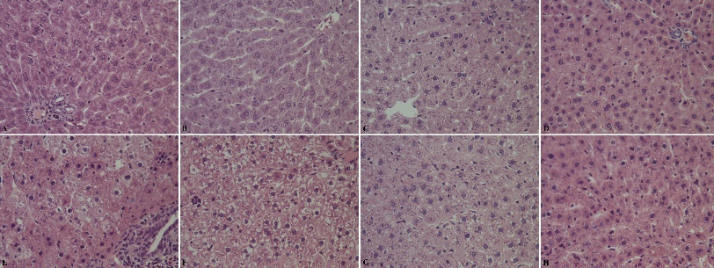
Figure 1. Histological evaluation of liver tissue (HE, 400x) in: (A) C-group; (B) NL-group; (C) LYC group; (D) ENL group; (E) MTX group; (F) MTX-NL group; (G) MTX-LYC group and (H) MTX-ENL group
Recent Publications
- Akbarzadeh A, Rezaei-Sadabady R, Davaran S, Joo SW, Zarghami N, Hanifehpour Y, Samiei M, Kouhi M, Nejati-Koshk Ki (2013) Liposome: classification, preparation, and applications Nanosc Res Lett 8: 102−111.
- Abu El-Saad AM, Ibrahim MM, AA Hazani AA, El-Gaaly GA (2015) Lycopene attenuates dichlorvos-induced oxidative damage and hepatotoxicity in rats. Hum Experiment Toxicol 1-12.
- Taskin B, Erdoğan MA, Yiğittürk G, Günenç D, Erbaş O (2017) Antifibrotic effect of lactulose on a methotrexate-induced liver injury model. Gastroentero Res Pract 7942531:1-5.
- Tan C, Xue J, Abbas S, Feng B, Zhang X, Xia S (2014) Liposome as a delivery system for carotenoids: comparative antioxidant activity of carotenoids as measured by ferric reducing antioxidant power, DPPH assay and lipid peroxidation. J Agric Food Chem 62: 6726−6735.
5. Stojiljkovic N, Ilic S, Jakovljevic V, Stojanovic N, Stojnev S, Kocic H, Stojanovic M, Kocic G (2018) The encapsulation of lycopene in nanoliposomes enhances its protective potential in methotrexate-induced kidney injury model. Oxid Med Cell Longev 2018:2627917.

Biography
Nenad Stojiljkovic, associate professor at the Department of physiology, Faculty of Medicine, University of Nis, is doing the experiments in the fields of experimental medicine, especially in the field of experimental nephrology and hepatology. His main work is related to the clarification of mechanism of action of different hepato/nerphoprotecitve agents (antibiotics, cytostatic drugs, heavy metals, etc.) in rats. Also, he is work is aiming to discover new hepato/nephroprotecive agents that can be used in every day clinical practice, such as naturally occurring and/or synthetic antioxidant agents. His current work involves encapsulation of carotenoid like antioxidants in nanoliposomes and evaluation of their potential in preventing anticancer drugs-induced liver and kidney damage.
Email: nenstojiljkovic@gmail.com

Notes/Comments: Work was funded by the project of the Faculty of Medicine, University of Niš (Project no. INT-MFN-13).

