Chemical compositions of the essential oils and antioxidant activity of some medicinal plants cultivated in semiarid and cold climate, Southwestern Iran
Abdollah Ghasemi Pirbalouti, Research Center for Medicinal Plants, College of Agriculture, Shahr-e-Qods Branch, Islamic Azad University, Tehran, Iran

Abstract
The products of plant secondary metabolism, such as essential oils (EOs), aromatics, and volatile constituents, have a wide range of applications in folk medicine, food flavoring, and food preservation as well as in food industries. Secondary metabolites of medicinal and aromatic plants (MAPs) have been used in many domains, including medicine, nutrition, flavoring, beverages, dyeing, repellents, fragrances, cosmetics, smoking, and other industrial purposes. Recently, interest in finding naturally occurring antioxidants to replace synthetic antioxidants in foods and medicines has increased considerably; primarily due to the possible carcinogenicity of the synthetic antioxidants. The objective of this study was to evaluate quality and quantity of the EOs and their antioxidant activity of some MAPs such as Sage, Lemon balm, Damask rose, Iranian thyme, Hyssop, Feverfew, etc. cultivated at semiarid and cold climate, southwestern Iran during 2014 to 2016. Chemical compositions were identified by GC-FID and GC/MS and antioxidant activity of the EOs was determined by DPPH assy. Results indicated that the studied MAPs had suitable growth and acceptable adaptation to ecological conditions. Results indicated that the main constituents of the aromatic plants were oxygenated monoterpenes (E/Z-citral and neral in the EOs from Damask rose and lemon balm; thymol and carvacrol in the EO from thyme; E/Z-pinocamphone and camphor in the EO from hyssop; 𝛼/β-thujone, 1,8-cineole, and camphor in the EO of sage; camphor in the EO of feverfew) and carbohydrate monoterpenes (p-cymene and ɣ-terpinene in the EO from thyme; β-pinene in the EOs from feverfew, hyssop, and Damask rose) and carbohydrate sesquiterpenes (β-caryophyllene in the EOs from lemon balm). The EOs of the herbs showed moderate antioxidant activity. The EO from Iranian thyme reveals the highest antioxidant capacity. This potential applicability can be used as antioxidant agents for food and pharmaceutical industries.

Image
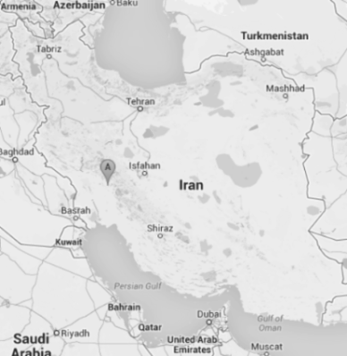

Recent Publications
- Talebi M, Moghaddam M, Ghasemi Pirbalouti A (2018) Methyl jasmonate effects on volatile oil compounds and antioxidant activity of leaf extract of two basil cultivars under salinity stress. Acta Physiologiae Plantarum 40:34-44.
- Imelouane B, Elbachiri A, Ankit M, Benzeid H, Khedid K (2009) Physico-chemical compositions and antimicrobial activity of essential oil of eastern Moroccan Lavandula dentate. Int J Agric Biol 11:113-118‎.
- Vosoughi, N., Gomarian, M., Ghasemi Pirbalouti A, Khaghani S, Malekpoor F (2018) Essential oil composition and total phenolic, flavonoid contents, and antioxidant activity of sage (Salvia officinalis L.) extract under chitosan application and irrigation frequencies. Industrial Crops and Products, 117:366-374.
- Ghasemi Pirbalouti A, Malekpoor F, Salimi A, Golparvar A, Hamedi B (2017) Effects of foliar of the application chitosan and reduced irrigation on essential oil yield, total phenol content and antioxidant activity of extracts from green and purple basil. Acta Scientiarum Polonorum-Hortorum Cultus 16:177-186.
- Adams, R.P. 2007. Identification of Essential Oil Components by Gas Chromatography/ Quadrupole Mass Spectroscopy. Allured: Carol Stream, IL, USA.

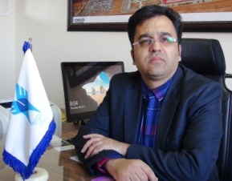
Biography
Abdollah Ghasemi Pirbalouti is professor at Medicinal Plants Depertment, Islamic Azad University, Shahrekord Branch, Iran. He has spent the past 15 years working with medicinal and aromatic plants, and considerable experience plant production and biology, botany, phytochemistry, and pharmacognosy. He is familiar with medicinal and aromatic plants production, and quality control for the development of new products. His experience also includes laboratory extraction and essential oil constituent analysis using gas chromatography, mass spectrometry, and HPLC. In addition, He is chief in editor of Journal of Herbal Drugs, International Journal of Medicinal Herbs (www.jhd.iaushk.ac.ir). During 2012-2013, he worked as a Research Scholar in the Medicinal Plant Program at the University of Massachusetts, Amherst, Massachusetts, USA. After 2015, He is head of the Islamic Azad University, Shahrekord Branch, and Chaharmahal va Bakhtiari Province, Iran
Email: ghasemi955@yahoo.com
Notes/Comments:

