In silico studies of plant triterpenoids: pharmacophore-based virtual screening and toxicity evaluation
Merilin Al Sharif, PhD, Institute of Biophysics and Biomedical Engineering, Bulgarian Academy of Sciences, Bulgaria
Antonia Diukendjieva, Institute of Biophysics and Biomedical Engineering, Bulgarian Academy of Sciences, Bulgaria
Vessela Vitcheva, PhD, Medical University of Sofia, Bulgaria
Denitsa Aluani, PhD, Medical University of Sofia, Bulgaria
Virginia Tzankova, PhD, Medical University of Sofia, Bulgaria
Petko Alov, Institute of Biophysics and Biomedical Engineering, Bulgarian Academy of Sciences, Bulgaria
Ivanka Tsakovska, PhD, Institute of Biophysics and Biomedical Engineering, Bulgarian Academy of Sciences, Bulgaria
Ilza Pajeva, DSc, Institute of Biophysics and Biomedical Engineering, Bulgarian Academy of Sciences, Bulgaria

Abstract (300 word limit)
Statement of the Problem: The metabolic syndrome (MS) represents a complex pathological condition featured by hypertension, type 2 diabetes (T2D) and obesity. It is among the risk factors for development of cardiovascular diseases (CVD) and is characterized by increasing global prevalence. Modulation of the nuclear peroxisome proliferator-activated receptor γ (PPARγ) by natural compounds is considered a promising pharmacological strategy for targeting the MS. Within this study we aimed at applying a virtual screening protocol for investigating the potential of triterpenoid sapogenins of natural origin to act as PPARγ partial agonists. Furthermore an in silico estimation of their safety profile has been performed.
Methodology & Theoretical Orientation: An in-house virtual library with more than 70 triterpenoids has been screened by a pharmacophore-based docking of the unique aglycons in the PPARγ binding pocket using MOE software (v. 2016.0802). The toxicity of these aglycons was evaluated using Derek Nexus knowledge-based system (v.5.0.1.).
Findings: Potential partial agonist-like binding modes were evaluated based on the binding energy scores of the protein-ligand (PL) complexes resulting from the docking simulation. The PL interactions and poses relevant to the PPARγ partial agonists’ binding pattern were predicted. Potential toxicity effects, including chromosome damage and developmental toxicity, were outlined for particular triterpenoid aglycons.
Conclusion & Significance: The results of this study contribute to the mechanistic explanation at molecular level of the effects of triterpenoid saponins/sapogenins by a potential PPARγ-mediated mode of action. This research can direct further studies of naturally-derived triterpenoids as potential MS modulators.
Acknowledgements: Support from the National Science Fund of Bulgaria (grant DM 01/1/2016), COST Action CM1407 and the matching project of the National Science Fund of Bulgaria
(No. DCOST 01/11/2016) is acknowledged.

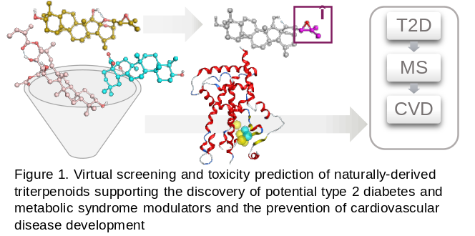
Image

Recent Publications (minimum 5)
- Al Sharif M, Alov P, Diukendjieva A, Vitcheva V, Simeonova R, Krasteva I, Shkondrov A, Tsakovska I, Pajeva I. (2017) Molecular determinants of PPARγ partial agonism and related in silico/in vivo studies of natural saponins as potential type 2 diabetes modulators. Food Chem Toxicol 112:47-59.
- Al Sharif M, Alov P, Vitcheva V, Diukendjieva A, Mori M, Botta B, Tsakovska I, Pajeva I. (2017) Natural modulators of nonalcoholic fatty liver disease: Mode of action analysis and in silico ADME-Tox prediction. Toxicol Appl Pharmacol 337:45-66.
- Al Sharif M, Tsakovska I, Pajeva I, Alov P, Fioravanzo E, Bassan A, Kovarich S, Yang C, Mostrag-Szlichtyng A, Vitcheva V, Worth AP, Richarz AN, Cronin MTD. (2017) The application of molecular modelling in the safety assessment of chemicals: A case study on ligand-dependent PPARγ dysregulation. Toxicology 392:140-154.
- Tsakovska I, Al Sharif M, Alov P, Diukendjieva A, Fioravanzo E, Cronin MT, Pajeva I. (2014) Molecular modelling study of the PPARγ receptor in relation to the mode of action/adverse outcome pathway framework for liver steatosis. Int J Mol Sci 15:7651-66.
- Al Sharif M, Alov P, Vitcheva V, Pajeva I, Tsakovska I. (2014) Modes-of-Action Related to Repeated Dose Toxicity: Tissue-Specific Biological Roles of PPAR γ Ligand-Dependent Dysregulation in Nonalcoholic Fatty Liver Disease. PPAR Res. 2014:432647.

Biography (150 word limit)
Merilin Al Sharif got her BS degree in Biotechnology and MS degree in Biochemistry from Sofia University “St. Kliment Ohridski”, Faculty of Biology, and PhD in Biological sciences from the Bulgarian Academy of Sciences (BAS). Currently she holds a position of a Senior Assist. Prof. at the Institute of Biophysics and Biomedical Engineering, Bulgarian Academy of Sciences. Her main scientific interests relate to predictive toxicology and in silico drug design. Her most recent investigations in the field of naturally-derived triterpenoids could aid in the discovery of promising leads for design of PPARγ-targeting modulators of the metabolic syndrome.
Email: merilin.al@biomed.bas.bg

Notes/Comments:

