In silico evaluation of new potential target proteins of flavonolignans
from Silybum marianum
Antonia Diukendjieva, Institute of Biophysics and Biomedical Engineering, Bulgarian Academy of Sciences, Bulgaria
Mattia Mori, PhD, Department of Biotechnology, Chemistry and Pharmacy, University of Siena, Italy
Petko Alov, Institute of Biophysics and Biomedical Engineering, Bulgarian Academy of Sciences, Bulgaria
Ivanka Tsakovska, PhD, Institute of Biophysics and Biomedical Engineering, Bulgarian Academy of Sciences, Bulgaria
Maurizio Botta, DSc, Department of Biotechnology, Chemistry and Pharmacy, University of Siena, Italy
Ilza Pajeva, DSc, Institute of Biophysics and Biomedical Engineering, Bulgarian Academy of Sciences, Bulgaria

Abstract (300 word limit)
The medicinal plant Silybum marianum (milk thistle) has been used from antiquity for treatment of liver and gallbladder disorders of different etiologies. Its main active component, silybin, occurs in two diastereoisomeric forms, silybin A and B. Silybin has been shown to exert a broad spectrum of bioactivities including cardioprotective, neuroprotective, antidiabetic and anticancer activities, however, the mechanisms of these actions have not been elucidated yet.
In the current study we assessed the chemical similarity of the silybin diastereoisomeres to all approved drugs in the DrugBank database using ROCS software. TanimotoCombo index, taking into account features obtained by shape and chemistry alignment of the compounds, was used as similarity estimator. The drugs scored with TanimotoCombo indices ≥ 0.9 (9 drugs for silybin A and 9 drugs for silybin B) were filtered and analyzed in terms of target pathology and mechanisms of action.
Among them 3 drugs exert antidiabetic (canaglifozin, dapaglifozin, empaglifozin) and 2 other drugs possess antitumor activities (vemurafenib and vismodegib). Since silybins have been reported to possess antitumor activities, the similarity with these drugs is of а particular interest when studying their mechanism of action. Since the X-ray structures of the antitumor drugs targets, Smoothened homolog (vismodegib) and BRAF kinase (vemurafenib) are available, further docking studies of silybins in these receptors were performed and the possibility of silybin interactions with them was estimated.
The results suggest that silybins can be accommodated in the binding sites of BRAF kinase and Smoothened homolog performing specific interactions with particular residues, including also those vemurafenib and vismodegib interact with. Experimental studies are necessary to prove the hypothesis that silybins can act as inhibitors of these proteins.
Acknowledgements: This work is supported by the project DFNP-134/01.08.2017 of the Program for Support of Young Scientists in Bulgarian Academy of Sciences and by COST Action CM1407
Image
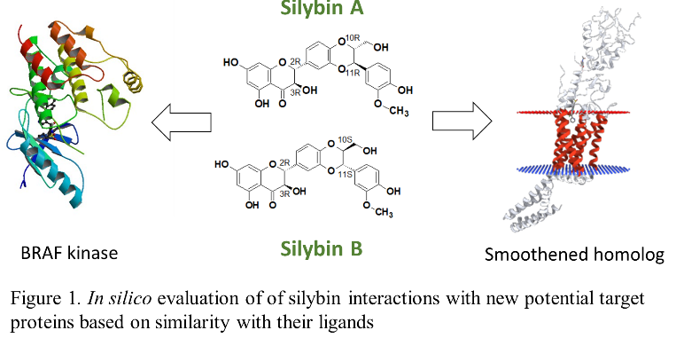
Recent Publications (minimum 5)
- Diukendjieva A, Al Sharif M, Alov P, Pencheva T, Tsakovska I, Paeva I (2017) ADME/Tox Properties and Biochemical interactions of Silybin Congeners: In Silico Study. Natural Product Communications, 12, 2.

Biography (150 word limit)
Antonia Diukendjieva got her BS degree in Biotechnology and MS degree in Biochemistry from Sofia University “St. Kliment Ohridski”, Faculty of Biology. Currently she is a PhD student at the Institute of Biophysics and Biomedical Engineering, Bulgarian Academy of Sciences. Her main scientific interests are in the field of predictive toxicology and in silico drug design. Her most recent investigations relate to pharmacokinetic and pharmacodynamics evaluation of naturally-derived flavonoids.
Email: antonia.diukendjieva@biomed.bas.bg

Notes/Comments:

