Treating abscess or furuncle and panaritium without touching the patient

Jean-Jacques SHAMAVU SAFARI (Shamsaf)

The objective of our research is to demonstrate the existence of the possibility of alternative treatment of the abscess, panaritium, and furuncle based on the medicinal plant called leucas deflexa, a fallow plant of lamiaceae family and leucas genus, without resorting to the Incision and Drainage method, which is believed to make the patient feel uncomfortable.
In other words, we would like to demonstrate the possibility of treating the above mentioned ailments by means of the therapeutic activity of this plant, which is loaded with medicinal properties necessary to cure pathology while sparing the patient from the pains he may feel (during the medical act aiming at the extraction of pus as well as other related acts such as pressing, wicking, suture, and any other practice of healing while touching the abscess). It is worth remembering that the person has already pains (abscesses, boils and whitlow) and it is useless to add others (pressing, etc.).
The plant was also analysed in the laboratory (phytochemical analysis, reactions, etc.) and the results were very conclusive.
Also, as part of our work, we spoke with the people we consulted to find out how they felt when we treated them (abscess, furuncle, panaritium). They did not seek four ways to declare that all the methods used to extract pus whether in modern or traditional medicine, were for them something very painful, exacerbating to the point that they indicated that this left them with bad memory.
Our work involves a sample of 25 people (children, young, adults) over a period of 3 years. It is obvious that the extract of the plant administered them gave good fruit because the pus came out without being pressed and the medicine proved to be successfully wound healing.

Image
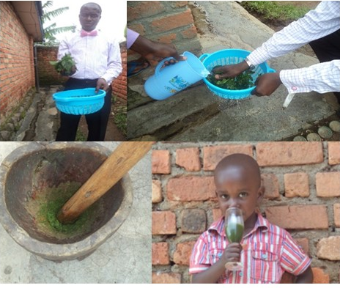
Figure: How the medicinal plant is processed traditionally.

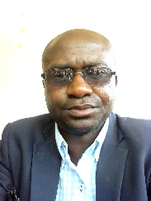Biography

Born 1975, Bukavu, South Kivu, DR Congo, Jean-Jacques Shamavu Safari (Shamsaf) is a writer, and herbalist, and an accredited translator, holding a Bachelor Degree in Community Development, with a long experience Community Relation , traditional medicine, treating a variety of diseases with herbs since the year 2000. He is currently focused on research in phytodermatology. He also believes that the promotion of health, through traditional medicine, which is one of the major keys for development, a community can contribute to the improvement of socio-economic life.
Email: jjshamsaf@mail.com

