Phytochemical and antioxidant evaluation of an ethno medicinal herb Euphoribia milii Des Moul.
Shabnum Saheen, Botany department Lahore College for Women University, Lahore, Pakistan
Nidaa Harun, Botany department Lahore College for Women University, Lahore, Pakistan
Tariq Mehmod, Faculty of Pharmacy, University of Central Punjab, Lahore, Pakistan
Farah Khan, Botany department Lahore College for Women University, Lahore, Pakistan

Abstract
Euphorbia milii Des Moul. belongs to family Euphorbiaceae . It is native shrub to Madagascar, but widely cultivated overall the world due to its medicinal importance. Its latex is used to cure cancer, hepatitis and abdominal edema, also used as a laxative. Its divers medicinal significance urges to evaluate phytochemical and antioxidant potential of this plant. Therefore current endeavor had been carried out which provides the scientific reasoning for its ethno medicinal properties. During this study some taxonomic (morphological, anatomical and palynological) markers also had been provided for correct identification of Euphorbia milii. It is reported as succulent climbing shrub having polygonal, irregular shaped leaf epidermal cells, paracytic stomata and spheroidal pollen grain. Phytochemical evaluation showed the presence of alkaloids, carbohydrates, proteins, tannins, saponins and anthraquinone. Whereas starch grains, glycosides and volatile oils were absent. With regard to antioxidant studies extracts of roots, stems, leaves, flowers and spines were prepared in different solvents i.e., petroleum ether, chloroform, methanol and distilled water. Their antioxidant capacity was measured on spectrophotometer by following standard protocol. Comparative studies showed that the supreme antioxidant activity was displayed by stem in methanol extract i.e., 0.855 ± 0.002 however least was observed in Petroleum ether extract of spines i.e., 0.192 ± 0.002. Generally among all used solvents, the methanol extracts exhibited fairly good antioxidant activity. These results strongly supported the fact that Euphorbia milii is potentially good source of antioxidants and various kinds of metabolites which help in maintenance of human health. As this plant’s cultivation is easy and less expensive, therefore it can be recommended for pharmaceutical uses to develop cheap and effective drugs.

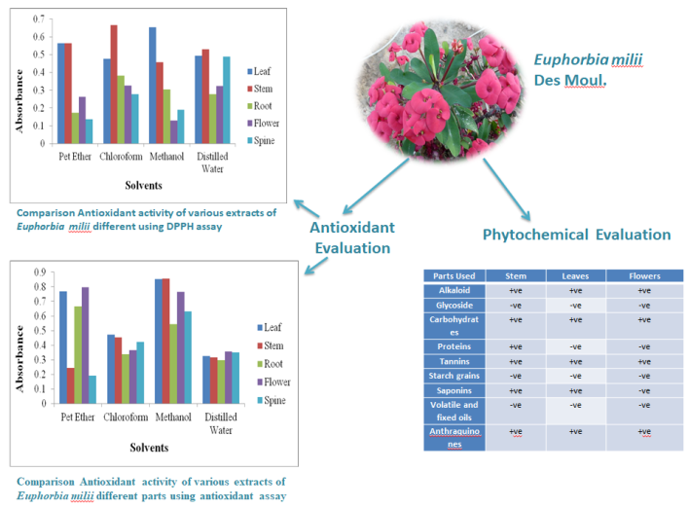
Recent Publications
- Muhammd Ullah, K. Khan, R. Kamal, M. Sohail, Abid Ullah, Kifayat Ullah, Anwar Ullah, Shabnum Shaheen, Inayat Ullah and Zafar Ali Shah. 2017. Removal of methylene blue dye from aqueous solution by using powdered Saccharum arundinaceum leaves. Transylvanian Review., XXV(18): 4746-4752
- Sumera Javad, Nadia Ghaffar, Iqra Naseer, Khajista Jabeen, Aroosa Aftab and Shabnum Shaheen. 2017. Antibacterial activity of phyto-mediated silver nanoparticles developed from Melia azedarach. Periodicum biologorum., 119(2): 107-111
- M. Ashfaq, M. Saleem Haider, M. Ali, Shabnum Shaheen, Farah Khan, Amna Ali and Urooj Mubshar.2017. Molecular diversity and heterosis analysis for rice grain discoloration. Pak.J.of Agr. Science.,54(3) 579-87
- A.Akram, K. Hussain, N. Nahid, Mehmood-Ur-Rehman, A. Naseem and S. Shaheen.2017. Molecular characterization of a begomovirus and associated satellites from cotton (Gossypium hirsutum from Dera Ghazi Khan district of Pakistan. The Journal of animal and plant sciences. 27(4)1245-1255.
- H.Ashraf, M. Jaffer and Shabnum Shaheen. Screening of Organisms and Optimization of Culture Media for the Production of Spirogyra. International journal of current research in bioscience and plant biology, (1): 32-36.

Biography
Shabnum Shaheen is a plant scientist in the field of Natural sciences. She has completed her post doctorate in biological science from Malaysia. She is the author of six books and has published many research articles in national and international journals. Her research interests include medicinal plants, neutraceutical studies and pharmaceutical studies, biodiversity and conservation and plant systematics.
Email: shabnum_shaheen78@hotmail.com

Notes/Comments:

