Investigations on some medical plants from Northern Cyprus
Ali Hikmet Meriçli, Prof.Dr., Near East University, Faculty of Pharmacy, Nicosia, TRNC
Filiz Meriçli, Prof.Dr., Near East University, Faculty of Pharmacy, Nicosia, TRNC

Cyprus is the third largest island of the Mediterranean sea and the point of the encounter of severel different eco-systems. Flora of Cyprus is represented with 1800 plants and 22 of them are endemic plants in Northern Cyprus (1).

Besides a rich plant diversity, Cyprus is also very rich in cultural variation depend on historical situations. The plant and cultural diversities in Cyprus, provide very rich traditional treatments and folk medicines. The active principles of some medicinal plants growing wildly in Northern Cyprus and their uses as sources of herbal medicinal products have been investigated by our research group. Ceratonia siliqua, Matricaria recutita, Prunus dulcis, and Thymus capitatus are the widespread medicinal plants used traditionaly in Northern Cyprus (2-3). On the other hand, Mediterranean Fever Disease is a serious health problem in the island and Colchicine containing medicinal plants are valued for treatment. Colchicum pusillum is widespread in Northern Cyprus, the active principles of the bulbs and aerial parts of C. pusillum are investigated. The anticancer activity of the bulb exract is also determined (5). Our researches on some medicinal plants from Northern Cyprus and their possibility of herbal medicines production will be summarized .
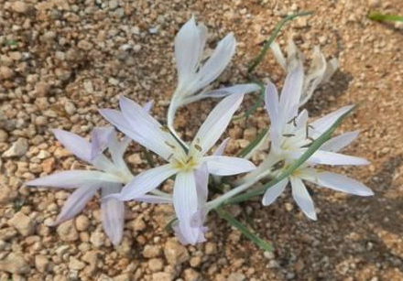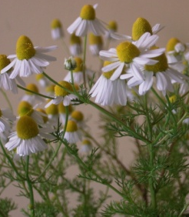
Colchicum pusillum Sieber (photos : by AH Meriçli) Matricaria recutita L.
References
- Viney, D. E. (1996) An Illustrated Flora of North Cyprus, Vol.2 .A.R.G. Gantner Verlag K.-G. Vadus / Liechtenstein.
- Tuncay,B., Özalp,Y. , Başgut,B., Yiğit-Hanaoğlu,D., Meriçli, F. (2017) Herbal Chewing Tablet Preformulation Studies Using A Mediterranean Plant Ceratonia siliqua For Weight Control And Diabetic Disorders, MESMAP-3(3rd Symposium on Medicinal and Aromatic Plants of Mediterranean, April 13-16, Kyrenia,TRNC
- Meriçli F., Becer E., Kabadayı H., Hanoğlu A., Hanoğlu Yigit D., Özkum Yavuz D., Özek T., Vatansever S. (2017) Fatty Acid Composition and Anticanser Activity in Colon Carcinoma cell Lines Of Prunus dulcis seed Oil, Pharmaceutical Biology, 55,1,1239-1248.
- Hanoğlu A , Hanoğlu Yiğit D., Özkum Yavuz D., Meriçli F., Meriçli, A.H. Chamazulene presence of Matricaria recutita samples collected from different region of Northern Cyprus, 22 nd Herbal Drug Raw Materials Meeting, 31 August-6 September 2016, Trabzon, Turkey.
- Meriçli F, Becer E., Hanoğlu D.Y., Hanoğlu A., Yavuz D.O., Vatansever S., Meriçli A.H., Bioactivity of Colchicum pusillum extract in human colon carcinoma cell lines, European Biotechnology Congress, 25-27 May, 2017, Dubrovnik , Croatia.

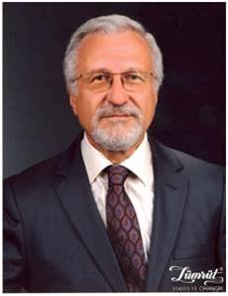
Prof.Dr.Ali Hikmet Meriçli: Gratuated Istanbul University, Faculty of Pharmacy; he is working on isolation and structure elucidation of natural compounds and biological activities of medicinal plants and also herbal medicines.

Prof.Dr.Filiz Meriçli: Gratuated Ankara University, Faculty of Pharmacy; she is working on active principles and biological activities of medicinal plants and phytotherapy (herbal medicines, medicinal teas and medicinal oils) and also other complementary therapies (aromatherapy, apitherapy ,e.g.)

Email: ali.mericli@neu.edu.tr filiz.mericli@neu.edu.tr

Notes/Comments:

