Women, Use of Southern Benin plants in the treatment of typhoid fever: Role of herbalists

Dougnon V., PhD Microbiology, Research Unit of Applied Microbiology and Pharmacology of Natural Substances, BENIN
Legba B., PhD student Biochemistry, Microbiology and Pharmacology of Natural Substances, Research Unit of Applied Microbiology and Pharmacology of Natural Substances BENIN
Yadouléton A., PhD, University of Parakou, BENIN
Agbankpe J., PhD, Research Unit of Applied Microbiology and Pharmacology of Natural Substances, BENIN
Koudokpon H., PhD Student, Research Unit of Applied Microbiology and Pharmacology of Natural Substances BENIN
Hounmanou¹ G., PhD Student, Research Unit of Applied Microbiology and Pharmacology of Natural Substances, BENIN
Bankolé¹ H.S., Full Professor, Research Unit of Applied Microbiology and Pharmacology of Natural Substances
Dougnon¹ J., Full Professor, Research Unit of Applied Microbiology and Pharmacology of Natural Substances
Baba-Moussa L, Full Professor, Laboratory of Biology and Molecular Typing in Microbiology

Abstract
Salmonella spp are pathogenic bacteria responsible for typhoid and paratyphoid fevers. faecal peril bacteria, they cause major and minor salmonellosis. Herbalists are one of the main use of primary health care for people in developing countries. They contribute to the conservation of plants and endogenous knowledge.
The aim of this study was to establish the potential of the Benin flora for the treatment of salmonellosis. It was carried out thanks to an ethnopharmacological study of medicinal plants sold. It was conducted with 90 herbalists located in 30 markets in Southern Benin. The method used is Triplet Purchase of Medicinal Recipes. This technique consisted in visiting the same herbalist three times in a weekly interval. These visits allowed us to buy plants suspected of treating a patient suffering from typhoid fever. At each visit, the herbalist was told that his treatment was effective but that the treatment was very difficult for the patient. The technique then allowed to check the concordance in the recipes proposed by these herbalists during the three visits and to identify the most cited plants in its recipes. In this study, 57 plant species sold by herbalists were identified. Senna siamea (8,32%), Phyllantus amarus (4,16%), Uvaria chamae (3,56%), Acacia siberiana (2,97%), Heterotis rotundifolia (2,97%), Crateva adansonii (2,77%), Citrus aurantiifolia (2,77%), Acanthospermum hispidum (2,57%), Corchorus olitorius (2,57%) were the most sold. Waiting to go through further biological explorations of their activities, extracts from these plants could be a source of Improved Traditional Medicines for the treatment of typhoid fever.

Image
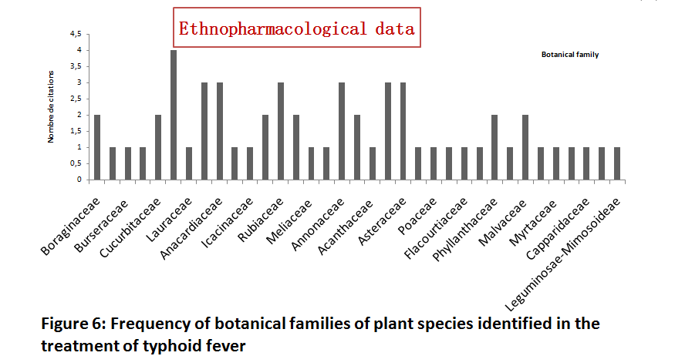

Recent Publications (minimum 5)
- Legba B, Vodounon A.C., 2016. Les plantes a proprietes antivirales du benin et de l’Afrique de l’ouest. revue Internationale des Sciences de Developpement (RISD) E issn : 9771-2345
- Скрипов B.C., Vodounon C. A., Reshetnikova I.D., Legba B., Abramova Z.I., 2016. Granule Associated DNase in T-Lymphocytes from Patients with Inflammatory Disease. American Journal of Biomedical Research ( 2016, Vol. 4, No. 4, 87-93 Available online at http://pubs.sciepub.com/ajbr/4/4/2
- Dougnon T.V., Deguenon E., Fah L., Legba B., Hounmanou Y.M.G Agbankpe J., Amadou A., Koudokpon H., Fabiyi K., Aniambossou A., Assogba P., Hounsa E., De Souza M., Avlessi F., Dougnon T.J., Baba-Moussa L, 2017. Traditional treatments of human and animal salmonelloses in southern benin: knowledge of food animal farmers and traditherapists. Veterinary World Journal. World, 10(6): 580-592.
- Dougnon T.V., Legba B., Yadouleton A., Agbankpe J., Koudokpon H., Hounmanou G., Amadou A., Fabiyi K., Assogba P., Hounsa E., Aniambossou A., Deguenon E., De Souza M., Bankole H.S., Dougnon T.J., Baba-Moussa L.,2017. Use of southern benin plants in the treatment of typhoid and paratyphoid fever: role of herbalists. Ethnopharmacologia (Accepted, in press)
- Hessou S., Dougnon V, Glele-Ahanhanzo Y., Imorou B.C.A, Ahoussinou C., Legba B., Zannou D.M, Baba-Moussa L., 2017. A behavioral and serological survey on HIV prevalence among prisoners in Benin. Journal of Public Health in Africa 2017; 8:678.
- Dougnon T.V., Fah L., Atchade P., Fagla I., Legba B., Koudokpon H., Baba- Moussa L.,2017. Impact Of Parasitoses On The School Performance Of Schools: The Case Of A Public Primary School In The Commune Of Bohicon (Benin). African Journal of Pathology and Microbiology (Accepted, In press)
- Lègba B., Dougnon V., Atégbo J., Hounmanou G., Hounsa E., Agbankpè J., Bankolé H., Dougnon J., Baba-Moussa L., 2017. Exploration of the antibacterial and chemical potentials of some plants of the Benin pharmacopoeia. African Journal of Pharmacology and Therapeutics AJPT (Accepted, in press)
- Dougnon T.V., LEGBA B., Deguenon E., Hounmanou G., Agbankpe J., Koudokpon H., Amadou A., Fabiyi K., Assogba P., Hounsa E., Aniambossou A., De Souza M., S. Bankole H., Baba-Moussa L., Dougnon T.J.,2017. Pathogenicity, Epidemiology and Virulence Factors of Salmonella species: A Review. Not Sci Biol, 2017. 9(4):466 -472(https://notulaebiologicae.ro/index.php/nsb/article/view/10125)

- Nounagnon M. S., Dah-Nouvlessounon D., Ntcha C., Legba B., BABA-MOUSSA F., Adjanohoun A., Baba-Moussa L., 2017. Phytochemistry and biological activities of Crateva adansonii extracts. BioMed Research International(in press)

Biography (150 word limit)
Young PhD student in Biochemistry, Microbiology and Pharmacology of natural substances, I think that
scientific research must be at the service of development. So, I have oriented my lines of research
towards the enhancement of the African pharmacopoeia for the development of more effective drugs. In
my country, the whole population does not have access to conventional medicines. Added to cases of
resistance, the use of natural substances from plants is an important alternative. I’m founder of 229Young scientific,
a association of young scientific of Benin Email: legba.boris5@gmail.com

