Chemical composition of essential oil of Hyssopus officinalis spp. angustifolius cultivated in Southwestern Iran
S. M. Alavi-Samani, Shahrekord Branch, Islamic Azad University, Research Center for Medicinal Plants &
Ethno-veterinary, Medicinal Plants Department, PO. Box: 166, Shahrekord, Iran
A. Ghasemi Pirbalouti, Shahrekord Branch, Islamic Azad University, Research Center for Medicinal Plants &
Ethno-veterinary, Medicinal Plants Department, PO. Box: 166, Shahrekord, Iran; Medicinal Plants Program, Stockbridge School of Agriculture, Collage of Natural Science, University of Massachusetts, Amherst, MA 01003, USA

Abstract (300 word limit)
Aromatic plants and herbal medicines have been used since antique time. They are applied in several aspects and important in various industries such as medical, pharmaceutical, food, and agricultural. The major source of phytochemicals in aromatic plants is essential oils that can play an important role in plants. The essential oils are widely used as preservative and flavoring additives in food production, fragrances in cosmetics, and components of soaps, air fresheners, and detergents. Biological activity of aromatic plants and their essential oils include pesticidal, herbicidal, insecticidal, nematocidal, antifungal and antibacterial properties were reported before as well as their application as natural food preservatives and food antioxidants. This study was done to identify chemical compositions of Hyssopus officinalis L. subspecies angustifolius M. Bieb. (hyssop), belonging to the family Lamiaceae, is a herbaceous plant of the genus Hyssopus native to Southern Europe, the Middle East, and the region surrounding the Caspian Sea. H. angustifolius is one of the most important medicinal plants in Iranian traditional medicine for the treatment of lung inflammation, laryngitis and cough relief. Much attention has been paid to this medicinal plant because of its traditional uses. The hydro distillated essential oil obtained from the aerial parts of H. angustifolius cultivated in the alpine of Southwestern Iran was analyzed by GC-FID and GC/MS to determine chemical compositions. Results of this study indicated that essential oil yield was from 0.5 to 1.2 ml/100 g dry matter. According to the results of this study, constituents representing 95–99% of H. angustifolius essential oil compositions were identiﬁed in two years exclusively represented by monoterpenoids as the main components. The major constituents were identiﬁed as pinocarvone, pinocamphone, α-pinene, 1,8-cineole, and isopinocamphone. In conclusion, the essential oil from H. angustifolius is a good raw source of oxygenated monoterpenes, which have been widely used in food and drug industries.

Image
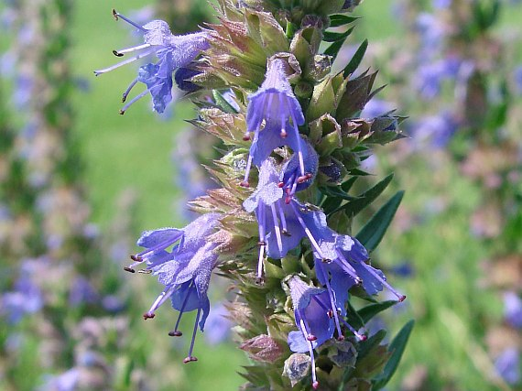

Recent Publications (minimum 5)
- Adams RP (2007) Identiﬁcation of Essential Oil Components by Gas Chromatography/Mass Spectrometry. Carol Stream, IL: Allured Publications.
- Bakkali F, Averbeck S, Averbeck D, Idaomar M (2008) Biological effects of essential oils – A review. Food Chem. Toxicol. 46:446–475.
- Saharkhiz MJ, Esmaeili S, Merikhi M (2010) Essential oil analysis and phytotoxic activity of two ecotypes of Zataria multiﬂora Boiss growing in Iran. Nat Prod Res. 24:1598–1609.
- Ghasemi Pirbalouti A (2010) Medicinal and Aromatic Plants (Introduction and Application). 2th Ed., I.A.U. Press, Iran, pp. 551.
- Ghasemi Pirbalouti A, Craker LE (2015) Diversity in chemical compositions of essential oil of myrtle leaves from various natural habitats in south and southwest Iran. J. For. Res. 26:971–981.


Biography (150 word limit)

Abdollah Ghasemi Pirbalouti is professor at Medicinal Plants Department, Islamic Azad University, Shahrekord Branch, Iran. He has spent the past 17 years working with medicinal and aromatic plants, and considerable experience plant production and biology, botany, phytochemistry, and pharmacognosy. He is familiar with medicinal and aromatic plants production, and quality control for the development of new products. His experience also includes laboratory extraction and essential oil constituent analysis using gas chromatography, mass spectrometry, and HPLC. In addition, he is chief in editor of Journal of Herbal Drugs, International Journal of Medicinal Herbs (www.jhd.iaushk.ac.ir). During 2012-2013, he worked as a Research Scholar in the Medicinal Plant Program at the University of Massachusetts, Amherst, Massachusetts, USA.
Email: ghasemi955@yahoo.com ghasemi@iaushk.ac.ir

Notes/Comments:

