The Effect of Arbutin Powder and A. uvaursi Aqueous Leaf Extract on Synthesis of Melanin by Madurella mycetomatis

Amina Saadeldin Abdelmotalib Omer, B. pharm, UMST, Sudan
Ikram Mohamed Eltaeb, PHD, UMST, Sudan

Abstract
Mycetoma is a devastating, slow-growing bacterial or fungal infection, which develops into a chronic infection of the skin tissues and, if left untreated, eventually results in amputation. With existing anti-fungals and surgery, only 35% of people living with the fungal form of the disease, known as eumycetoma, are cured, Madurella mycetomatis has been found to shield itself against the antifungal therapy through the production of melanin decreasing the effectiveness of the therapy, Arctostaphylos uvaursi has proven antimicrobial effect and is known for it’s content of arbutin which’s a potent inhibitor of melanin synthesis in humans, can hopefully potentiate the action of the present therapy and optimize its effect. The purpose of this study is to investigate the effect of arbutin powder and A. uvaursi aqueous leaf extract on synthesis of melanin by Madurella mycetomatis.
. Methodology & Theoretical Orientation. Aqueous extract of A.uvaursi was prepared by dissolving 50grams of A.uvaursi leaves in 1000ml of water:methanol with a ratio of 95:5 respectively. The arbutin solution was prepared by dissolving 0.5grams of arbutin powder in 20ml of sterile distilled water. The study of the effect of aqueous extract of arctostsphylos uvaursi and arbutin on the synthesis of melanin by M. mycetomatis was carried out as described by van de Sande
Findings: the inhibitory effect of arbutin on melanin synthesis by M. mycetomatis was found to be dose dependent. A. uvaursi aqueous leaf extract containing arbutin was also found to decrease melanin production by M. mycetomatis
Conclusion & Significance: inhibition of melanin synthesis was observed on the arbutin powder as well as the aqueous extract containing arbutin

Image
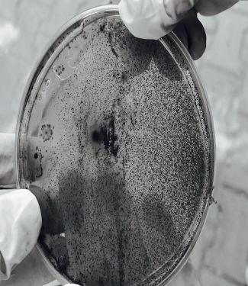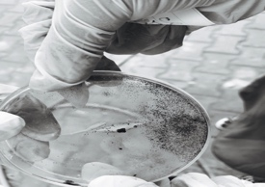
Figure: Effect of 25mg and 75mg Arbutin powder solution on melanin synthesis by Madurella mycetomatis
Recent Publications
- Ahmed, A., Adelmann, D., Fahal, A., Verbrugh, H., van Belkum, A., & de Hoog, S. (2002). Environmental Occurrence of Madurella mycetomatis, the Major Agent of Human Eumycetoma in Sudan. Journal Of Clinical Microbiology, 40(3), 1031-1036
- .Mycetoma:Background,Pathophysiology,Epidemiology.(2017). Emedicine.medscape.com. Retrieved 13 June 2017, from http://emedicine.medscape.com/article/211459-overview.
- Van de Sande, W. W., de Kat, J., Coppens, J., Ahmed, A. O., Fahal, A., Verbrugh, H., & van Belkum, A. (2007). Melanin biosynthesis in Madurella mycetomatis and its effect on susceptibility to itraconazole and ketoconazole. Microbes and Infection, 9(9), 1114-1123
- Van de Sande, W.W.J.; Fahal, A.; Verbrugh, H.; and Belkum, Al., 2007. Polymorphisms in Genes Involved in Innate Immunity Predispose toward Mycetoma Susceptibility. Journal of immunology, 179: 3065-3074
5. Elfadil, H., Fahal, A., Kloezen, W., Ahmed, E. M., & van de Sande, W. (2015). The In Vitro Antifungal Activity of Sudanese Medicinal Plants against Madurella mycetomatis, the Eumycetoma Major Causative Agent. PLoS Negl Trop Dis, 9(3), e0003488.

 Biography
Amina Saad is one of the brightest students; she has been the top of her class for 5 years and graduated with an honor degree, her critical thinking and passion for research has always lead her to a logical hypothesis through which she can find treatment to unresolved neglected diseases.
Email: aminaomer9@gmail.com

Notes/Comments:

