Evaluation of the Nephroprotective Activity of Vicia faba Leaves Extracts against Gentamicin Induced Nephrotoxicity in Rats
Howyda H Mohamed Salih, B. pharm, UMST, Sudan
Ikram Mohamed Eltaeb, PHD, UMST, Sudan

Abstract
Statement of the Problem: Acute kidney injury is common renal problem characterized by an abrupt reduction in renal function; acute tubular necrosis is a subtype of acute kidney injury caused mainly by medication such as aminoglycosides in high or unadjusted doses. Vicia faba is a widely used legume; mainly for its nutritional value but has additional uses such as muscle relaxant and for treating kidney stones.
The aim of our present study is to evaluate the protective effect of Vicia faba leaves extracts in experimentally induced nephrotoxic model in rats.
Methodology & Theoretical Orientation: Rats were induced to produce kidney injury by injecting them with 80mg/kg of gentamicin for 7 days in addition to this the ethanolic and aqueous extracts of Vicia faba leaves 500mg/kg were administered along with the gentamicin for 7 days. On the 8th day of the experiment the blood and kidney samples were collected from each animal and used for estimation of creatinine, urea, albumin and total protein.
Findings: Rats being injected only with gentamicin resulted in increased levels of creatinine and urea with a decrease in levels of albumin and total protein as compared to normal control rats.
Conclusion & Significance: All biomarkers were significantly reversed in the rats administering Vicia faba extracts with a p value of 0.000, 0.000, 0.02 for creatinine, urea, albumin respectively in the ethanolic extract and 0.000, 0.004, 0.015 for creatinine, urea, albumin respectively in the aqueous extract however there was no significant effect on the levels of total protein in neither extracts. Histopathological analysis also reveals disruption of tubular cells and presences of tubular casts which was reduced in rats treated with Vicia faba. These data suggest preventive effect of Vicia faba against gentamicin induced nephrotoxicity, also indicates that the ethanolic extract possess a higher activity
Recommendations: Further research should be done on Nephroprotective activity of Vicia faba to detect the active phytochemicals present in it.

Image
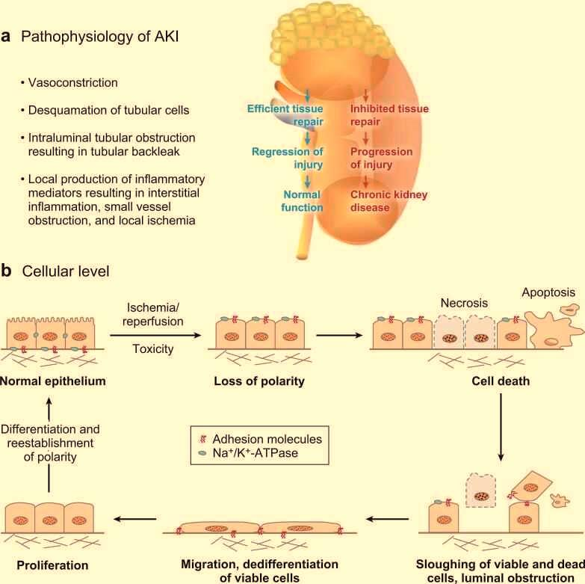
Figure: Schematic representation of (a) Pathophysiological and (b) Cellular Surviving cells that remain adherent to contribute to repair.
Recent Publications
- Warnock DG. Towards a definition and classification of acute kidney injury. J. Am. Soc. Nephrol. 2005;16:3149–50. [PubMed][Ref list]
- Singh, A. and Mamibhushan, N. (2013). An assessment of faba bean (vicia faba L.) current status and future prospect.African journal of Agriculture Research, [online] Vol,8(50)(1991-637X), pp.6635-6641. Available at: http://www.academicjournald.org/AJAR [Accessed 22 Jun. 2017].
- Abdel-Raheem I. T., Abdel-Ghany A. A., and Mohamed G. A., “Protective effect of quercetin against gentamicin-induced nephrotoxicity in rats,” Biological and Pharmaceutical Bulletin, vol. 32, no. 1, pp. 61–67, 2009. View at Publisher · View at Google Scholar View at Scopus
- Ali B. H., “Gentamicin nephrotoxicity in humans and animals: some recent research,” General Pharmacology, vol. 26, no. 7, pp. 1477–1487, 1995. View at Publisher · View at Google Scholar · View at Scopus.
- Emedicine.medscape.com. (2017). Acute Kidney Injury Treatment & Management: Approach Considerations, Vasodilators, Dietary Modification. [Online]

 Biography
Howyda Hashim a recent a graduate of pharmacy school with a first class honors degree and cGPA of 4.88, has always been an intelligent and motivated student, hardworking and discipline in addition to knowledge led her to be one of the most recognizable students among her colleagues. She believes that excellence and success are only achievable through diligence and participation in interactive learning. Respectfulness, Passion and kindness are part of her great character.
Email: howydahashim96@gmail.com

Notes/Comments:

