Evaluation of Pharmacological Effects and Phytochemical Screening of Rumex hastatus Extracts
Shaukat Ali¹, Rozina Ghulam Mustafa¹, Irsa Shafique¹, Saiqa Andleeb¹, Anum Naseer¹, Atiya Zafar¹, Abdul Rehman Niazi²
¹Microbial Biotechnology and Medical Toxicology Laboratory, Department of Zoology, University of Azad Jammu and Kashmir, Muzaffarabad (13100), Pakistan
²Department of Botany, University of Punjab, Lahore, Pakistan
Abstract
Statement of the Problem: The spread of bacterial infectious diseases is a major public threat. Herbs and spices have offered an excellent, important and useful source of antimicrobial agents against many pathological infections. The current study was aimed to investigate the in vitro pharmacological effects of Rumex hastatus extracts. Methodology: Antibacterial activity, antioxidant potential, phytochemical screening and the total contents of phenolic and flavonoids were evaluated for R. hastatus extracts. The antibacterial activity was performed against seven clinical bacterial pathogens viz., Escherichea coli, Serratia marcesscens, Klebsiella pneumoniae, Staphylococcus epidermidis, Streptococcus pyogenes, Pseudomonas aeruginosa, and Staphylococcus aureus. Antibiogram analysis for standard antibiotics was also determined by the agar disc diffusion method. ABTS {2, 2'-azino-bis (3-ethylbenzothiazoline-6-sulphonic acid)} and DPPH (2, 2-Diphenyl-1-picrylhydrazyl) assays was used for antioxidant activity. Phytochemical screening was performed through thin layer chromatography (TLC). Total phenolic and total flavonoid contents were estimated by folin-ciocalteau and colorimetric assays.
Findings: S. aureus, S. pyogenes and S. epidermidis were the most susceptible clinical pathogens to methanolic, ethanolic and acetonic extracts of R. hastatus with 9.2± 0.1 mm, 5.7± 0.6 mm and 6.8± 0.58 mm zone of inhibition respectively. Acetone and methanol extracts (70% and 63%) showed significant antioxidant potential by ABTS assay whereas 93% and 98% scavenging potential by DPPH assay. Qualitative phytochemical screening gave the positive indication for the presence of flavonoids, phenols, terpenoids, tannins, protein, carbohydrate, amino acids, phytosteriods, quinones and saponins. Positive indications of flavonoids, bioactive compounds, and antioxidant constituents were also observed through Thin Layer Chromatography (TLC) and TLC-developed plates. The spot screening and TLC-bioautography against all tested pathogens showed the significant use of R. hastatus as an antibacterial agent. Conclusion & Significance: R. hastatus could be used as antibacterial and antioxidant agents and be useful in promoting research in the discovery of new antimicrobial and antioxidant agents.
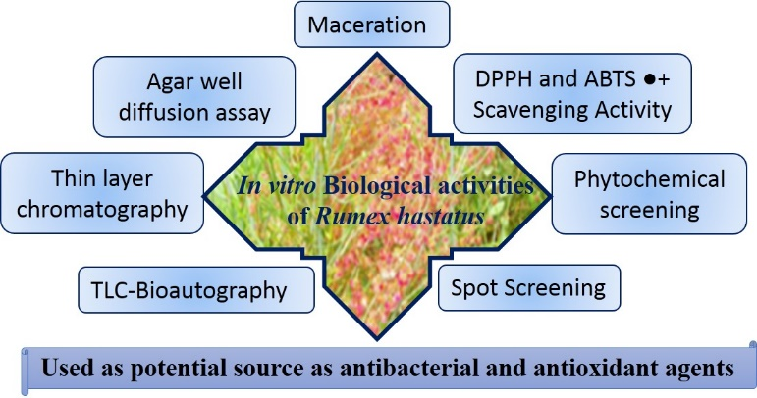
Publications.
1. Sahreen S, Khan MR, Khan RA. Hadda TB (2015)
Evaluation of phytochemical content, antimicrobial,
cytotoxic and antitumor activities of extract from Rumex
hastatus D. Don roots. BMC Complementary Alternative
Medicine 15:211-219.
2. Shami AMM, Philip K, Muniandy S (2013) Synergy of
antibacterial and antioxidant activities from crude extracts
and peptides of selected plant mixture. Complementary
Alternative Medicine 13:360-366.
3. Awan UA, Andleeb S, Kiyani A, Zafar A, Shafique I, Riaz N, Azhar MT, Uddin H (2013) Antimicrobial screening of traditional herbal plants and standard antibiotics against some human bacterial pathogens. Pakistan Journal of Pharmacological Science 26:1109-1116.
4. Joshi B, Sah GP, Basnet BB, Bhatt MR, Sharma D,
Subedi K (2011) Phytochemical extraction and
Antimicrobial properties of different medicinal plants:
Ocimum sanctum (Tulsi), Eugenia caryophyllata (Clove),
Achyranthes bidentata (Datiwan) and Azadirachta indica
(Neem). Journal of Microbiology Antimicrobes 3:1-7.
5. Hussain I, Khan N, Khan H, Ahmad M, Marwat GA,
Khan L, Khan FU, Khan FA, Shah SMH (2010) Screening
of antioxidant activities of selected medicinal plants.
World Applied Science Journal 11:338-340.



Dr. Shaukat Ali has done his Ph.D. studies from Leiden, The Netherlands. He was awarded “Author of the best thesis of the year 2011” of Institute of Biology, Leiden University and he was also nominated author of the best thesis of the the year 2011’ of Faculty of Sciences, and C.J. Kok prizes, Leiden University, The Netherlands. Dr. Ali’s research is mainly in the field of Plants Pharmacology and Medical Toxicology. His expertise to induce human diseases in Zebrafish and mice models has significantly contributed to understand the underlying significance of fish animal model for drug discovery from indigenous flora and fauna. Dr. Ali is also making significant contributions in establishing laboratory for biodiscovery of natural products at his University. These and other studies are helping to bring the Zebrafish to the forefront of biomedical research as an alternative model to rodents for the development and screening of natural products. He has published more that 50 articles in peer reviewed journals. Email: shaukatali134@yahoo.com.

