Anti-hyperglycemic effect of the extracts of Allium sativum Bulbs Growing in Sudan: with and without Metformin drug in Diabetes Treatment

Ikram Mohamed Eltayeb, PhD, U M ST, Sudan.
Amina Djamila Yacouba, B. pharm., U M ST, Sudan

Abstract

Statement of the Problem: Diabetes is now one of the major health problems among the world. Diabetic people have been treated with conventional synthetic drugs for a long time result in many side effects. Therefore, the search for more effective and safer anti-diabetic agents derived from plants has become an interest area of active research.
Today millions of people use herbs either with prescription and non prescription medications; the increasing use means that there is potential for more interactions between herbal products and conventional medicines; causing either potentially dangerous side effects and/or reduced benefits from the medication. As the incidence and severity of herb-drug interactions is increasing due to a worldwide rise in the use of herbal preparations, more research regarding herb-drug interactions are needed. The purpose of this study is to investigate the hypoglycemic effect of Allium sativum bulbs growing in Sudan, and to determine their interaction with Metformin drug used in diabetes treatment.
Methodology: The Soxhlet apparatus was utilized during extractions. The hypoglycemic effects were evaluated in vitro and in vivo by glucose reuptake using isolated rats hemi-diaphgrams tissue and by estimate glucose tolerance in glucose-loaded Wistar rats. GC-MS was used for chemical analysis.
Findings: The A. sativum extracts in this study have in vitro hypoglycemic effect on rat’s hemi-diaphgrams tissue. Petroleum ether extract has a highest effect even more than Metformin due to the presence of well known anti-diabetic compounds; its effect was reducing following Metformin combination. Chloroform extract has activity less than petroleum ether but still more than Metformin; its combination also show an antagonistic action. The ethyl acetate extract effect is less than chloroform and was reduced with combination. Methanolic extract have activity less than ethyl acetate and not affected with combination. The lowest effect obtained when used ethanoic crude extract; combination potentiate its effect but is still less than Metformin.
Petroleum ether extract has in vivo hypoglysimic effect greater than Metformin drug; decreased with Metformin combination.
Conclusion & Significance: The extract alone was significantly anti- diabetic agent; the effectiveness was decreased with Metformin combination.
Recommendations are further study to elucidate the mechanisms of interactions.
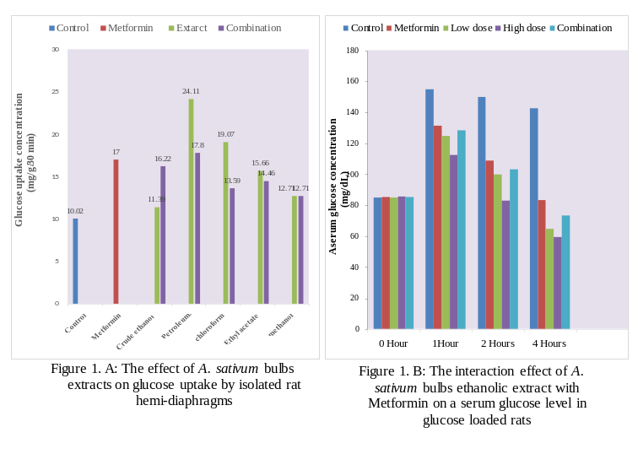
Recent Publications
- Abas Hj Hussin (2001) Adverse Effects of Herbs and Drug-Herbal Interactions. Malaysian Journal of Pharmacy 2:39-44.
- Awad Mohamed Ahmed, Nada Hassan Ahmed (2001) Diabetes Mellitus In Sudan: The Size of the Problem and the Possibilities of Efficient Car. Practical Diabetes Int 18(9): 324–327.
- Hayder Elthaher TE, Wahab Hassan Hamed, Ahmed Saeed Kabbashi, Mohammed Ahmed Abass (2015) The effect of Maerua pseudopetalosa ethanolic extract on glucose tolerance and glucose uptake in rat hemidiaphragm. International Journal of Multidisciplinary Research and Developmrnt 2(11): 359-62.
- Sandhya Mamindla, Prasad K.V.S.R.G and Bharathi Koganti (2016) Herb-Drug Interactions: An Overview of Mechanisms and Clinical Aspects. International Journal of Pharmaceutical Sciences and Research 7(9): 3576-86.
- Williamson E (2001) Synergy and Other Interactions in Phytomedicines. Phytomedicine ; 8: 401–409.

Biography
Ikram Mohamed Eltayeb has her expertise in evaluation and passion in research, search and discovery of natural drugs from plant origin. Her open and contextual evaluation model based on responsive constructivists creates new drugs for improving and treating of chronic diseases. She has built this model after years of experience in research, evaluation and teaching of medicinal plants in universities

Email: kramela_07@yahoo.com

Notes/Comments:

