Didehydro cortistatin inhibits HIV-1 replicating enzymes- an in silico molecular docking studies
Aishwarya P, Lavanya M, Prathiksha Lunked, Kavya K. Pai and Govindappa
Department of Biotechnology, Dayananda Sagar College of Engineering, Shavige Malleshwara Hills, Kumaraswamy Layout, Bengaluru-560078
AIDS is caused by an infection of HIV, it is the deadliest and most fear causing disease and is rapidly expanding across the world. HIV infection has serious consequences, leading to many complications ultimately suppressing the immune system of humans. There are currently many antiviral synthetic agents that are being used to treat or prevent HIV infection. Most of the available synthetic drugs are able to inhibit the replication of the HIV virus. The present work that we have carried out ,”an in silico molecular docking studies of didehydro cortistatin with HIV-1 proteins”. We have used 35 HIV-1 replicating enzymes and proteins with didehydro cortistatin to know their molecular interactions and to find out its use as a potent drug. Most of the available synthetic drugs inhibit the replication of the HIV and they are toxic. The didehydro cortistatin have shown highest interaction with 2b4c (-170.55 kJ/mol) followed by the 1w5x (-127.28 kJ/mol), 3bvb (-127.09kJ/mol),1a80 (-122.64kJ/mol),1hmv (-116.39kJ/mol),1e6j(-113.38kJ/mol), 2hmi(-108.9kJ/mol),1f6u(-108.77kJ/mol), 4e7i (-106.71kJ/mol), 3oy9 (-105.08kJ/mol),4e7k (-103.34kJ/mol), 2ezo (-102.47kJ/mol), 1hrh (-101.56kJ/mol), 3j4f(-100.96kJ/mol), 2m8n (-100.88kJ/mol), 1aik (-100.64kJ/mol). The didehydro cortistatin showed very good docking studies with other proteins but did not cross the -100kJ/mol mark. The compound showed drug likeliness in Molsoft software. The didehydro cortistatin have exhibited remarkable docking profiles with all HIV-1 enzymes/ protein targets and it is relatively a common herbal medicine. The findings suggest that didehydro cortistatin is a promising natural product and inexpensive HIV-1 therapy for this emerging global disease.
Keywords: HIV, replicating proteins, molecular docking, didehydro cortistatin, molsoft
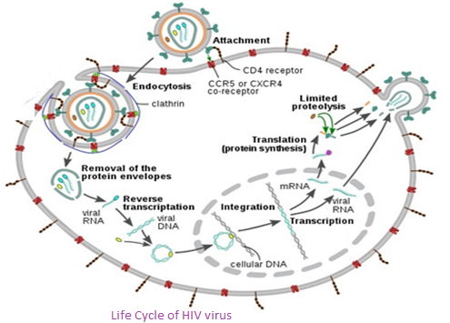

Biography:
Aishwarya P is studying the final year of Bachelors of Engineering in the field of Biotechnology at Dayananda Sagar College of Engineering, Bangaloe ,India. She has a keen interest for research in the area involving usage of natural products for disease management. She has communicated one manuscript titled Tulsi phytochemicals inhibits rubella virus replication and growth proteins –insilico study(TBSD-2017-0613) to The Journal of Biomolecular Structure& Dynamics

