Normalization of insulin resistance, glucose intolerance and lipid profile by Swietenia Mahagoni leaf extract in fructose induced diabetic rats
Naveen Y P and Asna Urooj

Department of Studies in Food Science and Nutrition, University of Mysore, Manasagangothri, Mysore, India

Abstract:
Swietenia mahagoni is a medicinal plant used in various medicinal practices for the treatment of various human ailments. Present study evaluates the anti-diabetic potential of Swietenia mahagoni aqueous extract (MAE) in fructose induced diabetic rats with insulin resistance. Diabetes was induced in the rats by treating the rats with 20 % fructose (W/V) in drinking water for 40 days. Diabetes and hyperinsulinemic condition was confirmed by assessing the glucose and insulin levels in the blood of the experimental rats. After the confirmation of diabetic condition, rats were treated with the MAE and the standard drug metformin and one group left without any treatment and labelled as positive control. MAE treatment improved glucose levels, reduced Insulin levels, improved insulin sensitivity, improved glucose tolerance, improved pancreatic β-cell health, decreased glycated hemoglobin content, reduced lipid peroxides, improved glycogen content and activity of enzymes involved in the synthesis of glycogen in the liver. There was also overall improvement in anti-oxidant status (improved levels of vitamin C, SOD and Catalase and decreased amount of lipid peroxides) of the treated groups when compared with the diabetic control. The treatment also improved the lipid profile (improved HDL and lowered LDL and triglycerides) of diabetic rats. Results confirmed the anti-diabetic potential of MAE in animal model indicating its scope for use as diabetic adjuvant in T-2 diabetic subjects.
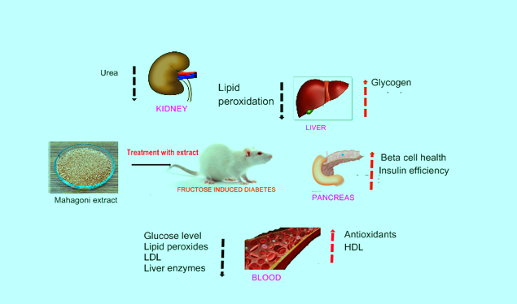
Recent Publications
- Naveen, Y. P., Rupini, G. D., Ahmed, F., & Urooj, A. (2014). Pharmacological effects and active phytoconstituents of Swietenia mahagoni: a review. Journal of integrative medicine, 12(2), 86-93.
- Yp, N., & Urooj, A. (2015). Phytochemical, proximite composition and antioxidant potential of Swietenia mahagoni leaves. Asian J. Pharm. Res. Vol, 5(3), 161-166.
- Naveen, Y. P., & Urooj, A. S. N. A. (2015). Preclinical safety evaluation of Swietenia Mahagoni leaf in wistar rats. International Journal of Pharmacy and Pharmaceutical Sciences, 7(5), 294-297.
- Naveen Y P, Divya Rupini G, Ahmed F, Urooj A. In vitro hypoglycemic potential of spices: cinnamon and cumin. Pakistan J of Pharmaceutical sciences (Accepted for publication)
- Naveen, Y. P., & Urooj, A. (2015). Amelioration of diabetes by Swietenia mahagoni in streptozotocin induced diabetic rats. International Journal of Pharmaceutical Sciences and Research, 6(9), 3892
- Yelaware Puttaswamy, N., & Urooj, A. (2016). In Vivo Antihypercholesterolemic Potential of Swietenia mahagoni Leaf Extract. Cholesterol, 2016.

BIOGRAPHY

Myself Dr. Naveen y p, have completed my Ph.D in Biochemistry and currently working as Assistant Professor in Department of Biochemistry, Pooja Bhagavath Mahajana PG Center, Mysore. I have experience on the screening of medicinal plants for the anti-diabetic potential using in-vitro assays and validation of the promising medicinal plants for anti-diabetic potential using in-vivo models. The theme of my research work has provided me a handful of experience on handling of the animal, screening methods for anti-diabetic potential (throughput screening) and characterization of phytochemicals. My research work resulted in the preclinical validation of a medicinal plant (Swietenia mahagoni) for the anti-diabetic potential and identification of a bioactive named scopoletin in the extract. My research work has laid a platform for studying the efficiency of the mentioned medicinal plant in Human diabetic subjects. Along with the hands-on experience in the diabetes pharmacology, I have gained the proficiency in communication of my research work both as presentations and publications in the journals. Indeed myself serving as a reviewer for few international journals.
E-mail: navee.yp@gmail.com

Presenting author details
Full name: Dr. Naveen Y P
Contact number: +918197690627
Linked In account:
Session name/ number: Pharmacology
Category: Oral presentation/Poster Presentation
Notes/Comments:

