Development of an herbal formulation containing extracts of Camellia sinensis and Limonium algarvense and assessment of its in vitro bioactivities
Maria J. Rodrigues, MSc, Centre of Marine Sciences, Portugal
Marta M. Oliveira, MSc, Centre of Marine Sciences, Portugal
Vanessa F. Neves, MSc, Centre of Marine Sciences, Portugal
Andreia Ovelheiro, MSc, Centre of Marine Sciences, Portugal
Catarina A. Pereira, MSc, Centre of Marine Sciences, Portugal
Nuno R. Neng, PhD, University of Lisbon, Portugal
José M. F. Nogueira, PhD, University of Lisbon, Portugal
João Varela, PhD, Centre of Marine Sciences, Portugal
Luísa A. Barreira, PhD, Centre of Marine Sciences, Portugal
Luísa M. Custódio, PhD, Centre of Marine Sciences, Portugal

Abstract

The growing interest of stakeholders and consumers in herbal products urges the need for research aiming to unravell innovative products with health improvement potential. Green tea (Camellia sinensis (L.) Kuntze, CS) is commonly sold in mixtures combining different herbs, fruits or spices in order to improve or add beneficial properties to such beverages. Having this in mind, and following previous promising results obtained with the halophyte sea lavender (Limonium algarvense Erben. LA) this work prepared and evaluated herbal beverages containing mixtures of CS and LA flowers in terms of antioxidant capacity and inhibition of enzymes related with Alzheimer’s (acetyl- and butyrylcholinesterase) and Type 2 diabetes mellitus (α-amylase and α-glucosidase). The phenolic profile was determined by HPLC. Both synergistic and antagonistic interactions were observed. LA and CS samples had strong antioxidant activity, whereas LA and CS mixtures exhibited higher OH• radical-scavenging and anti-lipid peroxidation capacity. LA samples had higher cholinesterase inhibition than CS and mixtures resulted in stronger enzymatic inhibition. CS had the highest α-glucosidase inhibition, which decreased when combined with LA. CS had higher phenolic contents, and its combination with LA increased the phenolic diversity of the mixtures. Results showed that LA and CS infusions and decoctions and their combinations have relevant in vitro antioxidant, neuroprotective and antidiabetic properties. Infusions and decoctions of LA and CS mixtures should thus can be further explored as potential innovative functional beverages able to prevent oxidative stress and lipid oxidation related diseases, and to reduce the progression of neurodegenerative diseases and diabetic complications.
Image
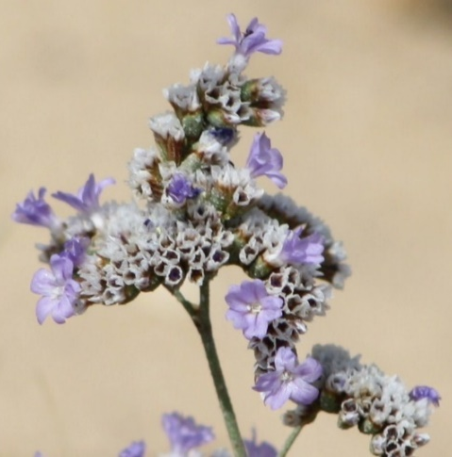
Figure 1. Limonium algarvense flowers.
Recent Publications
- Rodrigues MJ, Custódio L, Lopes A, Oliveira M, Neng NR, Nogueira JMF, Martins A, Rauter AP, Varela J, Barreira L (2017) Unlocking the in vitro anti-inflamatory and antidiabetic potential of Polygonum maritimum. Pharmaceutical Biology 55:1348-1357.
- Rodrigues MJ, Katkam GN, Zengin G, Mollica A, Varela J, Barreira L, Custódio L (2017) Juncaceae species as sources of innovative bioactive compounds for the food industry: In vitro antioxidant activity, neuroprotective properties and in silico studies. Food and Chemical Toxicology 107:590-596.
- Rodrigues MJ, Neves V, Martins A, Rauter AP, Neng NR, Nogueira JMF, Varela J, Barreira L, Custódio L (2016) In vitro antioxidant and anti-inflammatory properties of Limonium algarvense flowers’ infusions and decoctions: a comparison with green tea (Camellia sinensis). Food Chemistry 200:322-329.
- Rodrigues MJ, Soszynski A, Martins A, Rauter AP, Neng NR, Nogueira JMF, Varela J, Barreira L, Custódio L (2015) Unravelling the antioxidant potential and the phenolic composition of different anatomical organs of the marine halophyte Limonium algarvense. Industrial Crops and Products 77:315-322.
- Rodrigues MJ, Gangadhar KN, Vizetto-Duarte C, Wubshet SG, Nyberg NT, Barreira L, Varela J, Custódio L (2014) Maritime Halophyte Species from Southern Portugal as Sources of Bioactive Molecules. Marine Drugs 12:2228-2244.

Biography
Maria J. Rodrigues has a degree in Biology (major in Biomedicine) and a Master in Biomedical Sciences. She has interest in exploring new biotechnological applications and products from marine organisms (halophytes, microalgae, macroalgae, marine invertebrates) found in the Algarve coast. She has been working as a research fellow in the Marine biotechnology group under the scope of different projects: SEABIOMED (marine photosynthetic organisms of the Algarve coast with biomedical applications, XtremeBio (halophytes: a precious resource nutritional elements and bioactive compounds, MaNaCruzi (searching for marine origin molecules against Trypanosoma cruzi, and recently XtremeGourmet (Extremophile Plants in the Gourmet Cuisine). Since 2014 she has been working on her PhD project: "Unravelling the biotechnological potential of halophytes species of the Algarve coast". During this time, she participated in the preparation of 27 scientific articles published in international peer-reviewed journals and 17 communications in national and / or international conferences (oral and poster).

Email: mjrodrigues@ualg.pt

Notes/Comments:

