In-vitro Photoprotective Effect of Lotus (Nelumbo nucifera) and its Potential as Sunscreen
Tariq Mahmood*, Muhammad Abdul Majid, Abid Mehmood Yousaf, Yasser Shahzad

Faculty of Pharmacy, University of Central Punjab, Lahore, 54000, Pakistan

Abstract (300 word limit)
Statement of the Problem: Among the exogenous factors, ultraviolet (UV) irradiation rule is the major concern in photoaging and skin cancer. Recently, lot of studies focused on focused on the UV protective effects of botanical extracts because of their effectiveness, cost and safe use. Lotus (Nelumbo nucifera) is an ancient plant, which inhibits oxidative damages to DNA. Our study explores for the first time, the in-vitro Photoprotective potential of lotus extracts and sunscreen formulations thereof.
Methods: Briefly, shade dried lotus leaves were subjected to extraction either cold (maceration) or decoction while methanol used as solvent for cold extraction (pure or hydroalcoholic). Different extracts obtained in this way, assayed for their antioxidant activity using DPPH as stable free radical whereas L-ascorbic used as standard antioxidant. In-vitro sun protection factor (SPF) determined after appropriate dilutions and subjecting samples through spectrophotometry. For the calculation of SPF, Mansur equation used shown below;
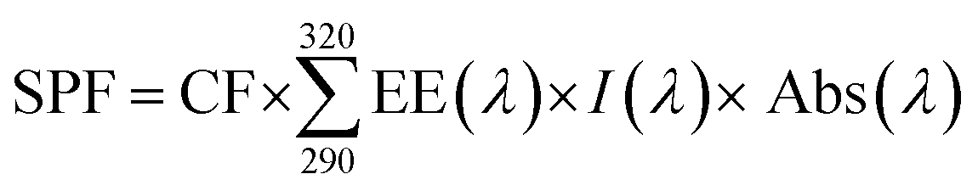
Findings: Among various extracts, pure methanolic extract showed maximum sun protection factor (at 500 µg concentration) compared to decoction (1000 µg) and hydroalcoholic extract (1000 µg). The most potent extract now loaded into different polymers (inclusion complexes) and a lotion (o/w emulsion) formulation. The sun protection showed following order; β- Cyclodextrin > PVP > HPMC > Lotion. We have found an association of viscosity versus SPF showing the thickener does matter. Furthermore, SPF of methanolic extract found in good relationship to antioxidant activity.
Conclusion & Significance: Results showed how minute quantities of lotus could be a better alternative to chemical sunscreens that are costly and bear harmful effects to skin. Thus, lotus extract alone or in combination with other sunscreens could prove as Photoprotective agent.

Image
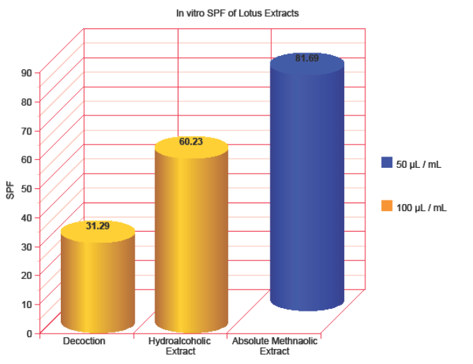
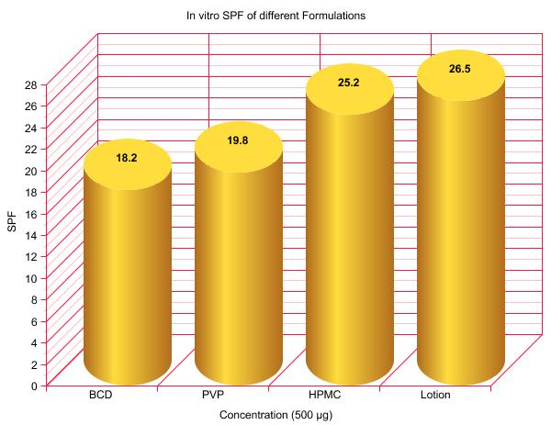

Recent Publications (minimum 5)
▪ Sidra Meer, Naveed Akhtar, Tariq Mahmood, Joanna Igielska-Kalwat. Efficacy of Phoenix dactylifera L. (Date Palm) Creams on Healthy Skin. Cosmetics 2017, 4, 13: 1-8.
▪ Sabeeh Mohsin, Naveed Akhtar, Tariq Mahmood, Hira Khan, Rehan Mustafa. Formulation and stability of topical water in oil emulsion containing corn silk extract. Tropical Journal of Pharmaceutical Research. 2016, 15(6): 1115-1121. (Impact Factor: 0.54)
▪ Tariq Mahmood, Naveed Akhtar. Skin Whitening Multiple Emulsions Loaded with Green Tea and Lotus Extracts: an Efficacy Study. Value Health. 2015, 18(7): A416. (Impact Factor: 3.82)
▪ Hira Khan, Naveed Akhtar, Tariq Mahmood, Adnan Jameel, Sabeeh Mohsin. Preliminary one-month stability screening of cosmetic multiple emulsions (W/O/W) prepared using cetyl dimethicone copolyol and Polysorbate 80. International Journal of Cosmetic Science. 2015, 37(1): 76-81. (Impact Factor: 1.54)
▪ Tariq Mahmood, Naveed Akhtar. The Tyrosinase-inhibitory activity of green tea and lotus subsequently revealed for depigmenting effects in healthy Asian subjects. Giornale Italiano Di Dermatologia E Venereologia. 2014, 149 (6): 730-731. (Impact Factor: 1.01)
▪ Tariq Mahmood, Naveed Akhtar, Sivakumar Manickam. Interfacial film stabilized W/O/W nano multiple emulsions loaded with green tea and lotus extracts: systematic characterization of physicochemical properties and shelf-storage stability. Journal of Nanobiotechnology. 2014, 12:20. (Impact Factor: 4.23)
▪ Muhammad Asad, Sajid Bashir, Tariq Mahmood, Imran Nazir, Muhammad Imran, Sabiha Karim, Fakhar ul Hassnain. Fabrication and Characterization of Gliclazide Loaded Microcapsules. Brazilian Archives of Biology and Technology. 2014, 57(6): 874-881. (Impact Factor: 0.46)
▪ Rashida Parveen, Naveed Akhtar, Tariq Mahmood. Topical microemulsion containing Punica granatum extract: its control over skin erythema and melanin in healthy Asian subjects. Advances in Dermatology and Allergology. 2014; XXXI, 6: 351-355. (Impact Factor: 1.34)
▪ Gulfishan, Naveed Akhtar, Tariq Mahmood, Hira Khan, Qazi Adnan Jamil, Muhammad Sohail and Shafia Arshad. Lipoxygenase assay and cutaneous erythema test have discovered a potent anti-inflammatory activity shown by some genus Prunus plants. Scientific Research and Essays. 2014, 9(23): 988-992.
▪ Tariq Mahmood, Naveed Akhtar. Combined topical application of lotus and green tea improves facial skin surface parameters. Rejuvenation Research. 2013, 16(2): 91-97. (Impact Factor: 3.66)
▪ Tariq Mahmood, Naveed Akhtar. Stability of a cosmetic multiple emulsion loaded with green tea extract. The Scientific World Journal. 2013, Volume 2013, Article ID 153695, 1-7.
▪ Tariq Mahmood, Naveed Akhtar, Barkat Ali Khan, Akhtar Rasul, Haji M. Shoaib Khan. Fabrication, physicochemical characterization and preliminary efficacy evaluation of a W/O/W multiple emulsion loaded with 5% green tea extract. Brazilian Journal of Pharmaceutical Sciences. 2013, 49(2): 341-349. (Impact Factor: 0.48)
▪ Tariq Mahmood, Naveed Akhtar, Cosmin Moldovan. A comparison of the effects of topical green tea and lotus on facial sebum control in healthy humans. Hippokratia. 2013, 17(1): 64-67. (Impact Factor: 0.56)
▪ Tariq Mahmood, Naveed Akhtar. Improvements in skin barrier function following long-term treatment with green tea and lotus in healthy adults, a step towards future treatment of atopic dermatitis. HealthMed. 2013, 7(2): 455-461.
▪ Tariq Mahmood, Naveed Akhtar. Short-term study of human skin irritation by single application closed patch test: assessment of four multiple emulsion formulations loaded with botanical extracts. Cutaneous and Ocular Toxicology. 2012, 32(1): 35-40. (Impact Factor: 1.11)
▪ Tariq Mahmood, Naveed Akhtar, Barkat Ali Khan. Herbs as alternate in treating acne. Bratislava Medical Journal. 2012. 113(2): 125. (Impact Factor: 0.45)
▪ Tariq Mahmood, Naveed Akhtar, Barkat Ali Khan, Haji M. Shoaib Khan, Tariq Saeed. Changes in skin mechanical properties after long-term application of cream containing green tea extract. Aging Clinical and Experimental Research. 2011, 23: 333-336. (Impact Factor: 1.36)
▪ Naveed Akhtar, Jehad Hisham, Barkat Ali Khan, Haji M. Shoaib Khan, Tariq Mahmood, Akhtar Rasul, Muhammad Iqbal, Mughal Qayum. Cosmetic Application of Phenolic Cream from Mulberry Bark Extract. Asian Journal of Chemistry. 2012, 24(4): 1805-1808.
▪ Akhtar Rasul, Naveed Akhtar, Barkat Ali Khan, Tariq Mahmood, Shahiq Uz Zaman, Haji M Shoaib Khan. Formulation Development of a Cream Containing Fennel Extract: in Vivo Evaluation for Antiaging Effects. Pharmazie. 2012, 67: 54-58. (Impact Factor: 1.26)
▪ Akhtar Rasul, Naveed Akhtar, Muhammad Iqbal, Barkat Ali Khan, Asadullah Madni, Ghulam Murtaza, Muhammad Khurram Waqas, Tariq Mahmood. Sebumetric and mexametric evaluation of a fennel based cream. ScienceAsia. 2012, 38: 262–267. (Impact Factor: 0.19)
▪ Haji M. Shoaib Khan, Naveed Akhtar, Fatima Rasool, Asadulllah Madni, Tariq Saeed, Barkat A. Khan, Tariq Mahmood. Investigation of a New Sebum Control Cream Containing Apple Juice Extract. Asian Journal of Chemistry. 2011, 23(2): 810-812.
▪ Barkat Ali Khan, Naveed Akhtar, Tariq Mahmood, Haji M. Shoaib, Mughal Qayum, Tariq Saeed. Effects of Antioxidants and Flavonoids of Sea Buckthorn on Skin Whitening and Skin Erythema. Asian Journal of Chemistry. 2011, 23(2): 903-906.
▪ Naveed Akhtar, Masood Anwar, Barkat Ali Khan, Tariq Mahmood, Shahiq-Uz-Zaman. Formulation Development and Pharmaceutical Evaluation of a W/O Emulsion of Coleus Extract. Indian Journal of Pharmaceutical Education and Research. 2011, 45 (3). (Impact Factor: 0.10)
▪ Naveed Akhtar, Barkat Ali Khan, Abdul Majid, Haji M. Shoaib Khan, Tariq Mahmood, Gulfishan, Tariq Saeed. Pharmaceutical and Biopharmaceutical Evaluation of Extracts from Different Plant Parts of Indigenous Origin for their Hypoglycemic Responses in Rabbits. Acta Poloniea Pharmaceutica Drug Research. 2011, 68(6): 919-925. (Impact Factor: 0.87)
▪ Tariq Mahmood, Naveed Akhtar, Barkat Ali Khan, Haji M Shoaib Khan, Tariq Saeed. Outcomes of 3% Green Tea Emulsion on Skin Sebum Production in Male Volunteers. Bosnian Journal of Basic Medical Sciences. 2010, 10(3): 260-264. (Impact Factor: 0.65)..

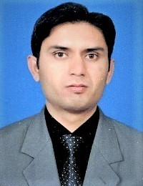
Biography (150 word limit)

Dr. Tariq Mahmood is currently working as Assistant Professor, Faculty of Pharmacy - University of Central Punjab, Lahore. He is also serving as Managing Editor for the Journal of Pharmacy and Alternative Medicine (USA). His research interests include Photoaging, trans-dermal drugs, cosmetics (safety, efficacy and quality control), cosmeceuticals, multiple emulsions and Nanoemulsions. Dr. Tariq has published over 50 research articles on cosmetics and Cosmeceuticals Sciences. He is currently reviewer / editorial board member of more than ten international journals including but not limited to Cosmetics, Health Sciences, Natural Products and Clinical research. In 2013, Dr. Tariq was nominated and short listed for the Lush Prize award held in UK, based on his Ph.D. research. In “Young Researcher Award” category, Dr. Tariq was the only one short listed from all over the Asia.

Email: dr.tariq@gmail.com

Notes/Comments:

