Image
Molecules identified in AEH and GEH

ABSTRACT
Doxorubicin (Dox) is a highly active chemotherapeutic drug used to treat several solid and hematologic tumors. However, its clinical use is limited by its severe cardiotoxic side effects include reactive oxygen species production. The aim of this study is to investigate the protective effects of plants extracts used as spices against the Dox-induced toxicity on H9c2 cells and elucidates their mechanism of action.
Methodology: The cytoprotective effects of the extracts of Afroxtyrax lepidephyllus (GEH) and Monodora myristica (AEH) were tested by assessing the growth and viability of H9c2 cells treated with Doxorubicin in presence of the extracts using sulforodamine B (SRB) and resazurine assays. The effects of extracts on morphological and biochemical changes of the cells were explored through the mitochondrial membrane potential (ΔΨm), the production of ROS, and the activity of caspases 3 and 9.
Results: The SRB assay showed that the samples AEH (60.56 ± 9.83 %) and GEH (65.26 ± 9.29 %) at the concentration of 25 µg/mL have revealed a significant (P<0.05) protective effect of cell growth and the resazurine assay confirmed their effect on cell viability with the respective values of 68.94 ± 6.00 % et 74.68 ± 5.84 % that were significantly higher compared to the control treated with Dox. We found an increase of the ΔΨm in presence of the samples: GEH (68.75 ± 7.99 %) and AEH (68.41 ± 3.21 %) compared to the group receiving the Dox (56.91 ± 4.18 %). Also we noted a decrease production of ROS in living H9c2 cells and reduction of the activity of the caspases 3 and 9. The morphological assessment showed a reduction of apoptotic cells, nucleus fragmentation and the TMRE showed an increase of the ΔΨm in presence of AEH and GEH.
Conclusion & Significance: AEH and GEH extracts demonstrated protective effect against the deleterious effects of Dox on cardiomyocytes. Their mechanism implied the reduction of apoptosis in cardiac cells and oxidative stress. Therefore, they could be used as inhibitor of Dox cardiotoxicity to improve cancer treatment.

Key Words: Spices, Antioxidants, Oxidative stress, Apoptosis, Doxorubicine, Cardiotoxicity, H9c2 cells

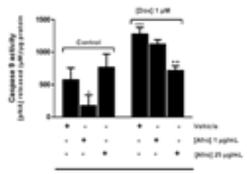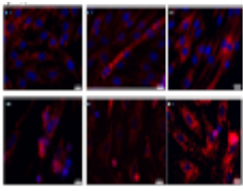

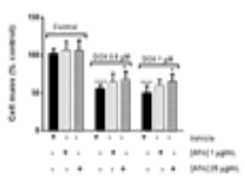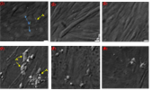

Constant Anatole PIEME is an associate Professor of Biochemistry at the Faculty of Medicine and Biomedical Sciences (University of Yaounde I- Cameroon). Constant Anatole PIEME is teaching general biochemistry and Chemical pathology to medical students of the same Faculty. He has his expertise in evaluation and passion in improve wellbeing and health using natural products and nutraceutics. He research focuses on drug discovery from natural products (mainly spices), targeting major on non-communicable diseases like diabetes and Cancer. He acquired research experiences on various mechanisms pathways of anticancer activity of molecules and extracts from natural products during different postdoctoral and visiting research in Switzerland (2014), India (2012), Italy (2010) and Romania (2008). He developed translation research which combined both fundamental and clinical research. He has several publications in journals with impact factor.
E.mail: apieme@yahoo.fr


CARDIOPROTECTIVE EFFECT OF TWO CAMEROONIAN SPICES AGAINST DOXORUBICIN INDUCED CARDIOTOXICITY ON H9C2 CELLS

MOUKETTE MB^{1,2}, FERREIRA L ², SIMÕES R², DEUS C², SILVA AM², SARDÃO V², PIEME CA ^{1*}, OLIVEIRA PAULO J²

¹Department of Physiological Sciences and Biochemistry, Faculty of Medicine and Biomedical Sciences, University of Yaounde I ; Cameroon
² Mitochondrial Toxicology and Experimental Therapeutics Laboratory Mitochondria, Metabolism and Disease Group; CNC - Center of neurosciences and cell biology, Coimbra University, Coimbra, Portugal

Corresponding author: apieme@yahoo.fr, +237 674 55 18 71

