Development and Evaluation of Biodegradable nanogel for the Treatment of skin cancer
Dr. Sushil Kumar Kashaw, PhD, Assistant Professor, Department of Pharmaceutical Sciences, Dr. Harisingh Gour University, Sagar, Madhya Pradesh, India.
Dr. Prashant Sahu, PhD, CSIR-RA, Department of Pharmaceutical Sciences, Dr. Harisingh Gour University, Sagar, Madhya Pradesh, India.

Abstract:
Objective & Background details: Developing pH responsive, controlled release, biodegradable nanogel against skin cancer. Squamous Cell Carcinoma is a cancer regards as most lethal form of skin cancer with 70-75% of occurrence rate. Targeted drug delivery is blooming stream in the field of medicine and disease treatment especially cancer Material & Methodology: Ion gelation technique was engaged to synthesize nanogel. TEM & DLS were employed for morphological analysis of nanogel. Hemolysis, MTT & Apoptosis assays were employed for biocompatibility and cytocompatibilty assessment. HaCaT cell line was used for cell uptake studies and DMBA-Croton oil animal model was employed for in-vivo assessment. Observations, Findings, Discussion & Importance: The nanogel was synthesized by optimized parameters of chitosan consisting TPP as cross linker and Pluronic as gelling media. The developed nanogel exhibits nano particle size screened by TEM with fine distribution when screened by DLS measurement. The Zeta potential of nanogel found cationic charge with slightly acidic pH of about 6 when evaluated by digital pH meter which mimics the skin environment. Rheological profile of developed nanogel shows fine gelling property and consistent viscosity assayed by viscometer. The In vitro cell lines results suggest that the nano-formulation exhibits significant hemo- compatible and cyto- compatible potentials with prominent permeation and distribution efficacy screened by confocal microscopy. In vivo pharmacokinetic and histo-pathological profile reveals perceptible anti-melanoma potential with negligible effect on normal melanin cells compare to the marketed standard 5-Fluorouracil gel at very low dose and frequency.

Image
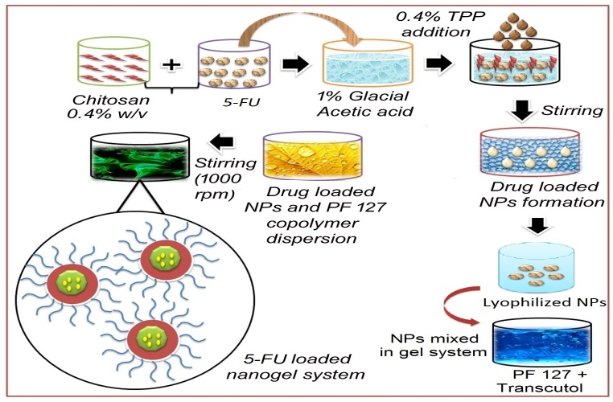
Recent Publications
- Sahu P, Kashaw SK, Jain S, Sau S, Iyer AK (2017) Assessment of penetration potential of pH stimuli double walled nanogel for the controlled delivery of 5- fluorouracil: Ex vivo and in-vitro evaluation. Journal of Controlled Release 253:122-136
- Gawde KA, Kesharwani P, Sau S, Sarkar FH, Padhye S, Kashaw SK, Iyer AK (2017) Synthesis and Characterization of Folate Decorated Albumin Bio-conjugate Nanoparticles loaded with a Synthetic Curcumin Difluorinated Analogue. Journal of Colloid and Interface Science 496:290-299.
- Alsaab OA, Sau S, Alzhrani R, Tatiparti K, Bhise K, Kashaw SK, Iyer AK (2017) PD-1 and PD-L1 CheckpointSignaling Inhibition for CancerImmunotherapy: Mechanism, Combinations, and Clinical Outcome. Frontiers in Pharmacology 8: 561. doi: 10.33 89/fphar.2017.00561
- Bhise K, Sau S, Alsaab H, Kashaw SK, Tekade R, Iyer AK (2017) Nanomedicine for cancer diagnosis and therapy: advancement, success and structure activity relationship. Therapeutic Delivery. 8(11). https://doi.org /10.4155/tde-2017-0062.
- Sau S, Alsaab HO, Kashaw SK, Tatiparti K, Iyer AK (2017) Advances in antibody-drug conjugates: A new era of targeted cancer therapy. Drug Discovery Today. 6446 (17) 3007-08. doi: 10.1016/j.drudis.2017.05.011.

Photograph

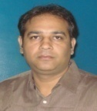
Biography:
Dr. Sushil K. Kashaw has recently joined Use‐inspired Biomaterials & Integrated Nano Delivery (U‐BiND), Systems Laboratory, Department of Pharmaceutical Sciences, Wayne State University, Detroit under the mentorship of Dr. Arun K. Iyer as Raman Post Doctoral Fellow under the visitor exchange program. He is Assistant Professor (Stage-III) in Department of Pharmaceutical Sciences, Dr. Harisingh Gour University, (A Central University; ‘A’ Grade by UGC-NAAC), Sagar (M.P.)-India. His area of research is drug design, medicinal chemistry and nanogels as a drug delivery system. He has thirteen years of academic and research experience. To his credit, he has completed three research projects and two research projects are ongoing which are sponsored by state and Indian government. Currently he is guiding four PhD scholars and 34 M.Pharm. students have done thesis under his guidance. Dr. Kashaw has published 84 research papers in the journals of great repute along with one book entitled “Text book of organic name reactions”. He has presented his research work in many national and international conferences. He is reviewer of many national and international journals. Dr. Kashaw has all the facilities to carrry out work of drug design and synthesis at his host department. Currently his focused area of research is design and synthesis of anticancer, antimalarial, antitubercular and anticonvulsant agents.

Email: sushilkashaw@gmail.com

