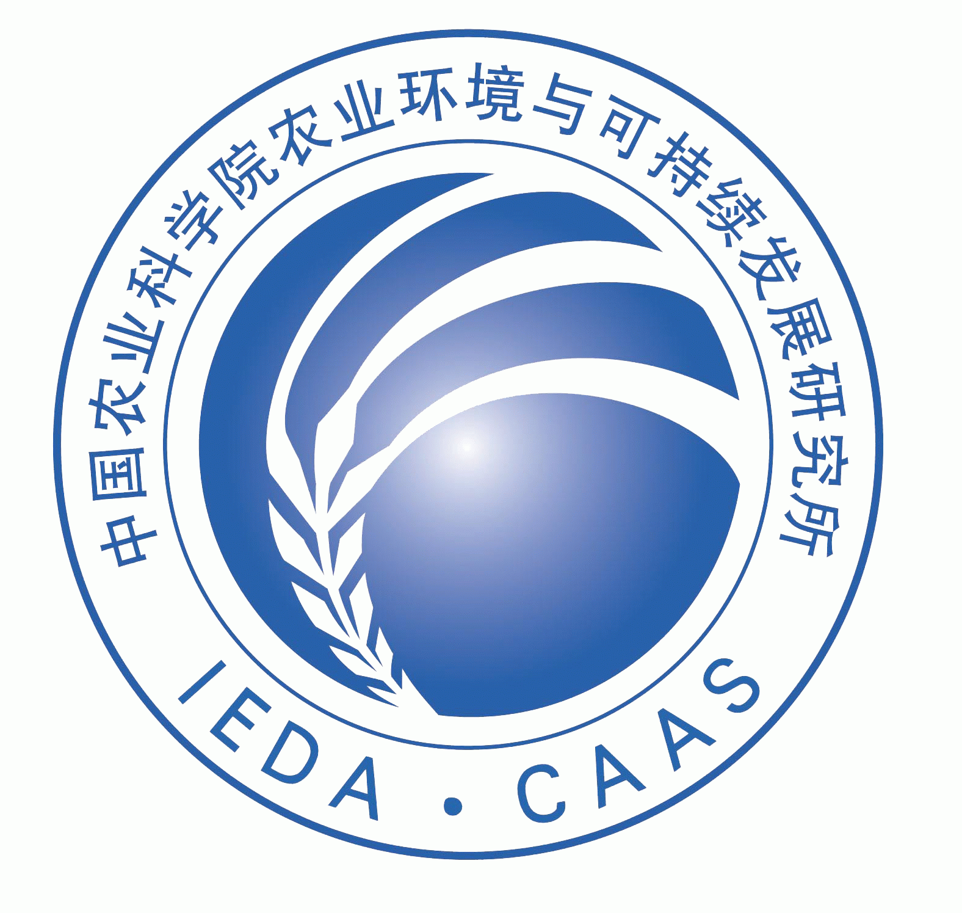


Title: Morphology, Structure and Function Characterization of PEI Modified Magnetic Nanoparticles Gene DeliverySystem
Name: Xiang Zhao, Yan Wang,Changjiao Sun, Bo Cui, Haixin Cui*
Institute of Environment and Sustainable Development in Agriculture, Chinese Academic of Agriculture Sciences, Beijing 100081, China
Abstract (250-300 words)
Modified magnetic nanoparticles are used as non-viral gene carriers in biological applications. To achieve successful genedelivery, it is critical that nanoparticles effectually assemble with nucleic acids. However, relatively little work has beenconducted on the assemble mechanisms between nanoparticles and DNA, and its effects on transfection efficiency. Usingbiophysical and biochemical characterization, along with Atomic force microscopy (AFM) and Transmission electronmicroscopy (TEM), we investigate the morphologies, assembling structures and gene delivering abilities of the PEI modifiedmagnetic nanoparticles (MNPs) gene delivery system. In this gene delivery system, MNP/DNA complexes are formed viabinding of DNA onto the surface of MNPs. MNPs are favorable to not only increase DNA concentration but also prevent DNAdegradation. Magnetofection experiments showed that MNPs has low cytotoxicity and introduces highly stable transfectionin mammalian somatic cells. In addition, different binding ratios between MNPs and DNA result in various morphologies ofMNP/DNA complexes and have an influence on transfection efficiency. Dose–response profile indicated that transfectionefficiency positively correlate with MNP/DNA ratio. Furthermore, intracellular tracking demonstrate that MNPs move thoughthe cell membranes, deliver and release exogenous DNA into the nucleus.
Biography(100-150 words)
Dr. Xiang Zhao has his expertise in thenovel transformation platform technology using the magnetic nanoparticles as DNA carriers. He has provided an important experimental basis forthe application of MNPs for effective magnetofection and applications in thegenetic transformation of plants and animals.

Presenting author details
Full name: Xiang Zhao
Session name/ number: 17th Edition of International Conference and Exhibition on Pharmaceutics & Novel Drug Delivery Systems 2018
Category: Poster
Email id: zhaoxiang@caas.cn
Contact number: 86-10-82105986

