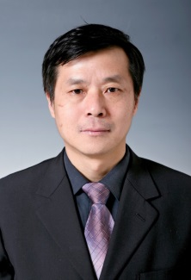
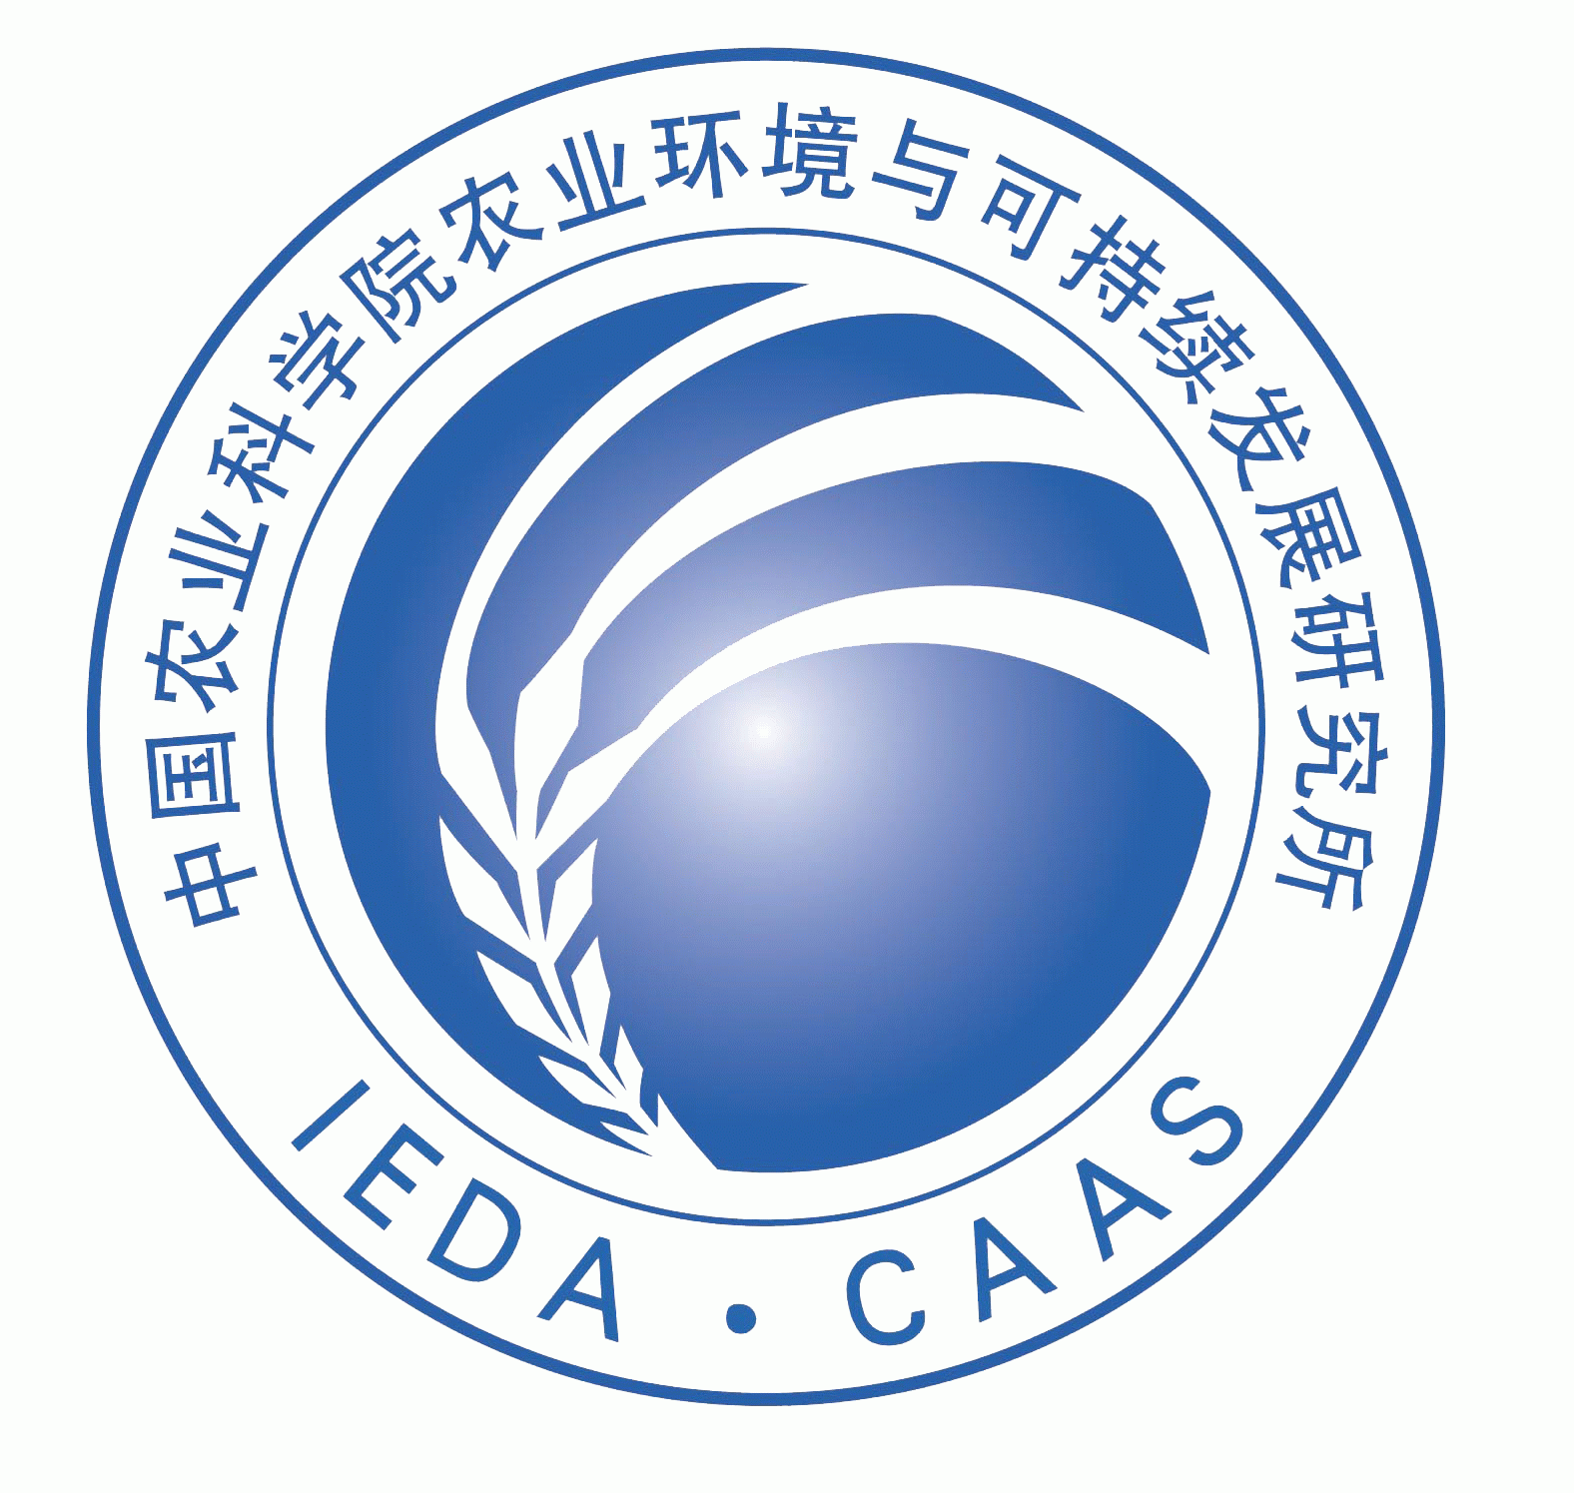

Title: Agrochemical smart nano-delivery systems for improved efficiency and safety
Name: Xiang Zhao, Bo Cui, Yan Wang,Changjiao Sun, Haixin Cui*
Institute of Environment and Sustainable Development in Agriculture, Chinese Academic of Agriculture Sciences, Beijing 100081, China
Abstract (250-300 words)
Pesticide is the foundation for preventing major biological disasters and the safeguard of national food security. However, conventional pesticide formulation process has presented some serious disadvantages, such as use of harmful solvent, poor dispersion, dust drift, etc. Also, pesticide loss of up to 70-90% in the field spraying process has caused some serious social concerns in food safety and ecological environment. Therefore, developing an efficient, safe, and green pesticide formulation process has become a national and strategic need to protect the national food and ecological security through nano-delivery system of pesticides with nanotechnology to improve the efficacy and safety of pesticides. Advance of nanotechnology offers some new approaches for the pesticide development：1） developing novel formulations of high efficacy and safety pesticide；2）developing sustainable agriculture system；and 3）controlling pesticide food residues and environmental pollution. The pesticide nano-delivery systems will be comprehensively introduced with perfect properties of water dispersion, chemical stability，efficacy，duration and degradation.
Biography(100-150 words)
Dr. Haixin Cui has completed his Ph.D from Osaka Prefecture University in 1996. He is the chief scientist of National 973 Project; director of Nanotechnology Research Center of Agriculture, Chinese Academy of Agricultural Sciences; research fellow and Ph.D. supervisor of Institute of Environment and Sustainable Development in Agriculture, CAAS; academic leader of Biological Physics, CAAS. Dr. Cui served as professional committee member of China Medicinal Biotechnology Association, evaluation expert of the award of National Science and Technology Conference, evaluation expert of 863 Program. His mian research areas are agricultural chemicals precisely controlled-release technology, nano-biotechnology, and the application of nanomaterials in agriculture.
Presenting author details
Full name: Haixin Cui
Session name/ number: 17th Edition of International Conference and Exhibition on Pharmaceutics & Novel Drug Delivery Systems 2018
Category: Poster
Email id: cuihaixin@caas.com
Contact number: 86-10-82106013

