
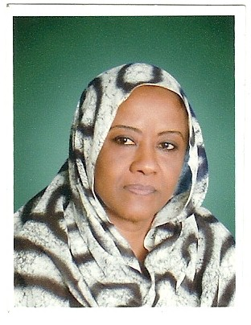

Gastroretentive Controlled Release Glibenclamide Oral Tablet Formulation.
Suad Yousif Abdalla Elkarib
Karary University , College of Pharmacy , Sudan .
Abstract
Hydroxypropyl methylcellulose (HPMC-4000cps, fixed amount), various
contents of calcium hydroxide, stearyl alcohol, magnesium stearate,different
drug: PVP ratios and altered tablet hardness were used to design floating tablet
formulation capable to deliver glibenclamide in a sustained manner.
Tablet hardness has revealed an influential effect on tablet onset of floating,
and drug release was shown to be more evident in the initial phase (p<0.05).
Loading level of calcium hydroxide, stearyl alcohol and tablet swellability all
have showed profound enhancing effects on duration of tablet buoyancy and
drug release which shown to follow the anomalous type (n=0.8212-1.0244)
with evidence of 25 and 84% drug release after 1 and 6 hours, respectively .
Application of statistical and mathematical modeling has enabled the optimization of the
developed tablet formulation to meet selective constraints for floating, hardness and drug release.
The optimized buoyant tablet revealed hardness of 50 N, immediate onset of floating and
floating duration >6 hours.
The in vivo dosage form residence time study in six human subjects demonstrated that the developed tablet formulation retained in the stomach for more than four hours under fasting conditions.
Comparative bioavailability study revealed that floating tablets showed sustained release
tendency of the drug from the floating tablet formulation.
The three months based stability study indicated that the drug and the dosage form retained their initial physical characters in both acceleratedand normal conditions for the test duration as far as blister pack is considered.

Keywords: Sustained release, Buoyancy, Hardness, Glibenclamide, Swellability.
Biography:-

Dr. Suad has completed her PhD in Pharmaceutics ,in College of Pharmacy, University of Khartoum – Sudan . She has worked as General Director and production manager of WafraPharma Lab, for Pharmaceutical Product. Now she is associate professor Dean College of Pharmacy. She has published more than 18 papers in reputed journals and has got four patents in the field of Gum Arabic in the Pharmaceutical Technology .
Presenting author details
Full name: Suad Yousif Abdalla Elkarib.
Session name/ number: Pharmaceutical Formulation.
Category: Oral presentation.
Email id: ombasil1@yahoo.com
Contact number: 00249912304739 .

