STRUCTURAL MODIFICATION OF LYCOPENE: CHEMICALLY WITH ITS EVALUATION & INDUSTRIAL APPLICATION
Gayatridevi G. P. Varma

I. Introduction
The aim of the study was to synthesize various derivatives of lycopene with their physical & chemical evaluation. ^{[1]} As we know lycopene contain rich source of many bioactive secondary metabolite such as carotenoids, terpenoids, flavonoids, saponins, alkaloids and other constituents were reported to have in vitro antimicrobial properties & powerful antioxidant that protect cells from damage. Therefore, the research on natural products and semi synthetic derivatives of the same has been increases due to their easy availability, effective pharmacological activity and their importance in drug discovery. And such

II. Background and Significance
The structural modification of some natural products is highly relevant because such molecular changes provide new structure-activity relationships (SAR) against specific targets. Their unique structural complexity allowing the development of new drug moiety and different molecular mechanisms of their biological targets. Natural products are also having certain pharmacological activity but not as its chemically modified derivative.
Lycopene is a plant nutrient with high antioxidant properties. It’s the pigment gives red and pink fruits, such as tomatoes, watermelons and pink grapefruit, their characteristic color. Lycopene has been linked to health benefits ranging from heart health to protection against sunburns and certain types of cancers. Lycopene (C40H56) has been found to be potentially beneficial for health as it reduces the oxidative stress appreciably. An epidemiological study shows that intake of carotenoids reduces the risk of several chronic diseases such as prostate cancer and cardiovascular diseases. ^{[18]}
III. Literature Review
Lycopene is a natural pigment that gives some vegetables and fruits their red color. It is a rich source of an antioxidant (a substance that protects against cell damage). Tomatoes processed with high heat contain lycopene in a form more usable by the body than in raw tomatoes; however, heat processing can destroy other nutrients such as beta-carotene, vitamin C, and vitamin E. ^{[1]}
Lycopene is an acyclic non-polar carotenoid having the molecular formula C40H56, contains 11 conjugated and 2 unconjugated double bonds. Its structure lacks terminal β-ionone ring and pro-vitamin A activity. As a polyene, it can undergo isomerization to cis-trans isomers. These isomers are induced by light absorption, heat exposure and chemical reaction. Lycopene exists predominantly as 80-97% in all-trans (E), thermodynamically stable configuration in tomatoes, fruits and vegetables [18]. In human plasma and body tissues, lycopene is found as a mixture of 50% cis (Z) and 50% all-trans isomers. ^{[19]}
The role of lycopene in helping prevent atherosclerosis (hardening of the arteries) that can cause high blood pressure, heart attack, and stroke. Some studies have associated high lycopene blood concentrations with reduction of the incidence of cardiovascular disease. One study suggested that lower blood concentrations of lycopene were associated with early atherosclerosis in men. ^{[1]}
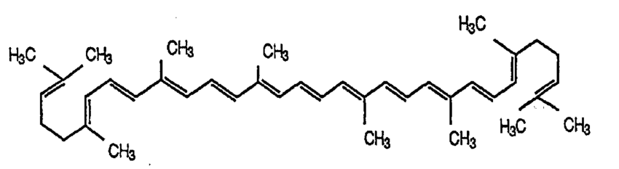

Properties of lycopene-^{[8]}
- Lycopene is insoluble in water
- Having molecular weight 536.89 g/mol & molecular formula C₄₀H₅₆
- Lycopene is large unsaturated hydrocarbon usually non-polar in nature.
- Having melting point 172 ºC

Absorption & distribution of lycopene: ^{[6][7]} As a fat-soluble compound, lycopene has a similar absorption as dietary fat.^{[16]} Lycopene bioavailability can be affected by a number of factors, including food processing and compoition. ^{[17]}
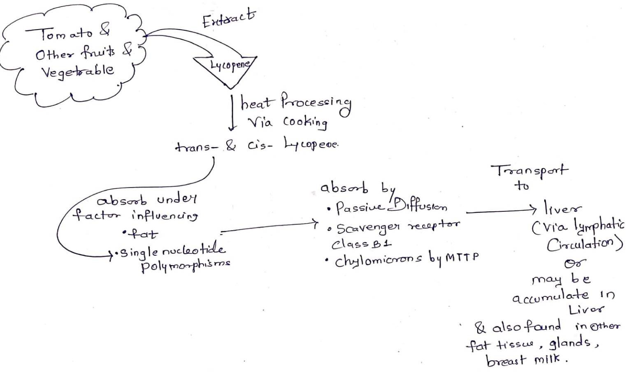

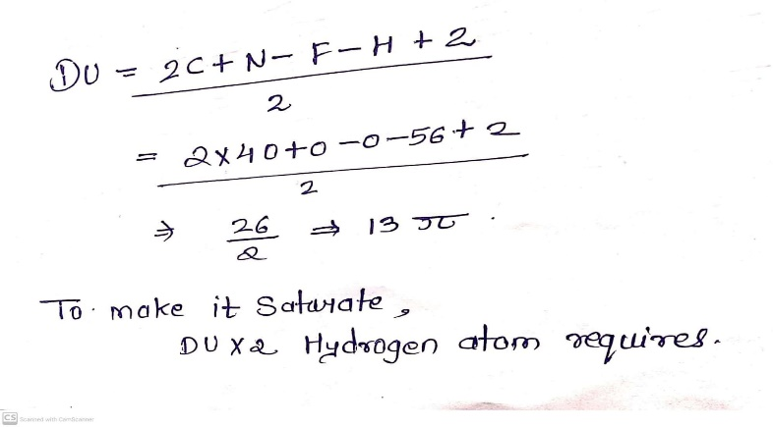
Degree of unsaturation of lycopene-

IV. Research Design and Methods
In 2007, the world cancer research fund reported that a diet high in fruits & vegetables help reduce the risk of cancer, including prostate cancer but a study that combined the results of RCTs concluded that there was not enough evidence to support the use of lycopene supplements to prevent prostate cancer. ^{[1]} So by considering this fact I want to modify the lycopene structurally by adding different reagents because might be the plain structure of lycopene not able to possess the optimum & desired activity.
Reactions for lycopene: ^{[9][10]}
- Sulphate derivative of lycopene- This derivative of lycopene was accidently synthesized during my graduation project lab work i.e. synthesis of azole derivative of lycopene. But due to end of academic & lack of chemicals and equipment, I couldn’t proceed this reaction further.
As Sulfur has antifungal, antibacterial, and keratolytic activity. It can be useful for various dermatological disorders such as acne vulgaris, rosacea, seborrheic dermatitis, dandruff, pityriasis versicolor, scabies, and warts. Adverse events associated with topically applied sulfur are rare and mainly involve mild application site reaction and has demonstrated efficacy in the treatment of many dermatological conditions. ^{[11][10]}
The alkenes react with concentrated Sulfuric acid in the cold to produce alkyl hydrogen sulphates. Therefore, lycopene reacts to give lycopene hydrogen sulphate.

C₄₀H₅₆ + H₂SO₄ C₄₀H₅₇OSO₂OH

This reaction is Electrophilic addition reaction. The mechanism of the reaction between alkenes (lycopene) and sulfuric acid: The hydrogen atoms are attached to very electronegative oxygen atoms which mean that the hydrogen will be slightly negative. In the mechanism, we just focus on one of the hydrogens to oxygen bonds, because the other one is too far from the carbon-carbon double bond to be involved in any way. ^{[12][13][10]}
I have again followed following steps for that accidental reaction to verify the process;

Procedure: ^{[10]}
- Weighted 0.5-gram lycopene and dispersed in 15 ml of distilled water.
- Added conc. H2SO4 1-1 ml with an interval of 2 minutes until the color turns in to reddish blue. This is highly exothermic reaction; the temperature of flask will be around 60oC. During the addition of acid, appears as dark blue color but disappears after well stirring.
- Flask kept a side until its temperature cools up to room temperature & then immediately poured in to 100 ml crushed ice water.
- After melting of crushed ice pieces added NaOH to neutralize the excess acidity.
- Filtered the product under suction pump, recrystallized, and dried in oven at 60oC. And Melting point of this product was reported to be more than 300oC.

Electrophilic addition reaction of lycopene-^{[9]}
Unsaturated hydrocarbon (lycopene) have high electron density can under go electrophilic addition reaction. Carbocation intermediate is usually involved in the reaction mechanism in which 1 pi bond breaks in to 2 sigma bonds.

- Hydrogenation reaction of lycopene-^{[9][10]}
This reaction results will be saturated hydrocarbon or may be semi-saturated hydrocarbon just by decreasing pi bond count. This kind of reactions usually require catalyst to enhances the rate of a chemical reaction.

-CH₂=CH₂- -CH₃-CH₃-
Reaction: Lycopene extract + H₂ + reducing reagent

- Halogenation reaction of lycopene-^{[10]}
Lycopene does not show any significant reactivity with the chlorine & chlorine water (at high or low temperature) and conc. HCl (with water in presence of HCl).
So, the reaction of bromine with diene can produce Regio isomers; the outcomes can be altered depending on the conditions used. Bromide is good allylic system like SN1 can take place in which both the nucleophile and the electrophile are bromide. Bromide just adds across one of the double bonds to give a 1,2 – dibromide. This is the kinetic product.
Even this reaction, I performed during my project work but didn’t get satisfactory or effective result.
I have followed following steps;^{[14][15]}
- Weighted 2.5-gram lycopene and dissolved in 11.25 ml of GAA in 250 ml in conical flask.
- Cooled to below 5 ⁰C.
- 1.05 ml bromine in added drop wise in 6.25 ml cold acetic acid with stirring.
- Bromine solution is transferred to lycopene solution slowly with stirring & flask is placed in cold water.
- Color changed to orange color.
- Allowed to stand at room temperature.
- Poured the content in to beaker having 50 ml ice cold water, reaction turned in to dark orange red color indicates the reaction is completed.
- Solution is colored so added the sodium metabisulfite to decolorize the product.
- Filtered the product and washed with cold water.
- For purification- dissolved the product in cold water and filtered it, dried in oven.

- Hydration reaction of lycopene-^{[10]}
As per the structure of lycopene this hydration will require strong acid catalysis because just addition of water will not react with lycopene as it is water insoluble.
We can neutralize the excess amount of acid by adding base.

Reaction: -CH₂=CH₂- + H₂O -CH₃-CH₂-OH

- Oxidation reaction of lycopene-^{[10]}
Lycopene is highly antioxidant so it will require strong oxidizing reagent may produce aldehyde or ketone as product by oxidative cleavage mechanism.
V. Physiological, Chemical & Biological evaluations
- Solubility testing & physical evaluation
- pH & titrimetric analysis of lycopene derivatives- to evaluate its acidic or basic strength
- Analytical evaluation-
TLC- to examine whether reaction is completed or not, to detect impurity & separate volatile mixture.
- If possible, conduct NMR spectroscopy to characterize the precise structure of molecule.
- Elemental analysis- for functional group detection
- Antimicrobial assay (specially for skin formulation)
- ORAC assay (The oxygen radical absorbance capacity)- for quantifying the antioxidant strength of substance.
- Some other parameters like dissolution testing, partition coefficient, melting point & other toxicity testing
VI. Application
- Accelerate wound healing & skin repair itself
- Inhibit cell with skin infection & protect from UV radiation
- Reduce skin inflammation
- Maintain youthful skin by minimizing aging
- Properties of lycopene, being a potent antioxidant, against a variety of ROS and RNS & consumption of tomato-based foods may lower CVD risk. ^{[2][4]}
- Lycopene minimize the risk of cancer. ^{[3]}
VII. Industrial application & formulation
- Cramp cure skin patches
- Infection cure skin patches
- Baby herbal care massage oil formulation (because absorption of lycopene increases in presence of oil) ^{[5]}
- Drop formulation to clean infection & wound if long duration application is found to be bit toxic after evaluation.
VIII. Citations
[Gayatri Gautam Varma, Pragya Seth and Shubhangi Kshirsagar (2020); ISOLATION & EVALUATION OF ANTIFUNGAL ACTIVITY OF THE SEMI SYNTHETIC DERIVATIVES OF LYCOPENE Int. J. of Adv. Res. 8 (Feb). 454-464] (ISSN 2320-5407). www.journalijar.com

References
- Willcox JK, Catignani GL, Lazarus S. Tomatoes and cardiovascular health. Crit Rev Food Sci Nutr. 2003;43(1):1-18.
- Kwatra, Bharat. (2020). A REVIEW ON POTENTIAL PROPERTIES AND THERAPEUTIC APPLICATIONS OF LYCOPENE. International Journal of Research in Pharmaceutical and Biomedical Sciences. 4. 33-44. 10.32553/ijmbs.v4i4.1081.
- Bayraktar, Soley & Lieberman, Ronald & Bayraktar, Ulas & Sahin, Kazim & Andic, Fundagul & Kucuk, Omer. (2008). Lycopene in Cancer Prevention and Treatment. American journal of therapeutics. 15. 66-81. 10.1097/MJT.0b013e31804c7120.
- De Pablo, P.; Dietrich, T.; Karlson, E.W. Antioxidants and other novel cardiovascular risk factors in subjects with rheumatoid arthritis in a large population sample. Arthritis Care Res. 2007, 57, 953–962.
- Arballo, J.; Amengual, J.; Erdman, J.W., Jr. Lycopene: A Critical Review of Digestion, Absorption, Metabolism, and Excretion. Antioxidants 2021, 10, 342. https://doi.org/10.3390/ antiox10030342
(15) (PDF) Lycopene: A Critical Review of Digestion, Absorption, Metabolism, and Excretion. Available from: https://www.researchgate.net/publication/349607141_Lycopene_A_Critical_Review_of_Digestion_Absorption_Metabolism_and_Excretion [accessed Nov 21 2021].
- Arballo J, Amengual J, Erdman JW Jr. Lycopene: A Critical Review of Digestion, Absorption, Metabolism, and Excretion. Antioxidants (Basel). 2021;10(3):342. Published 2021 Feb 25. doi:10.3390/antiox10030342
- Leung W.C., Hessel S., Méplan C., Flint J., Oberhauser V., Tourniaire F., Hesketh J.E., von Lintig J., Lietz G. Two common single nucleotide polymorphisms in the gene encoding β-carotene 15,15′-monoxygenase alter β-carotene metabolism in female volunteers. FASEB J. 2009;23:1041–1053. doi: 10.1096/fj.08-121962.
- Shi, J.; Le Maguer, M.; Bryan, M. Lycopene from tomatoes. In Functional Foods-Biochemical and Processing Aspects. Shi, J., Mazza, G., Le Maguer, M., Eds.; CRC Press: USA, 2002; pp. 135–168.
- https://www.angelo.edu/faculty/kboudrea/index_2353/Chapter_02_2SPP.pdf
- Gayatri Gautam Varma, Pragya Seth and Shubhangi Kshirsagar (2020); ISOLATION & EVALUATION OF ANTIFUNGAL ACTIVITY OF THE SEMI SYNTHETIC DERIVATIVES OF LYCOPENE Int. J. of Adv. Res. 8 (Feb). 454-464] (ISSN 2320-5407). www.journalijar.com
- Gupta AK, Nicol K, “The use of sulfur in dermatology” J Drugs Dermatol 2004 Jul-Aug; 3(4): 427-31.
- Chemguide.com, “Alkenes and sulphuric acid” Jim Clark 2003 (modified August 2015).
- Jim Clark, CHEMISTRY LIBRETEXTS, “Reaction of alkenes with sulfuric acid” June 6, 2019.
- Chem Tube 3D – Electrophilic addition to butadiene.
- L. F. Hatch, P.D. Gardner and R.E. Gilbert, J. Am. Chem. Soc., 1959, 81, 5943- 5946.
- Krinsky , N.I.; Johnson, E.J. Carotenoid actions and their relation to health and disease. Mol. Aspects Med. 2005, 26, 459–516.
- Kaur, Gurpreet & Sandal, Anupama & Dhillon, Navjot. (2017). Lycopene and human health-A review. Agricultural Reviews. 38. 10.18805/ag.R-1741.
- https://www.researchgate.net/publication/261955889_Modeling_the_mechanism_of_action_of_lycopene_as_a_hydroxyl_radical_scavenger [accessed Nov 21 2021].
- Lycopene Extraction and Analysis. Available from: https://www.researchgate.net/publication/275350733_Lycopene_Extraction_and_Analysis [accessed Nov 21 2021].

