Chitosan coated Halloysite Nano Tubes megatnetic micro-composite: A promissing tool for controlled release of anticancer drugs
Hanif, M¹,. S Majid Khan¹

¹ Department of Pharmaceutics, Faculty of Pharmacy, Bahauddin Zakariya University Multan, Pakistan.

Abstract

Haematochezia is the common cause of colorectal cancer (CRC) which can be treated by chitosan containing micro-composite due to its already reported hemostatic activity. Chitosan composites are very delicate and thermally unstable, which can be improved by addition of naturally occurring halloysite nano tubes (HNTs). Chitosan coated HNTs with the magnetic properties was the aim of present study. Micro-composites of simple, morganatic and HNTs containing prepared by precipitation technique and gemcitabine (GC) was used as model drug. Micro-composites were characterized by energy dispersive x-ray spectroscopy (EDS), Fourier transform infrared spectroscopic analysis (FT-IR), magnetic field study, scanning electron microscope (SEM), x-ray powder diffraction (XRD), thermo-gravimetric Analysis (TGA) and satisfactory results were obtained. Hemostatic activity of CTS-Fe₃O₄-HNTs micro-composites compared and found early clotting time as compare to chitosan alone. Light FTIR peaks, presence of small tube like structures of final formulation, mico porous and having the different components showed complete complex formation between –OH group of HNTs and –NH2 group of chitosan. Gemcitabine (GC) release studies in different media showed controlled release behaviour. In vitro pharmacokinetic model dependent approaches first, zero, Higuchi, Korsmayer peppas and Hixson crowell models were applied and micro-composites followed first order model and korsmayer peppas followed fickian behaviour. Micro-composites had a spherical shape with positive charge and micron size confirmed by zeta sizer studies and can be used as promising candidate to control the haematochezia in cancerous patients.

Keywords: Haematochezia, halloysite nano tubes (HNTs), Micro-composites and gemcitabine

Professional Biography (100-150 words)

Dr. Muhammad Hanif is currently working as an Assistant Professor in the field of Pharmaceutics. He has done his Ph.D from University of Karachi, Pakistan and doing Postdoc studies in University of Innsbruck Austria under the supervision of Prf. Dr. Andreas Bernkop-Schunüch. He has published more than 80 research article. Dr. Muhammad Hanif has supervised 4 Ph.D. theses and 5 Ph.D. scholar are doing their research work under his supervision. He has supervised more than 30 theses of M.Phil level. He is a managing editpr of Pakistan Journal of Pharmaceutical Research, a biannually published research journal of Faculty of Pharmacy, Bahauddin Zakariya uNiversty Multan. He has presented his work in more than 30 national and international conference along with UK, Italy and Innsbruck Austria.

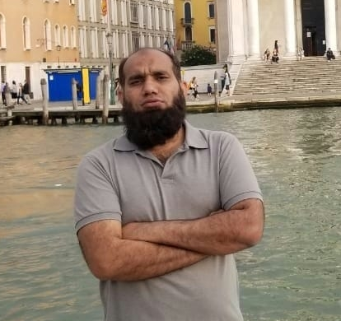
Paste your Photograph here

Full Name; Dr. Muhammad Hanif
Email Id#: muhammad.hanif@bzu.edu.pk
Contact No: +923336103668
Social Network Details (FaceBook/LinkedIn):

Any Comments:

