Abstract Template
Abstract Title: Metabolic engineering of microalgae cells for the production of pharmaceutical Amaryllidaceae alkaloids.
Isabel Desgagné-Penix¹

¹Department of chemistry, biochemistry and physics, Université du Québec à Trois-Rivières, QC, Canada

Abstract (not more than 300 words)

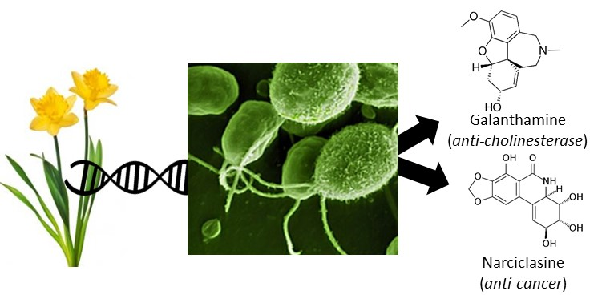
Amarylllidaceae plant alkaloids (AAs) possess powerful pharmaceutical and biotechnological properties. AA metabolism and its fascinating molecules, including anti-acetylcholinesterase galanthamine, anti-microbial lycorine and anti-cancer narciclasine, have attracted the attention of both the industry and researchers involved in plant science, chemical bioengineering and medicine. Currently, access and availability of high-value AAs [commercialized (e.g. galanthamine) or not (e.g. narciclasine)] is limited by low concentration in plants, seasonal production and time-consuming low-yield extraction methods. Nevertheless, commercial AA galanthamine is still extracted from plant sources. Efforts to improve the production of AA have largely been impaired by the limited knowledge on AA metabolism. The purpose of this study is to use recent development and integration of next-generation sequencing technologies and metabolomics analyses to unravel metabolic pathways allowing the use of metabolic engineering approaches to increase production of valuable AAs (Figure 1). Novel genes encoding AA biosynthetic enzymes were identified from our transcriptome databases using bioinformatics tools. The genes were characterized and their activities were studied through classical biochemistry experiment such as cloning into expression vectors, heterologous expression, recombinant protein purification and enzyme assays. In addition, AA precursor pathway was introduced into microalgae cells to 1) validate the function of the biosynthetic genes and 2) to produce AA molecules. Next, the final steps of the AA biosynthetic pathway will be added to reach galanthamine or other AA synthesis in microalgae. Metabolic engineering provides opportunity to overcome issues related to restricted availability, diversification and productivity of plant alkaloids. Engineered cells can act as biofactories by offering their metabolic machinery for the purpose of optimizing the conditions and increasing the productivity of a specific alkaloid.

Keywords—Amaryllidaceae alkaloids, metabolic engineering, biosynthesis, phytochemistry.

Professional Biography (100-150 words)

Isabel Desgagné-Penix has completed her PhD in Cell and Molecular Biology in 2008 from the University of Texas at San Antonio and postdoctoral studies in plant biochemistry at the University of Calgary. She has expertise with medicinal plant metabolism specifically with molecule of the alkaloid category. She is the director of the plant specialized metabolism research laboratory. She has published numerous papers in reputed journals and has been serving as an editorial board member of the journal of Plant Studies.



Email Id: Isabel.Desgagne-Penix@uqtr.ca

Any Comments:

