Artificial Lift Design for Depleted Wells

Case study :( Continous Gas Lift & Jet Pump)

Ibrahim Ayuba¹,T .S. Manasseh² and M.S Gwio³,
Department of Petroleum Engineering AbubakarTafawaBalewa University

Abstract
The essence of artificial lift is to initiate the production rate in depleted or mature reservoir field. This is simply the use of any artificial lift method to increase the flow potential of the well to the optimum desired rate for production.
In this paper work, two artificial lift systems of approach are used. The Continuous Gas Lift and Hydraulic Jet Pumps with comparisons to their respective production capabilities, Jet pump being the main focus in the work, due to no moving parts, compatible with all bottom holes assemblies, lifting of fluid in difficult well scenarios, greater depth of penetration, high volume production capabilities, with minimum cost operations, makes it a perfect usage in the oil and gas industry today.
The Production and System Performance Analysis Software (PROSPER) was used for the modelling. The Base Case, Continuous Gas Lift and Jet pump were all modelled for an onshore well named A-1 in Alpha field located In Greece. The modelled for the base case (natural flow) was not producing; the IPR+VLP matching did not intersect (no solution point). The gas lift model was producing at 7564.4STB/day oil with liquid rate of 11819.4STB/day. While Jet pump gave production rate of 9518.5 STB/day oil with a liquid rate of 14872.7 STB/day
Performance plot estimating the past and future performance of the well productivity relating to the lift approaches was also carried showing their respective yearly performances under the effect of different reservoir pressures and water cut.
Sensitivity analysis was carried out, to optimize the well productivity, in determining the optimum flow potential for the well, by optimizing the well and Jet pump parameter on various tubing diameters (1.5, 2.5, 3 and 4) inches at different pump injection depth, to determine the most efficient and cost effective parameter for the well optimum productivity. Tubing size 2.5inches gave maximum production rate with pump efficiency of 98.72 percent.

Keywords: Jet Pump, Continous Gas Lift, Natural flow, Production Optimization, PROSPER, Sensitivity Analysis

Introduction
A natural flowing oil well that have been producing for a period of time will deplete in it energy, which will reduce the production rate thus having effect on well deliverability. To rectify this problem, the used of gas lift approach
by injecting gas through the production casing tubing, or the installation of Jet pump down-hole, to reduce the pressure gradient and hydrostatic weight at the column of the tubing for the well to flow vertically to the surface at the required optimal flow potential. Most oil wells in the early stages of their lives flow naturally to the surface with their natural energy until this so called energy, depletes to the level that it cannot support itself again. The design of gas lift and Jet pump for depleted or dead wells is to revive or recover the well to it optimal possible production rate, by the introduction of a gas through the production casing tubing or the installation of pumps via wire-line or by using pressurised power fluid to transport the pump down hole, In other words, artificial lifting can be considered an extension of a well’s flowing life.
The focus of this paper is to optimize the well productivity through usage of Jet pump in determinening the most efficient and cost effective parameter for the well uptimum productivity. The study is basically design to evaluate the efficacy of Jet hydraulic pump as a tool for production optimization, with Production and Systems Performance Analysis Software, PROSPER. Though, there are other artificial lift techniques such as Sucker Rod Pump, Plunger Lift, Progressive Cavity Pump, Hydraulic Pump etc, but will not considered in this study.
The correct selection of an artificial-lift method is important to the long-term profitability of most producing oil wells. A poor choice can reduce production and increase operating costs substantially. To realize the maximum potential in developing any oil or gas field economically.
J.D Clegg (1988) mentioned some economic factors such as: revenue, operational and investment costs as the basis for Artificial Lift selection. He believed that the selected Artificial Lift method could have the best production rate with the least value of operational costs. He alsocarried out study on some operational and designing characteristics of Artificial Lift methods and found that the operational costs and production rate are affected by different factors. In other Brown et al.(1980) listed 31 different design and operational attributes given for new comparisons between all eight techniques. Each attribute nomally affects operating costs or production rate, which then affects profitability. Heinze et al. (1995) used a decision tree to evaluate artificial lift selection based on a longtime economic analysis which considered primary investment, operational costs, and life time cost and energy efficiency.

Continuous Gas Lift
This approach of optimization needs a lot of effort and faces many obstacles while carrying out the process. In continuous gas lift, compressed gas is injected from the surface through the annulus to reduce the flowing pressure losses which allows the actual bottom-hole pressure to move the well fluids to the surface. This compressed gas is generated by compressor stations around. It is accomplished by continuously injecting a proper amount of lift gas into the upward moving well stream to supplement the well’s produce gas-liquid ratio. Increase in water cut could cause reduction of the production gas-liquid ratio and an increase in the flowing pressure gradient to such an extent that the well can no longer flow against the required wellhead pressure.
Ayatollahi et al., (2001) used PVT data combined with fluid and multiphase flow correlations to optimize the continuous gas lift process in Aghajari oil field. From actual pressure and temperature surveys and determining the point of injection, a gas lift performance curve was constructed. In order to determine the optimal gas lift condition
Camponogara and Nakashima (2006) developed a dynamic programming (DP) algorithm that solves the profit maximization problem for a cluster of oil wells producing via gas lift, with multiple well performance curves (WPCs) and constrained by the amount of lift gas available for injection. The injection of gas can be at fixed or variable points where the gas will be mixed to the fluid coming from the reservoir, resulting in reduction of total pressure losses in the tubing (bottom-hole pressure). This reduction of pressure is due to the light fluid or reduction of the mixture density circulating in the column, therefore large amount of fluid will flow along the production tubing to the surface increasing the oil production. However at some point if large amount of gas is injected the oil production will decrease, this happen when the friction pressure loss increase up to certain point where the gas phase moves faster than the liquid, leaving behind the fluid coming from the reservoir. Therefore, there is optimum limit of injection for a particular well. Some other related disadvantages of continous gas lift include:
- High initial cost of investment.
- Difficulty in producing deep well to abandonment.
- Difficult to lift emulsions and viscous crude
- The casing must withstand lift pressure and
- Safety problems with high pressure gas.
Hence, this study presents a sensitivity analysis on these factors for production optimization through the usage of hydraulic Jet pumps.

Jet Pump
Jet pump is a dynamic-displacement pump with a simple down-hole architecture that is, driven by oil or water as power fluid that conveys reservoir fluid from the well to the surface at the required wellhead pressure in a mature or depleted reservoir field. The pump is one of the versatile lift methods for producing reservoirs with depleted energy. This pump produces at greater depths, navigating extreme deviations, encountering high levels of gas and sand, handling heavier more corrosive fluids. In these conditions, many artificial lift techniques can stick, lock, or wear down. Where the potential for high volume exists but conditions are tough, jet pump lifting systems bring more of this hydrocarbon to the surface.
The man who is said to have worked on theory Jet pump operation is J.M Rankin Circa 1870. Subsequently worked was done by number of men including Lorenz in 1910. His modelling of pressure and velocity losses during the fluid mixing has been used by many authors afterwards. Because jet pumps have simple down-hole architecture and no moving parts, they have become an increasingly popular artificial lift option in challenging production scenarios. The principles underlying the operation of a jet pump have been known for hundreds of years, starting in 1738 when Bernoulli’s principle was introduced; the principle states that an increase in the speed of a fluid occurs simultaneously with a decrease in its pressure.
The nozzle introduces a constriction in the power fluid flow path that causes the fluid speed to increase through the nozzle per venturi effect, a corollary to Bernoullis principle, that describe the reduction in fluid pressure that results when a fluid flows through a constriction section of the pipe.
Although the first patents for oil well jet pumps were issued in the 1860s, jet pump technology was not applied in the oil field until the late 1960s, and only in onshore wells. Hardware improvements and the introduction of computer models enabling improved pump designs led to more widespread use of jet pumps throughout the 1970s, and their application to other production scenarios has increased steadily since then.

Advantages of Jet Pump
- No Moving Part: Because Jet pump have simple down hole architecture no moving part to generate mechanical wear they can operate for several years at low risk of failure with minimal maintenance requirement.
- Long operational life.
- Low installation and work over operation costs which helps to reduce downtime cost
- High tolerance for gas and solid in production fluid.
- High volume of production
- Horizontal, Highly Deviated Wells: Because jet pumps are compact, rig free, and powered using pressurized fluid, they can adapt to tight turns up to 24°/100ft in severity and are as reliable in deviated holes as in straight holes.
- Deep Wells: - Positive displacement pumps are capable of pumping depths to 17,000 feet, and deeper. Jet pumps can be run to 20,000 feet with design target of 25% submergence at intake.
- Compatibility with all bottomhole assemblies (BHAs).
- Corrosion - Corrosion inhibitors can be injected into the power fluid for corrosion control.
- Viscous, Heavy Oil:Able to produce oils with API values as low as 6, jet pumps can use heated power fluid to dilute heavy, viscous crudes and enable consistent flow.
- Dewatering Gas, Coal Bed Methane, and Shale Wells: Water buildup in gas and coal bed methane wells can create pressures that hinders hydrocarbon recovery. Jet pumps effectively pump out liquids and produce down to 13 B/D (2.07 m3/d).
- Frac Fluid Recovery: When it is difficult to initiate flow during frac operations, jet pumps are an asset. Frac sand has no effect on pump operation, which enables easy recovery of frac fluid and sand at rates of 2,000 B/D(317.97 m3/d) or more.
- Remote Location: The compact, simple, and rig-free design of jet pumps enables easy transportation to remote well sites. You can also repair jet pumps at your site, which minimizes downtime and costs.

Disadvantages.
- Bottom Hole Pressure- Jet pumps require approximately 1000 PSI bottom hole pressure when set at 10,000 feet and approximately 500 PSI when set at 5000 feet.
- Skilled Personnel- Pump speed needs to be monitored daily and not allowed to become excessive. Secondly, power fluid cleaning systems need frequent checking to keep them operating at their optimum effectiveness.
- Cavitation: Jet pump are prone to some design drawback including the risk of cavitation. Cavitation occurs when throat-inlet pressure drops beneath the vapour pressure. Typically, cavitation is a problem when too much fluid is forced through the throat area. Cavitation contributes to the deterioration of the pumps, as bubbles implode and shockwaves hit the jet pump wall.

Cost Benefit of Jet Pumps
- Jet pump have no moving parts which can inevitably cause the wearing away of part that have to replace, does saves the cost of maintenance and repairs.
- Long life of operation.
- Repairs and resizing can be done on site which helps to reduce downtime cost
- Jet pump can effectively be configured through a manifold to run multiple wells, which serves to reduce operating expenses by limiting the amount of equipment on location.
- High volume of production with minimal cost input

Table 1: Jet Pump Different Specifications
The values below shows different jet specifications based on standard circulation with a power-fluid to produced-fluid ratio of 2:0 and without the presence of gas.
Tubing size | Pump type | Maximum production Rate
1 ½ | Standard | 400 B/D (63.59 m³/d)
1 ½ | High volume | 600 B/D (95.39 m³/d)
2 | Standard | 2000 B/D (317.97 m³/d)
2 | High volume | 2500 B/D (397.47 m³/d)
2 ½ | Standard | 3000 B/D (476.96 m³/d)
2 ½ | High volume | 3500 B/D (556.46 m³/d)
3 | Standard | 4000 B/D (635.95 m³/d)
3 | High volume | 5000 B/D (794.94 m³/d)

Table 2: Operating Production Capabilities of Jet Pump
Parameter | Typical Range | Maximum
Operating depth | 5000 to 10000ft | 20000ft
Operating temperature | 100° to 250°F  ( 38° to 121°C) | 500°F  (260°)
Wellbore deviation | 0° to 20°  ( 24°/100-ft build angle) | 0 to 90  ( 24°/100-ft build angle)
Operating volume | 300 to 1000 B/D | ≤ 35000 B/D

Modeling for Natural Flow (Base Case)

The modelling for natural flow, the well is not producing. From the IPR and VLP curve, it can be seen the two curves didn’t intersect, (no solution point) this implies the well is not producing at natural reservoir pressure, but depleted. The well can be revived back to its flow potential, by installation of pumps down hole or the injection of gas, to reduce pressure gradient and hydrostatic weight at tubing column, for the well optimum productivity. The two lift systems are shown below.

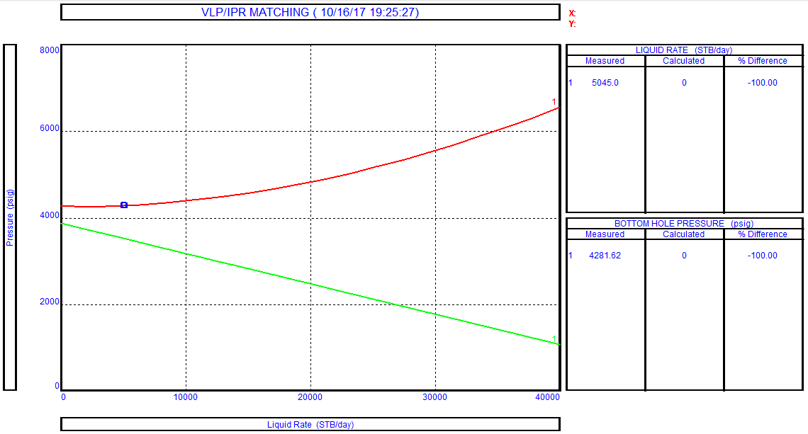

Figure 1: A Model for Depleted (Dead) Well

Continous Gas Lift Modeling
The gas lift performance curve provides the optimum injection rate that constitutes a design parameter for the valve spacing process. After 7.616MMscf/day of gas injected, the curve start declining when higher gas injection continues, the tubing friction forces prevail in the system.

When the friction pressure loss reaches a certain limit (friction is dominant over gravity term reduction) and pressure drop in the tubing becomes larger, which eventually reduces the production rate, where gas phase travels faster leaving behind the liquid phase, resulting more gas been produce to oil, hence the gas curve to starts declining as shown below in figure 2.
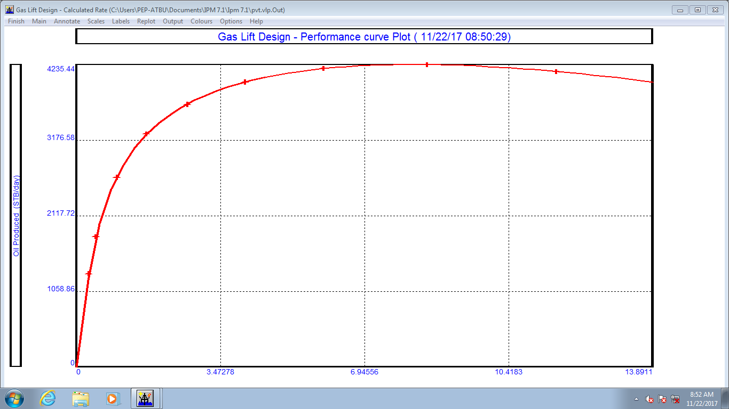

Figure 2: Gas lift design Performance Curve

Modelling Using Jet Pump Artificial Lift Approach
In designing a Jet Pump installation using PROSPERS is divided into two main phases. Calculate and Design. Choosing a pump from
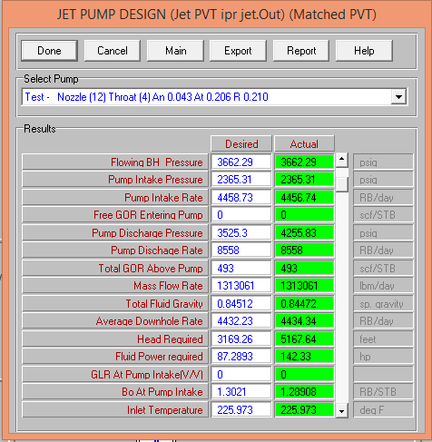

the database which matched the desired parameters determined in the pump calculation. Choosing the pump determines the table that better fits the data reported in the desired green column.

Figure 3: Jet Screen Result

Performance Production Forecast Table (Base case, CTGL and Jet pump)
The production table shows the past and future performance of the well productivity under different years of production parameter using, reservoir pressure and water cut.
Table 3: Production Performance forecast
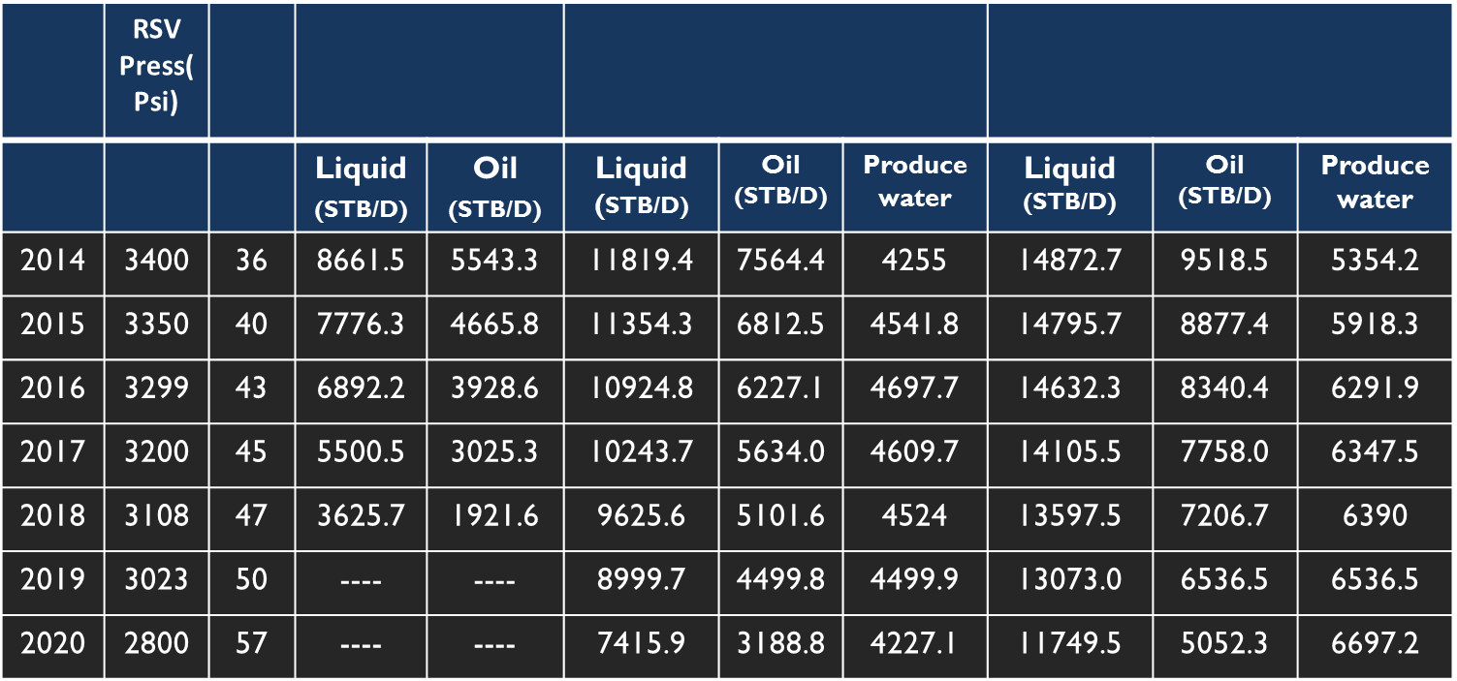
Hydraulic Jet pump
Continuous Gas Lift
Natural Flow
WC
Yrs

The table above shows the production performance for the base case and the two lift approaches (CTGL and JP) under the influence of different water cut and flowing bottom-hole pressures. To predict the past and future performance of the well productivity at a fixed
GOR of 493 SCF/STB, maximum gas injection and pump depth at 8000ft when the TVD is reduced to 11500ft.The natural production (base case). The well was producing and at 2017 the well became depleted, no production at it reservoir energy.
The continuous gas lift system of approach gave a high production rate with a slight decline in production, when the well was still producing at it natural energy. From year 2017 a sharp

decline in production occurs when the reservoir pressure finally depleted, which indicate, Gas lift works perfectly in lifting condensate and volatile wells but difficulty in lifting heavy wells due to high liquid and heavy proportion of hydrocarbon content.
The Jet pump system gave highest production rate under the different year parameters, with a slight decline in production as the reservoir pressure reduces, and produced water increases optimally with increase in water cut. The produced water can be treated and recycled as power fluid for the pump system to initiate production. Deployment of the pumps down-hole and redeployment to the surface can be done with same water as power fluid which eliminates the cost expense of wire-line.

Graphical Production Trend

Figure 4.1: Oil Production Performance Plot

NOP: Natural flow Oil Production.
CGOP: Continuous Gas Lift Oil Production
JPOP: Jet Pump Oil Production.s
The production trends for oil is graphically shown in figure above were a decline in production occurs over the years. In the oil production rate both lift approaches decreases gradually. While in the liquid production rate Jet declines less gradually and the continuous gas lift shows a sharp decline in production over the years with values 14872.7 STB/D to 11749.5 STB/D of liquid and CTGL 71819.4STB/D to 7415.9 STB/D. And from 2018 for the base case there was no production.the finally got depleted.

Jet Pump Sensitivity Analysis
Sensitivity analysis was carried out to optimize the well productivity to determine the optimum flow potential for the well productivity with minimum cost input, by effectively optimizing the well and Jet pump parameters. Relating to pump different injection depth and various tubing diameters as shown in table 4: The logic for this analysis is determining the most efficient and cost

effective parameter for the well optimum productivity.
The table below of the jet sensitivity analysis 2.5inche tubing gave the maximum optimum
production rate for the well flow potential, at
shallow and greater depth with low rate of produced water, compare with the other tubing sizes. The pump result for 2.5inches indicated pump efficiency of 98.722 percent with horse power of 116.007 hp. This signifies the pump efficiency can effectively be optimized by increasing the size of the nozzle and throat to increase the production rate.
The Jet pump sensitivity result and plot are shown in the appendix B, figure B1 and B2.

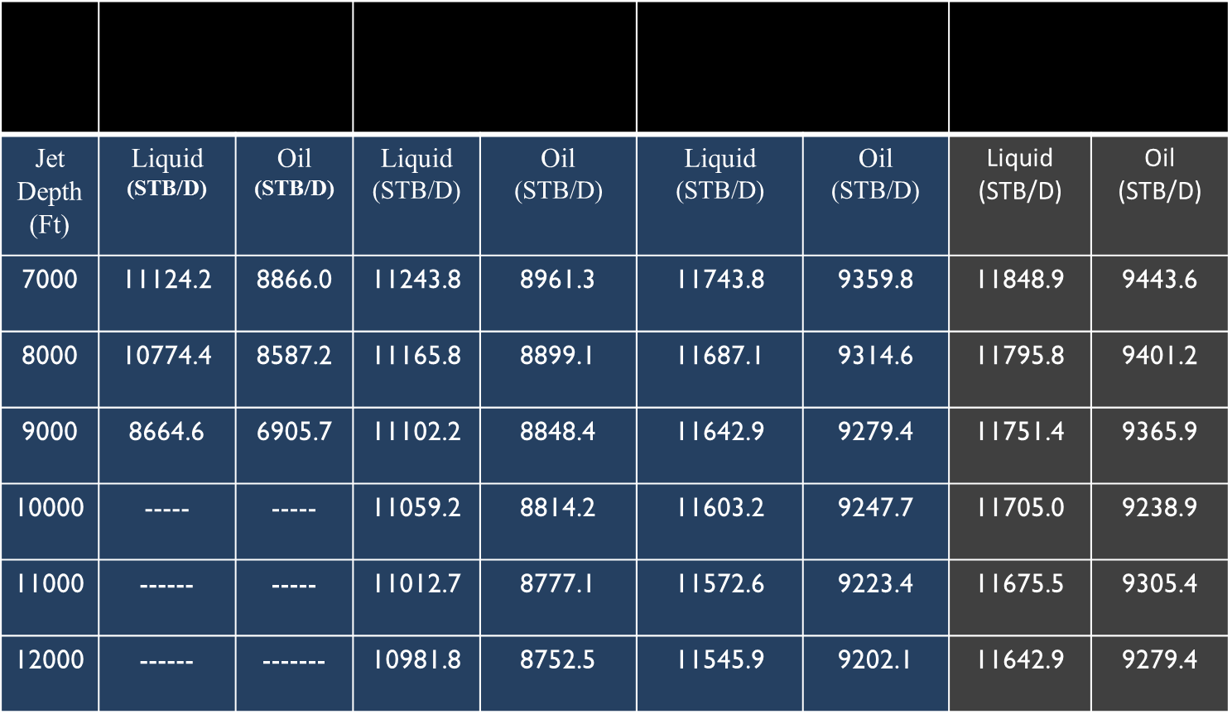
Table 4: Jet sensitivity Result
1.5inch Tubing
4inch Tubing
3inch Tubing
2.5inch Tubing

Conclusions
The well at it base case was not producing, the use of CTGL and JP artificial lift systems were used to rectify this problem, in reviving the well to its flow potential. Considering the production performances, list of advantages, disadvantages and cost of operations. The conclusions were made.
Both lift systems gave high production performance, under the well operating conditions, Jet pump gave the optimum productivity for the well, effectively lifting both crude oil and produced water as the water cut increases.
Jet pump with diverse usage, and no moving parts to cause mechanical wearing, this reduces cost of maintenance, repairs and the equipment failure, with low cost of installation through usage of power fluid (oil/water) which eliminates expense of wire lines. Repairs and resizing can be done on site which reduces downtime cost. While the CTGL works perfectly in selected well scenarios like condensate and volatile wells, with high cost of operations especially in lifting heavy wells.

At maximum gas injection depth of 8000ft
with a TVD of 11000ft from the production
performance table gave high production for the CTGL compare to depth 12000ft and injection gas depth 11000ft from the gas lift performance plot with, an optimum gas lift injection rate of 7.616MMscf/day to avoid effect of frictional pressure loss. This indicates the CTGL can be considered in lifting the well but not at greater depth.
Sensitivity Analysis to optimise well productivity was carried on different Jet pump injection depth and tubing different diameters, to determine the most efficient and cost effective parameter with the optimum productivity for the well. Tubing size 2.5 inches gave the optimal flow potential at all the respective pump depths. Therefore, due to production capabilities and cost of operations, the Jet pump should be the priority considered in lifting the well using 2.5inch tubing.

Nomenclature
JP- Jet Pump
DP - Dynamic Programming
API – American Petroleum Institute
IPR-Inflow Performance Relationship
VLP - Vertical Lift Performance
THT – Tubing Head Temperature
THP – Tubing Head Pressure
BHA_{S -} Bottom hole Assemblies
BHP - Bottom hole Pressure
PVT – Pressure Volume Temperature
TVD - True Vertical Depth
GOR - Gas Oil Ratio
NOP - Natural flow Oil Production
CTGL - Continuous Gas Lift
CGOP - Continuous Gas Lift Oil Production
JPOP - Jet Pump Oil Production
PROSPER - Production and Systems Performance Analysis Software

Refrences
- Ahmed, T. (2010). Reservoir Engineering Handbook. Reservoir Engineering Handbook.
- Brown, K.E.: The Technology of Artifidal Lift, Petroleum Publishing Co., Tulsa (1980).
- Ayatollahi S, Bahadori A, and Moshfeghian A. (2001). “Method optimises Aghajari oil field gas lift,” Oil and Gas Journal, vol. 99, no. 21, pp. 47–49.
- Camponogara E and Nakashima P.H.R., (2006) "Solving a gas-lift optimization problem by dynamic programming," European Journal of Operational Research, 174 1220-1246.
- Clegg, J.D., (1988). High-rate Artificial Lift. Journal of Petroleum Technology, SPE#17638.
- Chukwunyere George (2016), Design of Continuous Flow Gas Lift for Depleted Natural Flowing Oil Wells, University of Miskolc Petroleum and Natural Gas Institute.
- Fredrik Liknes (2013) Jet Pump. Norwegian University of Science and Technology, MScThesis.
- Heinze Lloyd R., Herald W. Winkler, James F. Lea, (1996).“Decision Tree for Selection of Artificial Lift Method,”SPE 29510.
- Ioannis E. Tetoros (2015), MSc Thesis Design of a continuous gas lift system to initiate production in a dead well Technical University of Crete School of mineral resources engineering.
- James F. Lea and Henry Selection of artificial lift method. SPE 5217 February 2008.
- J.D. Clegg, SPE, consultant S.M. Bucaram, SPE, Arco E&P Technology N.W. Heln Jr.,SPE, Conoco Inc. Recommendations and Comparisons for Selecting Artificial-Lift Methods
- Lea, J.F. and Nickens, H.V. 1999. Selection of Artificial Lift Presented at the SPE Mid-Continent Operations Symposium, Oklahoma City, Oklahoma, 28-31 March 1999. SPE-52157-MS.
- Manzoor Ahmad, Mehtab Ahmad Weathered oil limited Increase production and profit from mature field through optimization Jet pump Design. SPE169644 November 2013.
- PROSPER v.10 User Manual, Petroleum Experts. 2008
- Schlumberger. Gas Lift Design and Technology. Well Completions and Productivity.
- Weatherford. Jet Pump Lifting system and applications.

Appendix A

Data

Table A2: nclination / Deviation Data

Table A1: Fluid PVT Properties

Type | Measured Depth (Ft) | Tubing I.D (inches)
X mass tree | 0
Tubing | 800 | 4.052
Tubing | 12500 | 4.052
Casing | 15443 | 6.4

Property | Value | Unit
GOR | 493 | SCF/STB
Oil Gravity | 38.7 | API
Gas gravity | 0.798
Water Salinity | 80000 | PPM

Pressure (Psig) | GOR (SCF/STB) | Oil  viscosity (cp) |  | Oil FVF (rb/STB)
2241 | 493 | 1.32 | 0.41

Parameters | Values | Unit
THP | 264 | Psig
THT | 124.8 | ⁰F
Water cut | 20.3 | o/o
Liquid rate | 5045 | STB/d
Gauge depth | 14800 | Ft
Gauge pressure | 3382 | Psig
RSV Pressure | 3382 | Psig
GOR | 493 | SCF/STB

Table A4: Well Test Data

Parameter | Value | Unit
Pump Depth | 12500 | Ft
Max O.D | 4.5 | Inch
Surface Injection Rate | 4005 | STB/d
Surface Injection Pressure | 4679 | Psig
Water cut | 50
GOR | 293 | SCF/STB
Top Node pressure | 264 | Psig

Table A3: Jet Pump Data

RSV pressure | 3844 | Psig
RSV temperature | 260 | ºF
Water cut | 20.3
Total GOR | 493 | SCF/STB
RSV Permeability | 100 | MD
RSV Thickness | 100 | Ft
Drainage area | 100 | Acres
Dietz Shape | 30.99 | -
Wellbore radius | 2.9 | Ft
Skin | 0.5 | -

Table A5: Inflow Performance Relationship Data

Appendix B
Figure B1: Jet Pump 2.5inch Tubing Sensitivity Result

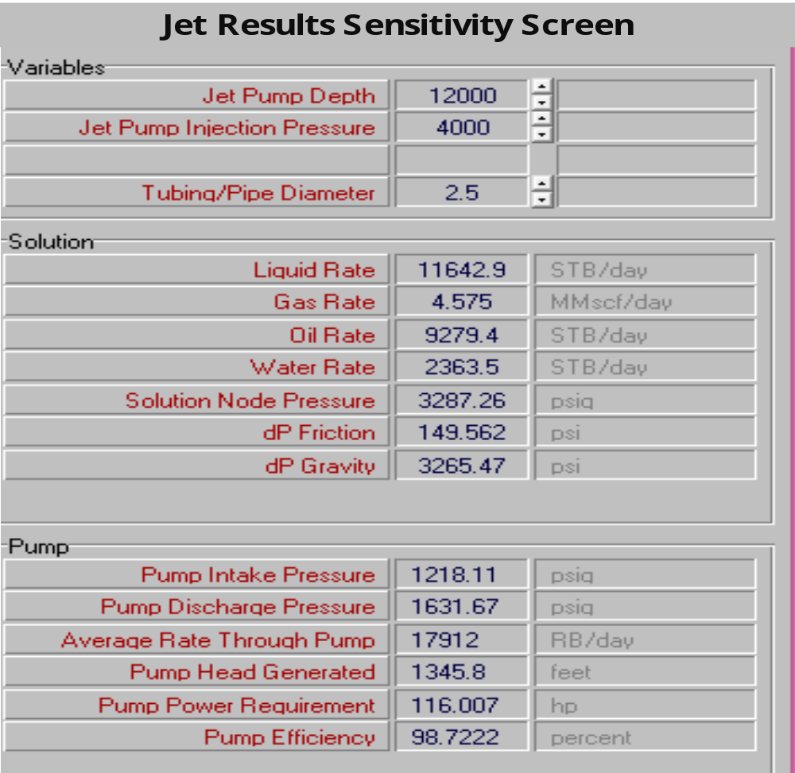

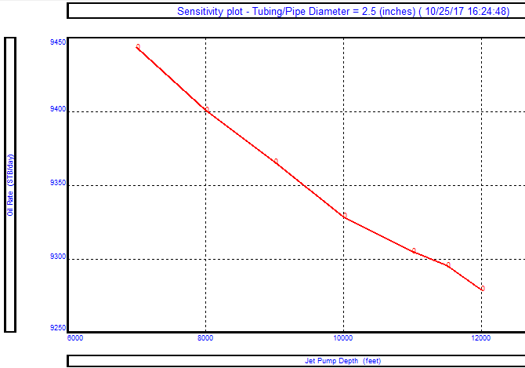

Figure B3: Inflow and Outflow oil Performance at
Pump depth, tubing sizes under pressure effect

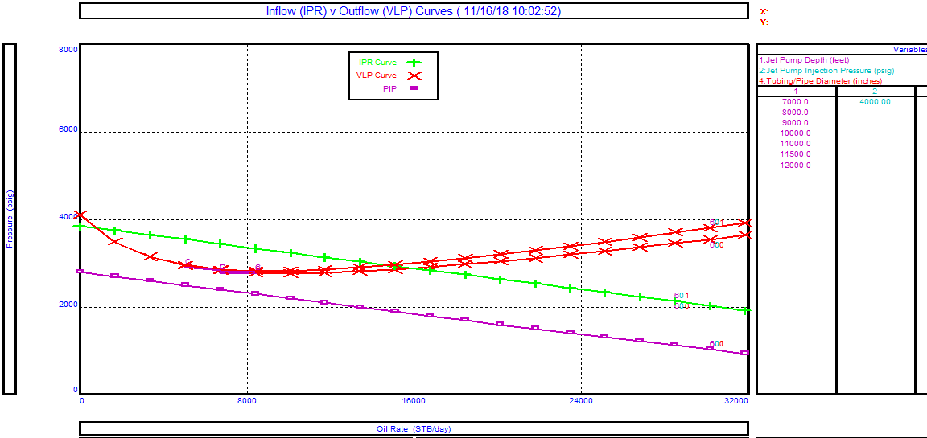
Figure B2: Jet Pump 2.5inch Tubing Sensitivity Result Plot

Figure B4: Pump Duty necessary to achieve the design rate

