Intermetallic Aluminides for Electronic / Semiconductor Applications

T. Joseph Sahaya Anand*, S. Shariza, R. Singh

Abstract

Metallic alloy that forms an ordered solid state compounds between two or more either metallic or non-metallic elements are called Intermetallics. One of the most common wire bonding technology involving Cu wire interconnections is the thermosonic bonding technique. Effects of Cu free air ball and bonding temperature with high temperature storage (HTS) treatment on Cu-Al bonding interface are unclear due to varying observations and inconsistencies in the bonding parameters. A quantitative stress analysis via statistical modelling could close the research gap. Microstructural characterizations were focused on Cu-Al IMC crystallographic system, compositional classification and ball bond mechanical strength analyses. The bonding temperature was found to affect the thickness of the initial IMC layer formed at the bonding interface. The amount of the initial IMC formation in turn influences the saturation thickness of the IMC after HTS treatment. In the theoretical part, a stress model was proposed by coupling of both thermal misfit and diffusion induced stresses. It was found that the stress developed by interfacial Cu-Al IMC generally increased with the bonding temperature. The influence of forming gas supply was found to be less significant to affect the interfacial stress development, as the oxide layers did not hinder much the interdiffusion of Cu and Al atoms in the Cu-Al IMC formation. This report addressed the research gaps and presented a better understanding of the fundamental of interfacial stress formation of thermosonic Cu-Al interconnection.

Image

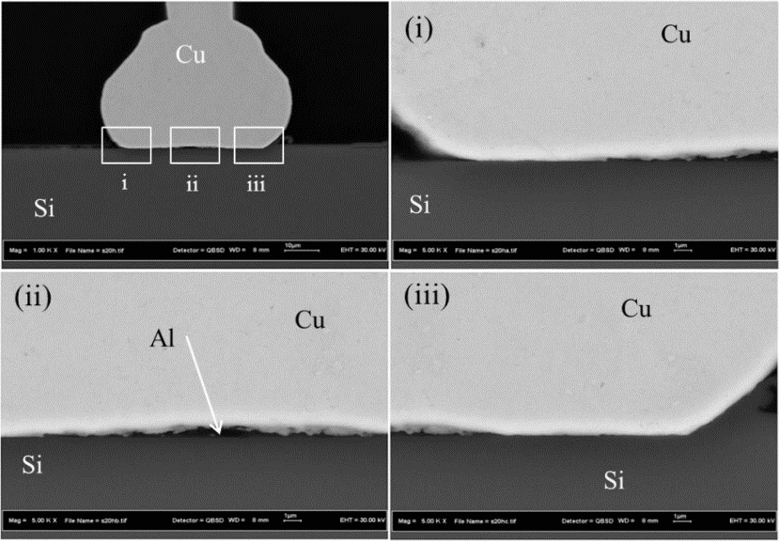
Figure: FESEM images of the cross-sectioned Cu-Al sample.

Recent Publications (minimum 5)
- Xyloglucan-co-MAAc/HAp/SiO₂ bioactive scaffold for bone tissue engineering applications: Physicochemical characterization and in vitro evaluation, Rashid Amin, Muhammad Umar…, Abdul Halim, Muhammad Hanif, T. Joseph Sahaya Anand, Rozita Hassan, Athar Aziz, Polymers-788971, MDPI Publishing, (Scopus / ISI ) Vol. 12 (2020) 1238 .
- Recent Advances in Biopolymeric composite materials for tissue engineering and regenerative medicines: A review, Rashid Amin, Muhammad Umar, Saiful Izwan Abd Razak, Wafa Shamsan Al-Arjan, Samina Nazir, T. Joseph Sahaya Anand, Hassan Mehboob, Molecules, MDPI Publishing, (Scopus / ISI Index) 2021 Vol 26, 619 .
- Synthesis and Characterization of silver-coated polymeric scaffolds for bone tissue engineering antibacterial and in vitro evaluation of cytotoxicity and biocompatibility, Khan, …Abdul Kadir, Mohammed Rafiq; Sahaya Anand, T. Joseph ; Inam, Fawad; Shah, Saqlain A ; Abdel-Haliem, Mahmoud; A, Rashid ACS Omega, Vol. 6 (6), 4335–4346, 2021.

- Electrospun Nanofiber and Cryogel of Polyvinyl Alcohol Transdermal Patch Containing Diclofenac Sodium: Preparation, Characterization and In Vitro Release Studies, Shafizah Sa’adon, Mohamed Ansari, Saiful Izwan Abd Razak, … Nadirul Hasraf, Joseph Sahaya Anand and Khairul Anuar, Pharmaceutics 13 (11), 1900, 2021, MDPI Publishing, (Scopus / ISI Index)..
- The Influence of Bath Temperature on the Properties of SILAR Deposited Cobalt Selenide Thin Films, Soon Min Ho, T Joseph Sahaya Anand, Engineering, Technology & Applied Science Research, Vol. 11 (4) pp. 7393-7398, 2021.
- Real -Time Analytic Face Thermal Recognition System Integrated with Email Notific., R Singh, TJS Anand, S. Anas and B. Acharya, Engineering, Technology & Applied Science Research, Vol. 13, 1 (2023) pp. 9961-9967.
- Graphene Oxide role in Bacterial Cellulose and Gelatin cross linked hydrogels for wound dressing applications, Muhammad Umar Aslam Khan, Goran M. Stojanović, R. Hassan, T. Joseph Sahaya Anand, Maryam Al-Ejji and Anwarul Hasan, ACS Omega - ACCEPTED Vol. 8 (7) 2023.
Photograph

Biography

Prof. T. Joseph Sahaya Anand, an expatriate staff from INDIA who is currently I am working as a Professor in Materials Science / Engineering in the Faculty of Mechanical and Manufacturing Engineering Technology, Universiti Teknikal Malaysia Melaka on contract basis since December 2008. Graduated from St. Joseph's College, Bharathidasan University, INDIA for my BSc., MSc and MPhil in Physics and completed the doctoral degree in Materials Engineering from the University of Hong Kong in 2004. After spending a year as Post-doctoral researcher from the Tohoku University, Sendai JAPAN started my full-time academic career in Malaysia in 2005. Joined as a Senior Lecturer first in AIMST University, Kedah and then moved to UTeM as an Associated Professor and promoted to full professor in 2018. Published about 80 Journal articles and 60 conference proceedings. Received 9 International / National awards about 15 students completed their Master / PhD degrees under my supervision. | 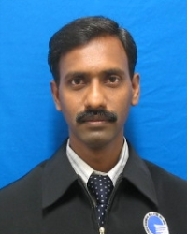

Speaker Name: Prof. Ts. Dr. T. Joseph Sahaya Anand
Type of Presentation: Keynote Speaker
Contact Number: +60-16 412 7232

Email: anand@utem.edu.my

