Sedimentological characteristics and reservoir quality prediction in the Upper Ordovician glaciogenic sandstone of the In-Adaoui-Ohanet gas field, Illizi basin, Algeria
Dr Soumya BENAYAD ,PhD, Faculty of Hydrocarbons and Chemistry, University M’Hamed Bougara Boumerdes, Algeria,
Dr Rabah CHAOUCHI, PhD, Faculty of Hydrocarbons and Chemistry, University M’Hamed Bougara Boumerdes, Algeria,

Abstract
The Upper Ordovician glaciogenic deposits are thought to have an important quantity of hydrocarbon across North Africa. Insight is provided about the IV-3 reservoir unit in the In-Adaoui-Ohanet field in the Illizi basin of south-east Algeria. The aim is to: 1) describe the lithofacies; 2) interpret the depositional environment; 3) describe the petrographic characteristics; 4) investigate the petrophysical properties; and 5) perform a biostratigraphic analysis of the unit IV-3 reservoir (Upper Ordovician) in the In-Adaoui-Ohanet field based on the core description and samples collected from the well IA-115.
Lithofacies described in the study area are MT1, MT2, MT3, MT6, and MT9. Subglacial tillite is the depositional environment associated with lithofacies MT3, MT6, and MT9. These lithofacies are thought to be deposited medial to a distal fan, whereas lithofacies MT1 and MT2 are thought to be deposited in high-energy flows. Acritarch and Chitinozoan species are the most common biozones described in the study reservoir and they are thought to be affiliated with an Upper Ashgilian stage. Petrographic analysis shows that the study reservoir unit is formed by fine to coarse-grained sandstone. Quartz is considered to be the principal framework mineral (mean, 56.30%). Cementing minerals observed in this reservoir unit are quartz and carbonate. From a compositional point of view, the unit IV-3 reservoir in the In-Adaoui-Ohanet field is predominantly formed by quartz arenites, which are considered to be mature. Additionally, the tectonic setting of these arenites is most likely associated with a passive margin origin. The emphasis throughout this study is on the role of factors such as permeability, carbonate cement, and quartz overgrowth on the reservoir quality of unit IV-3 in the In-Adaoui-Ohanet field. The quality of this reservoir unit is highly influenced by the quartz overgrowth and pores that are plugged by carbonate cement, which dramatically reduces the pore network. An enhanced porosity was observed only in the MT3lithofacies (up to 22.3%). Additionally, from an economic point of view, the study reservoir unit is classified as a tight gas-bearing reservoir.

Image
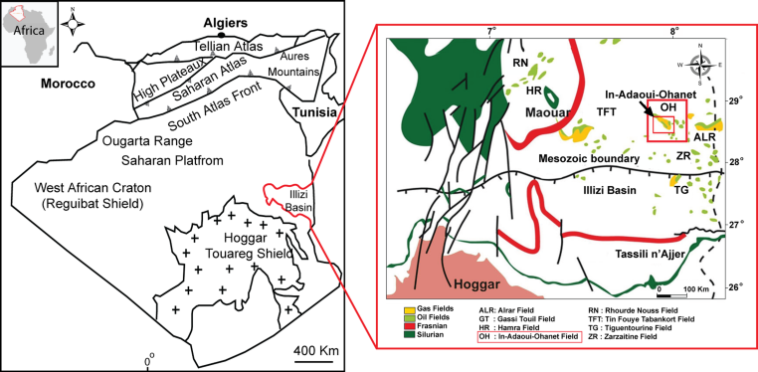

Figure 1 Geological map of the In Adaoui-Ohanet field, located between longitude 8º 52’ 37’’ East and latitude 28º 35’ 35’’ North, Illizi basin, Algeria
Recent Publications (minimum 5)
- Benayad S (2019) Sedimentological characteristics and reservoir quality prediction in the Upper Ordovician glaciogenic sandstone of the In-Adaoui-Ohanet gas field, Illizi basin, Algeria 179, 159-172
- Benayad S (2017) The evolution of the Algerian hydrocarbons law 24, 104-112
- Benayad S (2016) Sedimentological evolution of the Lower Serie formation in the southern area of the Hassi R’mel field, Saharan Platform, Algeria 9,481
- Benayad S (2013) Parameters controlling the quality of the Hamra Quartzite reservoir, southern Hassi Messaoud, Algeria: Insights from a petrographic, geochemical and provenance study 7,1541–1557
- Benayad S (2013) Unconventional resources in Algeria: Appraisal result from the Hamra Quartzite Reservoir 17, 313–327

Photograph


Biography
Soumya Benayad is a Lecturer Teacher at the Faculty of Hydrocarbons and Chemistry, University M’hamed Bougara Boumerdes, Algeria since Novermber 2013, where she is in charge of Petroleum Geology and Geo-statistical courses. His recent activities includes publication of different scientific articles in his research field as well as participating to various scientific projects in here faculty
Email: s.benayad@univ-boumerdes.dz or benayadsim@gmail.com

