Synthesis of acryloylated starch-g-poly acrylates crosslinked polymer functionalized by emulsified vinyltrimethylsilane derivative as a novel EOR agent for severe polymer flooding strategy
Dr A.N. El-hoshoudy, Egyptain petroleum Research Institute, Egypt
Dr S.M.Desouky, Egyptain petroleum Research Institute, Egypt

Abstract (300 word limit)
Starch is a natural polysaccharide with reasonable biodegradable properties, which grafted with vinyl monomers through different initiators to be applied in enhanced oil recovery (EOR) techniques. Several authors stated about starch modification through copolymerization and grafting of different monomers, however, these derivatives have some drawbacks related to bacterial biodegradation, ionic and thermal aging under severe reservoir conditions. The present study reported the preparation of grafted acryloylated starch with acrylamide/acrylic acid monomers and vinyltrimethylsilane through initiation copolymerization with the aid of quaternary ammonium-based surfmer. The chemical analysis generated by various spectroscopic analysis comprising IR, NMR, meanwhile particles distribution estimated through DLS. The embedded silica through a polymer matrix photographed by TEM, SEM and EDX elementary analysis, and the thermal effect determined by thermal gravimetric analysis. The rheological analysis estimated relative to shear degradation, ionic strength, and thermal aging at imitated reservoir environment. Flooding runs performed on linear non-consolidated sandstone model at nearly practical field conditions, where the displaced oil by polymer effect was recorded through the volumetric collector. The flooding tests designate that the synthesized starch-g-copolymer is prospering for chemical flooding applications under severe reservoir conditions, and achieve a recovery factor of 46% Sor.
Image
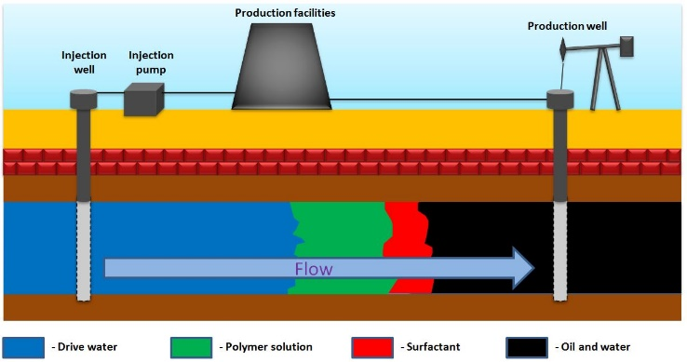
Figure 1: Mechanism of polymer flooding

Recent Publications (minimum 5)
- 1. A.N. El-hoshoudy “Synthesis of acryloylated starch-g-poly acrylates crosslinked polymer functionalized by emulsified vinyltrimethylsilane derivative as a novel EOR agent for severe polymer flooding strategy ” International Journal of Biological Macromolecules, vol.; 123 pp.124 -132 (2019).
- 2. A.N. El-hoshoudy*, Desouky S.M, A.M. Attia “Synthesis of starch functionalized sulfonic acid co-imidazolium/silica composite for improving oil recovery through chemical flooding technologies” International Journal of Biological Macromolecules, vol.; 118 pp.1614-1626 (2018).
- 3. A.N. El-hoshoudy*, Desouky S.M, “Synthesis and evaluation of acryloylated starch-g-poly (Acrylamide/Vinylmethacrylate/1-Vinyl-2-pyrrolidone) crosslinked terpolymer functionalized by dimethylphenylvinylsilane derivative as a novel polymer-flooding agent” International Journal of Biological Macromolecules, vol. 116; pp. 434-442 (2018).
- 4. A.N. El-hoshoudy* , Desouky S.M, Attia A.M., and Gomaa S. “Synthesis and Evaluation of Xanthan-G-Poly (Acrylamide) CoPolymer for Enhanced Oil Recovery Applications” Petroleum and Petrochemical Engineering Journal, vol, 2, issue (3) pp.147-154 (2018).
- 5. A.N. El-hoshoudy “Quaternary ammonium based surfmer-co-acrylamide polymers for altering carbonate rock wettability during water flooding” Journal of Molecular Liquids, vol, 250, pp.35-43 (2018).

Photograph

Biography (150 word limit)
Dr. Abdelaziz has his expertise in the synthesis of synthetic polymers and modification of biopolymers to be utilized in the field of enhanced oil recovery. He evaluate the prepared compounds for field application through conducting flooding runs on a simulated sandpack model,then validate the data through mathematical simulators. He has a lot of publications in this field
Email: azizchemist@yahoo.com

Notes/Comments:
N/a

