Immersive Virtual Reality Planning for Neurosurgical Procedures in Children

Kurtis Auguste, MD, UCSF Benioff Children’s Hospital, USA

Abstract

Analysis of radiologic images for pediatric neurosurgical procedures typically involves review of multiple, separate, two-dimensional stacks of scans that are presented individually. This exercise can be time-consuming and the end-goal of an assembled three-dimensional structure in the mind’s eye can be inaccurate. Virtual reality (VR) surgical planning stations construct three-dimensional renderings for users, synthesizing multiple imaging modalities into one platform that can be navigated with immersive lenses in a 360 degree experience. The authors use VR technology to prepare for tumor, epilepsy, arteriovenous malformation (AVM) and hydrocephalus surgery in children. Pediatric patients undergoing neurosurgical procedures at the University of California San Francisco Benioff Children’s Hospitals were included in this study. Images were processed on the Surgical Theater Virtual Reality surgical planning station. Virtual models were evaluated pre-operatively by surgeons and with patients/families in patient engagement sessions in the outpatient clinic. Questionnaires were distributed to assess the technology’s impact on patient/family understanding and anxiety. Preliminary surgical plans as designed by standard two-dimensional reviews were often modified as a result of 360-degree virtual fly-throughs. Furthermore, anatomy was often visualized in three-dimensional viewing that was poorly-visualized in two-dimensional imaging. No significant delays were recorded as a result of VR analysis. All patients and families reported increased understanding of their pathology and surgery as well as a decrease in their anxiety. Virtual planning is a useful adjunct in the preparation of neurosurgical procedures in children. This immersive technology is an efficient, time-saving method for surgeons to visualize complex anatomic relationships. VR can reveal anatomy that is poorly-represented or not visualized using conventional imaging reviews. Coordination of intraoperative VR navigation is seamless with standard neuronavigation systems. In addition to increased understanding of the diagnosis and treatment, pediatric patients and their parents report a significant reduction in anxiety levels as a result of their VR sessions.

Image
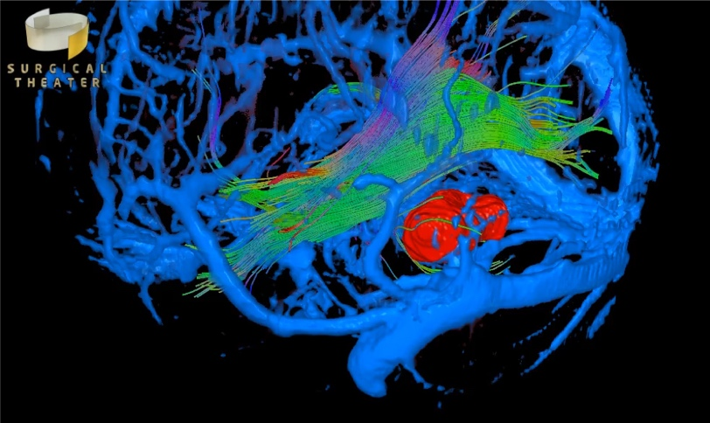
Recent Publications
- Collins MK, Ding VY, Ball RL, Dolce DL, Henderson JM, Halpern CH (2018) Novel application of virtual reailty in patient engagement for deep brain stimulation: a pilot study. Brain Stimul 11(4): 935-937.
- Kockro RA, Killeen T, Ayyad A, Glaser M, Stadie A, Reisch R, Giese A, Schwandt E (2016) Aneurysm surgery with preopereative three-dimensional planning in a virtual reality environment: technique and outcome analysis. World Neurosurg 96: 489-99.
- Kin T, Nakatomi H, Shono N, Nomura S, Saito T, Oyama H, Saito N (2017) Neurosurgical virtual reality simulation for brain tumor using high-definition computer graphics: a review of the literature. Neurol Med Chir (Tokyo) 57(10): 513-520.
- Ryu JH, Park SJ, Park JW, Kim JW, Yoo HJ, Kim TW, Hong JS, Han SH (2017) Randomized clinical trial of immersive virtual reality tour of the operating theatre in children before anaesthesia. Br J Surg 104(12): 1628-1633.
- Bekelis K, Calnan D, Simmons N, MacKenzie TA, Kakoulides G (2017) Effect of an Immersive Preoperative Virtual Reality Experience on Patient Reported Outcomes: A Randomized Controlled Trial. Ann Surg 265(6): 1068-1073.

Photograph

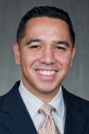 Biography
Dr. Kurtis Auguste graduated from Harvard University. He conducted his medical training, internship and neurosurgery residency at the University of California, San Francisco School of Medicine. He completed his pediatric neurosurgery fellowship at the Hospital for Sick Children in Toronto, Canada. Since 2008, he has directed the UCSF Pediatric Epilepsy Surgery Program. He has been the Division Chief of Neurosurgery at the UCSF Benioff Children’s Hospital Oakland since 2014 and was elected Chief of Surgery in 2016. His practice focuses on the the surgical management of pediatric seizure disorders, complex hydrocephalus, spinal dysraphism, neuro-oncology, neurotrauma and craniofacial disorders. His research interests have included neural stem cell transplantation for the study of central nervous system migrational disorders, the role of aquaporin water channels in hydrocephalus, seizure propagation and astroglial migration, and the use of immersive virtual reality imaging for pre-operative and intraoperative neurosurgical planning.
Email: Kurtis.Auguste@ucsf.edu

Notes/Comments:

