Development of a perinatal electronic health record model
Dra Mañas Uxó, María Isabel, Health Sciences PhD Program, Universidad Católica de Murcia (UCAM), Campus de los Jerónimos, nº 135, Guadalupe, 30107 Murcia, Spain
Dr Leante Castellanos, José Luis, Healthcare General Management, Murcian Health Service, Central Street 7, Habitamia Building, 30100 Espinardo. Murcia, Spain

Abstract
Statement of the Problem: Electronic record of newborn health data contributes to improving the quality of health care. However, information on perinatal electronic health record models is limited.
Methodology & Theoretical Orientation: We describe the creation and implementation of an electronic record model that integrates information on medical care provided to both mother and baby, standardized for six medical centers in a regional health system.
The implementation procedure was formulated in two phases. During the initial phase, the tool was introduced in medical centers to initiate first interaction with the medical staff. The next phase consisted of devising a new approach to stabilize the project. Technical flaws were rectified and a new edition was formulated based on interdisciplinary consensus.
Indicators to monitor implementation were measured in both phases and analyzed using the chi-square test.
Findings: In the primary phase, almost all newborns obtained their electronic medical records with an adequate connection to the mother's data. However, certain forms completed by staff were frequently not completed (completion rates: 36.7%-55.3%). In the secondary phase, there was a statistically remarkable growth in the completion rates of all these forms. Consequently, a standardised discharge report was provided to every newborn at the end of stage two.
Conclusion & Significance: There is little published evidence on the existence of standardized models of electronic perinatal medical record keeping at regional, national and international levels. In addition, there are no adequate systems for monitoring and standardizing different perinatal indicators related to such important areas as skin-to-skin contact and breastfeeding.
This electronic record model serves as an innovative illustration of how the digitization and standardization of data linked to the care of healthy newborns in maternity units can be implemented throughout a network of medical centers.

Image
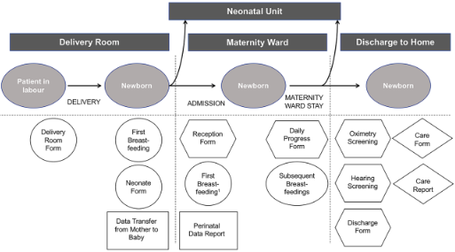
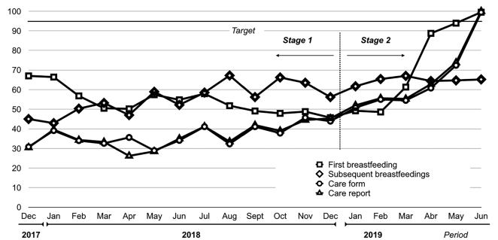
Recent Publications

- Leante-Castellanos JL, Mañas-Uxó MI, Garnica-Martínez B, Tomás-Lizcano A, Muñoz-Soto A (2022). Implementation of a Regional Standardised Model for Perinatal Electronic Medical Records. J Med Syst 46(12):103.
- Statnikov Y, Ibrahim B, Modi N (2017) A systematic review of administrative and clinical databases of infants admitted to neonatal units. Arch Dis Child-Fetal Neonatal Ed 102: F270–6.
- Hornik CP, Atz AM, Bendel C, Chan F, Downes K, Grundmeier R, et al (2019) Creation of a Multicenter Pediatric Inpatient Data Repository Derived from Electronic Health Records. Appl Clin Inform 10:307–15.5.
- Chi BH, Vwalika B, Killam WP, Wamalume C, Giganti MJ, Mbewe R, et al (2011) Implementation of the Zambia Electronic Perinatal Record System for comprehensive prenatal and delivery care. Int J Gynecol Obstet. 113:131–6.
- Stelwagen MA, van Kempen AAMW, Westmaas A, Blees YJ, Scheele F (2020) Integration of Maternity and Neonatal Care to Empower Parents. J Obstet Gynecol Neonatal Nurs JOGNN 49:65–77.

 Biography
Dr. María Isabel Mañas Uxó is a pediatrician subspecialized in Neonatology since 2018. She has worked in different neonatal units nationwide. She is currently doing her doctoral thesis on the implementation of a regional program for the promotion of breastfeeding. The work presented here is part of this research project, which aims to improve the regional quality of care and serve as a model for other regions and nations.
Email: mabeluxo@gmail.com

