Vomiting and Gastric Motility in Early Brain Damaged Children With
Congenital Zika Syndrome.
*†‡Georgia Lima de Paula, MSc; *Giselia Alves Pontes da Silva, PhD; *‡Eduardo Just da Costa e Silva, PhD; *Maria das Graças Moura Lins, PhD; *Olga Sophia de Sousa Martins, MSc; *†Danielle Maria da Silva Oliveira, MSc; *Eric de Santana Ferreira, MD and *Margarida Maria de Castro Antunes, PhD.

Abstract
Statement of the Problem: Feeding difficulties are frequent in children with early brain damage and can be associated with dysphagia and motility disorders. In 2015, northeastern Brazil was the epicenter of an outbreak of microcephaly; its etiology was later defined as the Congenital Zika Syndrome (CZS), which affects the formation and functioning of several organs, especially the brain, given the neurotropism of the virus. This study investigated the occurrence of vomiting and gastric dysmotility in dysphagic children with CZS and assessed possible associations of these findings with the severity of dysphagia and the presence of tube feeding. Methodology: Forty-six children with CZS were evaluated for the occurrence of dysphagia, vomiting, dietary volume intolerance and prolonged feeding time. Gastric antrum ultrasonography was used to detect the frequency of contractions and measure antral areas, from which the gastric emptying rate (GER) was calculated. Antral ultrasonography findings were compared with those of ten healthy controls. Vomiting and gastric motility were compared between CZS patients according to the severity of dysphagia and the requirement for tube feeding. Findings: Overall, 76% (35/46) of children with CZS had moderate-to-severe dysphagia (MSD), among whom 60% (21/35) were tube fed [MSD tube fed (MSDTF)]. Vomiting occurred in 54% (25/46) of children, whereas dietary volume intolerance and prolonged feeding time were observed in 59% (27/46) and 37% (17/46), respectively, most frequently in MSDTF patients. On ultrasound, 61% (28/46) of children with CZS had no antral contractions, whereas 90% (9/10) of controls did. Compared to healthy controls, GER was eight-fold lower in children with CZS and 60-fold lower in MSDTF children. Conclusions: In dysphagic children with CZS, vomiting, volume intolerance, and prolonged feeding time were frequent and possibly associated with impaired antral contraction and delayed gastric emptying, especially in cases of severe dysphagia and tube feeding.

*Universidade Federal de Pernambuco (UFPE), Recife, PE, Brazil, the †Universidade de Pernambuco (UPE), Recife, PE, Brazil, and the ‡Instituto de Medicina Integral Professor Fernando Figueira (IMIP), Recife, PE, Brazil.

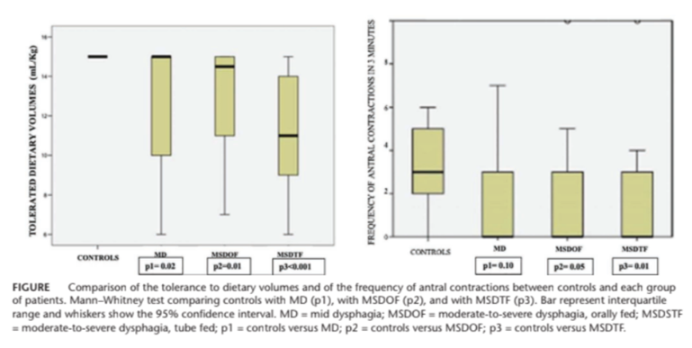
References
- de Paula GL, da Silva GAP, E Silva EJDC, Lins MDGM, Martins OSS, Oliveira DMDS, Ferreira ES, Antunes MMC. Vomiting and Gastric Motility in Early Brain Damaged Children With Congenital Zika Syndrome. J Pediatr Gastroenterol Nutr. 2022 Aug 1;75(2):159-165. doi: 10.1097/MPG.0000000000003504. Epub 2022 Jun 1. PMID: 35653500.
- Oliveira DM da S, Miranda-Filho D de B, Ximenes RA de A, et al. Comparison of oropharyngeal dysphagia in Brazilian children with pre-natal exposure to Zika virus, with and without microcephaly. Dysphagia[Internet]. 2021;36:583–94. Available from: https://doi.org/10.1007/s00455-020-10173-4.
- Moore CA, Staples JE, Dobyns WB, et al. Characterizing the pattern of anomalies in congenital Zika syndrome for pediatric clinicians. JAMA Pediatr. 2017;171:288–95.
- Kapogiannis BG, Chakhtoura N, Hazra R, et al. Bridging knowledgegaps to understand how Zika virus exposure and infection affect child development. JAMA Pediatr. 2017;171:478–85.
- Romano C, Dipasquale V, Gottrand F, et al. Gastrointestinal and nutritional issues in children with neurological disability. Dev Med Child Neurol. 2018;60:892–6.
- Devanarayana NM, Rajindrajith S, Bandara C, et al. Ultrasonographic assessment of liquid gastric emptying and antral motility according to the subtypes of irritable bowel syndrome in children. J Pediatr Gastroenterol Nutr. 2013;56:443–8.


Dr de Paula has her expertise in Pediatric Gastroenterology and Master's degree in Child and Adolescent Health. She lives in Pernambuco, Northeast of Brazil, known as the epicenter of the Zika epidemic and she works in three public teaching hospitals, where she and the other authors assist most of the affected patients, in addition to many other children with gastrointestinal problems associated with neurological diseases.
Email: gelipaula@gmail.com

