Still's disease in adolescence

Adail Orrith Liborio Neto, Medical intern. Federal University of Rio de Janeiro Campus Macaé (UFRJ). Division of Neonatology, Department of Pediatrics, Macaé, Brazil
Fernanda Marvila Fagundes Lamarca. Rheumatologist. Center for Assisted Therapy, Endoscopy, Rheumatology and Gastroenterology, CLIGED, Macaé, Brazil.

Abstract (300 word limit)

Still's disease is a rare systemic inflammatory disease of unknown etiology and a frequent cause of fever of unknown origin in adults. It is similar to juvenile idiopathic arthritis in the systemic form and can be considered a variant of this. It affects both sexes in the same proportion, and in 75% of cases is between 16 and 35 years old.

JPLB, male, 14 years old, brown was admitted to HPM Serra Trapiche. Young man previously healthy, history of fever, polyarthralgia in hands, wrists, feet and ankles with wrist arthritis for about 10 days, with sporadic rash. No report of previous infections. Lucid and oriented patient, acyanotic, anicteric, flushed, hydrated, average of 3 febrile peaks per day (38ºC). Hemodynamically stable. Normal physical exam. Hb = 12.0; Hto = 37.3; Leukogram = 26,470; Rod = 11%; Segmented = 84%; PCR = 178; Cr = 0.4; Urea = 20; TGO = 28 / TGP = 24; CPK = 465; Rheumatoid Factor = Negative; Ferritin = 2,075; Glucose = 100

Serology was performed for chikungunya less than 10 days after febrile episode (IgM and IgG = negative) and CBC with leukocytosis and elevated ferritin. Thus, the diagnosis of systemic juvenile idiopathic arthritis was made - compatible clinical and laboratory picture. Initiate Prednisone 20mg / d and Methotrexate. Patient evolved with improvement of symptoms and laboratory improvement: Hb = 15.1; Hto = 45.3; Leukogram = 5,300; CRP = 0.2; ESR = 02 and Ferritin = 20.8.

Characterized by high fever, evanescent rash and arthritis, in addition to multisystem involvement, renal and neurological involvement are rare. Serum ferritin levels above 1,000 ng /ml correlate with disease activity. The diagnosis of Still's disease is difficult, but should be considered in cases of fever of undetermined origin in adolescents, after excluding infectious and neoplastic causes.
Image

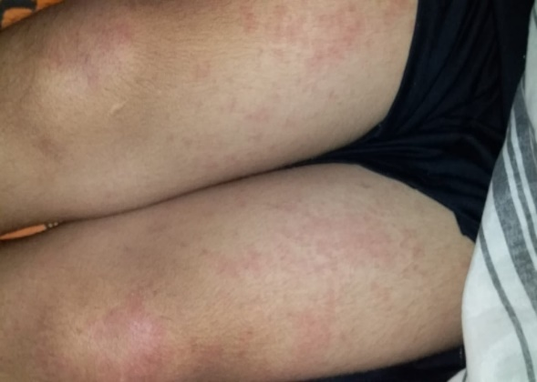

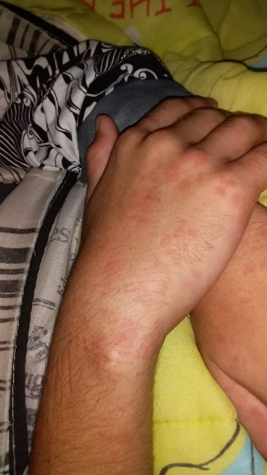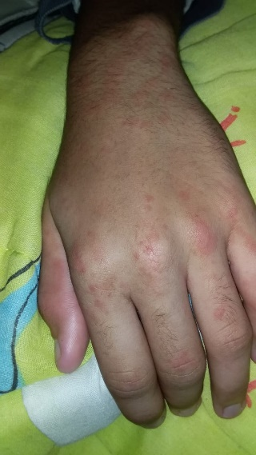

Recent Publications (minimum 5)
- LIBORIO NETO, A. O.; CORDEIRO, I. A. P. . Eritema Multiforme idiopático en preadolescente: A propósito de un caso. Revista Argentina de Dermatologia, v. 100, p. 10, 2019.
- BAHIA-OLIVEIRA, LILIAN MARIA GARCIA ; LIBORIO-NETO, ADAIL ORRITH ; DUDUS, MARTA MACIEL . Microcefalia por toxoplasmose congênita em tempos de epidemia por Zika vírus no Brasil. SCIENTIA MEDICA (PORTO ALEGRE. ONLINE), v. 28, p. 29527, 2018.
- LIBORIO NETO, A. O.. Herpes zóster en escolar inmunocompetente: el diagnóstico controvertido de la pediatria. Revista Argentina de Dermatologia, v. 99, p. 81-90, 2018.
- LIBORIO NETO, A. O.. Histologia do Sistema Nervoso: Diversidade Celular e Suas Localizações. Revista Científica Multidisciplinar Núcleo do Conhecimento, v. 05, p. 74-93, 2017.
- TATAGIBA, A. D. ; LIBORIO NETO, A. O. ; RIBEIRO, D. F. ; BERNARDO, T. T. ; ABREU, A. M. O. W. Fatores de risco para a toxoplasmose gestacional em campos dos goytacazes rj. revista científica da faculdade de medicina de campos, V. 11, P. 12-18, 2016.

Photograph

 Biography (150 word limit)
Academic and Intern of Medicine at the Federal University of Rio de Janeiro Campus Macaé (UFRJ Macaé). Currently working in research in the area of Neonatal Clinical Microbiology as a student PIBIC UFRJ Working in the areas of Clinical Pathology and Nutrition and Gynecology and Obstetrics. I worked in the project Prevalence of congenital toxoplasmosis in an endemic area for toxoplasmosis in northern Rio de Janeiro. QualiVida project extensionist - Multidisciplinary intervention as a health health strategy in the objectives of the University City of Macaé - Rio de Janeiro, linked to the Laboratory of Research and Innovation in Sports Sciences - LAPICE UFRJ Macaé. He was an intern at the Cardiology outpatient clinic at the Dr. Jorge Caldas Health Center. Currently, trainee in Rheumatology at Cliged Macaé.

Email: adail_orrith@hotmail.com

Notes/Comments:

