TITLE: A QUALITY IMPROVEMENT (QI) PROJECT TO IMPROVE TIMELY ADMINISTRATION OF FIRST DOSE ANTIBIOTICS IN THE NICU
Gagandeep Brar, MD, MBA¹, Victoria Eck, CNNP¹; Christine Calcamuggio, CNNP¹ ; Kathryn J Clicker, PharmD²
¹Department of Pediatrics, Division of Neonatology, Mercy Children's Hospital, Toledo, OH, USA; ²Pharmaceutical Care Department, St Vincent’s Mercy Medical Center, Toledo, OH, USA
Abstract

Objective: To increase administration of first dose of parenteral antibiotics within 1 hour of order entry in the NICU at Mercy Children’s Hospital from 32% to 48%, to achieve a 50% improvement in timely initiation of antibiotic therapy.
Interventions/Performance Measures: Retrospective audits conducted on 45 neonates who received antibiotic treatment between 12/19/2016-2/13/2017 revealed that only 32% of the initial antibiotics were administered within 1 hour of order entry, the average time to administration being 106 minutes. Barriers to timely antibiotic administration were identified and interventions were designed and implemented in 4 PDSA cycles conducted from 2/14/2017-1/15/2018. Cycle 1 focused on improving the antibiotic turnaround time in the pharmacy. Cycle 2 focused on the development of a unit policy and staff education on timely sepsis evaluation and initiation of antibiotics. Cycle 3 entailed placement of STAT antibiotic orders in EMR (Electronic Medical Record). Obtaining intravenous access within 30 minutes of NICU admission was the focus of Cycle 4. Chart audits were performed every 2 weeks to test the changes implemented in these cycles and feedback given to the NICU staff through in services and staff meetings.
Results: During the 32 weeks, 271 antibiotics were initiated in 130 patients. Chart audits were available for 136 antibiotic orders on 72 of these patients. The number of antibiotics administered within an hour of order entry increased from a baseline of 32% to 61.8% in Cycle 1 and to 70.8% in Cycle 2. Cycle 3 and cycle 4 resulted in a further increase in timely antibiotic administration to 85.4% and 93.8% respectively, thus resulting in an overall improvement of 267% (figure 1).
Discussion: Implementation of QI initiative resulted in a significant increase in the percentage of timely administration of 1st antibiotic doses within 1 hour of order entry. The average time to administration 1st antibiotic dose decreased from 106 minutes to 45 minutes.
Keywords- antibiotics, neonates, quality improvement, timely administration

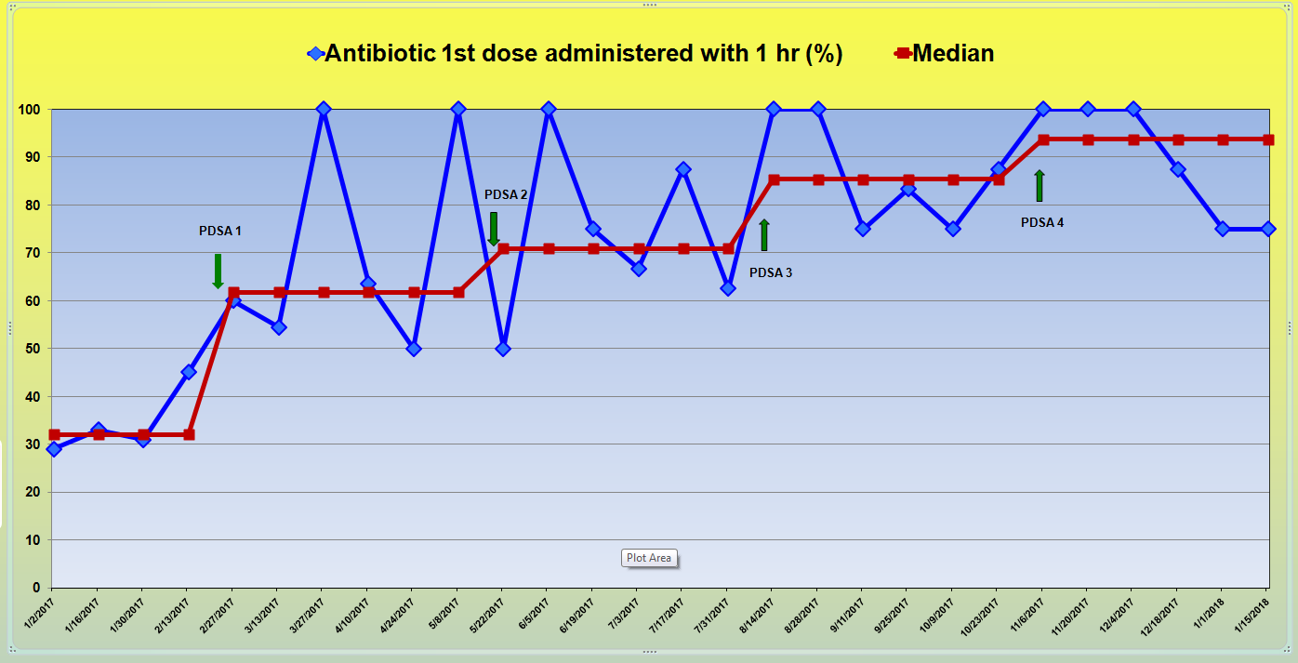

Professional Biography (100-150 words)

Gagandeep Brar MD, MBA, FAAP, has completed her MBBS from Dayanand Medical College and Hospital, Ludhiana, Punjab, India. She completed her residency in Pediatrics at St John’s Hospital and Medical Center in Detroit, Michigan and her fellowship in Neonatology at Detroit Medical Center, Detroit, Michigan. She completed her MBA (Masters in Business Administration) from University of Toledo, OH. She is currently the Director of Neonatology and the Associate Program Director, Pediatrics Residency Program, St Vincent’s Medical Center, Toledo, Ohio, USA. She is an avid champion for Quality Improvement (QI) in her institution and has worked tirelessly on projects to increase the use of breast milk in the NICU, decrease central line associated blood stream infections, and decrease the length of stay in infants with neonatal abstinence syndrome and many more. She has been presenting her work at the Vermont Oxfort Netwok (VON) conference yearly since 2011.

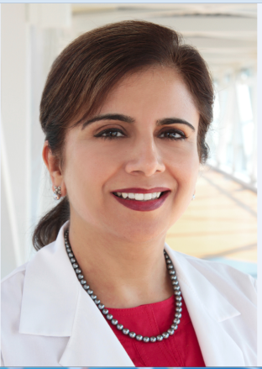
Email Id: bgbrar@aol.com

