Open removal of pediatric airway foreign body: A case report
Dr Alireza Malekzadegan MD, ZUMS, Zabol, Iran
Dr Majidreza Akbarizadeh MD, ZUMS, Zabol, Iran

Abstract

Foreign Body Aspiration is a common finding in children that should be diagnosed based on clinical signs and radiological studies so that timely diagnosis and successful removal of the foreign Body is essential to reduce complications and mortality.

Our case was a 7-year-old boy with a Date kernel's aspiration whose bronchoscopy was not successful in removing the foreign body due to both edematous vocal cord and foreign body. The next day, the patient's CT scan showed intraparanchymal hemorrhage and collapsed lung on the right side ( figure 1), and he underwent bronchoscopy again. The FB was seen in the right bronchial opening on the Carina but bronchoscopy was not successful in removing the foreign body. The patient underwent open surgery, and the FB was removed ( figure 2) . The patient underwent intubation and was transferred to the PICU ward. He was hospitalized there for four days.

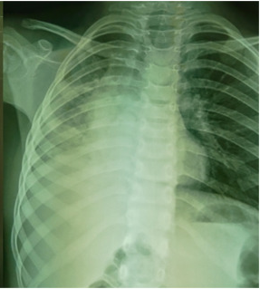
Conclusion: Rigid bronchoscopy involves fewer complications and is more successful in removing the foreign body in children. However, a small percentage of children require open surgery for removal, which can be attributed to the size of the FB, its shape, how long the FB stays in the airways, and the changes that follow are involved and sufficient expertise in rigid bronchoscopy.
Image

Figure 3: Chest X-Ray of the patient after removal of the foreign body

Figure 1: Chest X-Ray of the patient CXR at the time of the patient's arrival at the hospital
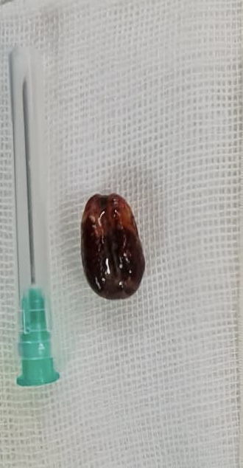

Figure 2: Removed date kernel

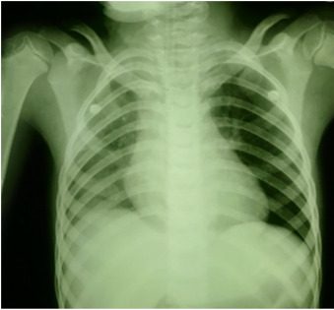

Recent Publications
1. W. Qiu, L. Wu, Z. Chen. Foreign body aspiration in children with negative multi-detector computed tomography results:own experience during 2011–2018
2. S. Na’ara, I. Vainer, M. Amit, A. Gordin. Foreign body aspiration in infants and older children: a comparative study. Ear Nose Throat J., 99 (1) (2020), pp. 47-51
3. W. Gan, N. Xiao, Y. Feng, D. Zhou, J. Hu, S. Liu, J. Zou
Clinical analysis of tracheobronchial foreign body aspiration in children: a focus on external and intrinsic factors
BMC Surg., 21 (1) (2021), pp. 1-6
4. F. Pinzoni, C. Boniotti, S.M. Molinaro, A. Baraldi, M. Berlucchi Inhaled foreign bodies in pediatric patients: review of personal experience
Int. J. Pediatr. Otorhinolaryngol., 71 (12) (2007), pp. 1897-1903
5. J. Liang, J. Hu, H. Chang, Y. Gao, H. Luo, Z. Wang, G. Zheng, F. Chen, T. Wang, Y. Yang
Tracheobronchial foreign bodies in children–a retrospective study of 2,000 cases in Northwestern China
Ther. Clin. Risk Manag., 11 (2015), p. 1291

Photograph


Biography
Malekzadegan, MD, general surgeon, thoracic surgeon, breast surgeon, assistant professor of the University, Head of the General surgery department ZUMS. Interested in airway and tracheal surgery. Both in adult and children from9 years ago.interested and doing surgery on stenosis and other kind of diseases of the air way, needs to be operated. Educated in MASIH DANESHVARI Hospital SBMU. continue to learn more in ESTS programs in kopenhagen and then in Lausanne, Airway sector.i am the only thoracic surgeon in my state and 2 nearby States, so, I have the privilege to have many cases to practice and help, both the patients and my colleagues.To my opinion there is much more to learn and practice in airway diseases in pediatrics. I have the experience of extracting 278 foreign body in pediatrics and working on publishing the results.
Notes/Comments:

