Familial Mediterranean fever: The need for a new standard criterion in clinical diagnosis
Emmanuel Fagbola, BScH candidate, Queen’s University, Canada

Abstract (300 word limit)
Statement of the Problem: The current standard for diagnosing FMF (Familial Mediterranean fever) in children established by Yalçinkaya et al.¹, was a great advancement in the clinical diagnosis of the disease worldwide. However, this set of criteria is based on a non-representative group of children who are homozygous recessive for the disease. Recent evidence shows that children are being diagnosed with FMF without meeting the standard criteria and/or without being homozygous recessive for the known MEFV gene mutations. The purpose of this clinical case study is to further support the need to establish a new standard diagnosis criterion for the disease. Methodology & Theoretical Orientation: The medical history of a 5-year-old girl was analyzed in this case study. When suspected to have FMF a treatment of colchicine was started. A graph showing documented temperatures prior to, during, and after colchicine treatment was created to establish a possible relationship and confirm diagnosis. Findings: The 5-year-old girl in this study presented to the emergency room with a history of recurrent fever (15-months). Out of the 5-criterion used to diagnose FMF, this child only associated with one. FMF was suspected none-the-less and a treatment of colchicine began. Simultaneously, DNA genetic testing revealed a heterozygous mutation of the MEFV gene (met694val). Four years after diagnosis, patient returned to normal showing no manifestations of the disease. Conclusion & Significance: As shown by the building evidence in the pediatric field, FMF is a disease that can affect anyone (not just those identifying with lineage from the Mediterranean basin) and can manifest differently amongst those affected. Therefore, a new set of criteria is needed to be able to effectively diagnosis children with FMF with a high degree of sensitivity and specificity (especially in diverse ethnic populations) allowing improved and uniform care throughout the world.

Image
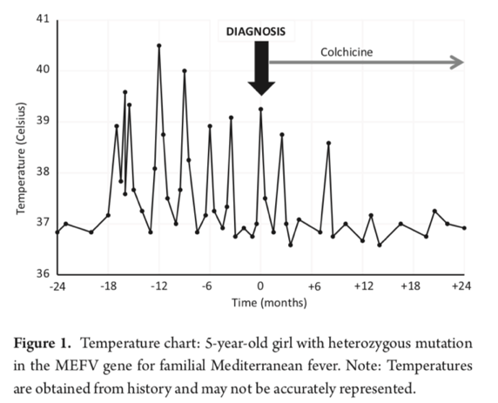
Recent Publications (minimum 5)
- Aksentijevich I, Kastner DL (2011) Genetics of monogenic autoinflammatory diseases: past successes, future challenges. Nat Rev Rheumatol 7:469–78.
- Giancane G, Ter Haar NM, Wulffraat N, et al. (2015) Evidence-based recommendations for genetic diagnosis of familial Mediterranean fever. Ann Rheum Dis 74:635–41.
- Lachmann HJ, Sengül B, Yavuzşen TU, et al. (2006) Clinical and subclinical inflammation in patients with familial Mediterranean fever and in heterozygous carriers of MEFV mutations. Rheumatology (Oxford) 45:746–50.
- Marek-Yagel D, Berkun Y, Padeh S, et al. (2009) Clinical disease among patients heterozygous for familial Mediterranean fever. Arthritis Rheum 60:1862–6.
- Uruthirakumar R, Fagbola E, Tse TT, Moodie RG, Etoom Y, Laxer R, Wong PD (2019) A 5-year-old girl with recurrent fever. Paediatrics and Child Health 1:1-3.
- Yalçinkaya F, Ozen S, Ozçakar ZB, et al. (2009) A new set of criteria for the diagnosis of familial Mediterranean fever in childhood. Rheumatology (Oxford) 48:395–8.

Photograph

 Biography (150-word limit)
Emmanuel has his background in biochemistry and is entering his third year of post-secondary education at Queen’s University in Ontario, Canada on route to complete a BScH as well as a certificate in business. He has recently completed 4 months of full-time research in an organic chemistry lab (Nickel Catalysis focused) at U of T under Sophie Rousseaux funded by NSERC Canada. Emmanuel is actively involved in many diversity initiatives when it comes to post-secondary education and the medical field. Emmanuel looks to continue to be an advocate for diversity especially when it comes to the lack of research for ethnic focused genetic diseases.
Email: 16eoaf@queensu.ca

Notes/Comments:

