BLOODSTREAM INFECTION AT CHILDREN IN BELARUS
Serhiyenka E.N., Romanova O.N.
Department of children's infectious diseases, Belarusian state medical university, Minsk, Belarus

Abstract (300 word limit)

In a retrospective study from 2009 to 2017 was studied identified etiological pattern of bacteremia. Only for the period allocated 655 pathogens cultured from blood cultures 515 patients aged from 3 weeks to 18 years old.

According to the results of the study, the proportion of gram-negative bacteria was 31.7%, gram-positive bacteria-61.9%, fungus -6.4%. Fungemia was registered in different years from 2.2 (2013) to 14.7% (2010) of all positive hemocultures. Candida parapsilosis prevails in the structure of pathogens (64.3%) and 27 cases (64.3%) of the genus Torulopsis. Among the isolated microorganisms, staphylococci prevailed (41%), the 2nd place in the frequency of isolation was occupied by non-fermenting bacteria (16.7%), the 3rd place-bacteria of the Enterobacteriacae family (14.1%) and the 4th place – streptococci (10.8%).

The spectrum of gram – negative bacteria in the family Enterobacteriacae (n=86) is diverse: Escherichia – 10.5%, Salmonella – 5.8%, Shigella – 25.6%, Proteus mirabilis – 1.15%, Providencia stuartii – 1.15%, Serratia – 15.1%, Klebsiella – 27.9%, Enterobacter – 10.5% and others – 2 (2,3%).

Gram-negative non-fermenting bacteria were isolated in 102 (16.7%) episodes of bacteraemia. Among them dominated Acinetobacter – 47.1%, Pseudomonas – 20.6%, Achromobacter – 12.7% and Stenotrophomonas maltophilia – 7.8%.

The structure of gram-positive bacteria (n=404) was dominated by staphylococci (62.1%), with the most frequently isolated coagulase-negative types (84.5%). In the structure of all staphylococci (n=251), S. aureus was found with a frequency of 15.1%, the most common was S. epidermis – 63.3% of cases. Streptococci (n=66) were dominated by Str. pneumonia (27.3%) and Str. agalacia (19.7%) and Str. viridans groups (15.2%). Enterococci were isolated in 31 patients (5.1%), with almost the same frequency dominated by Enterococcus faecalis and Enterococcus faecium (41.9% and 38.7%, respectively). During the study period, 7 (1.1%) strains of Corynebacterium spp were isolated.
Structure of bloodstream

infections in CIDH, 2009-2017
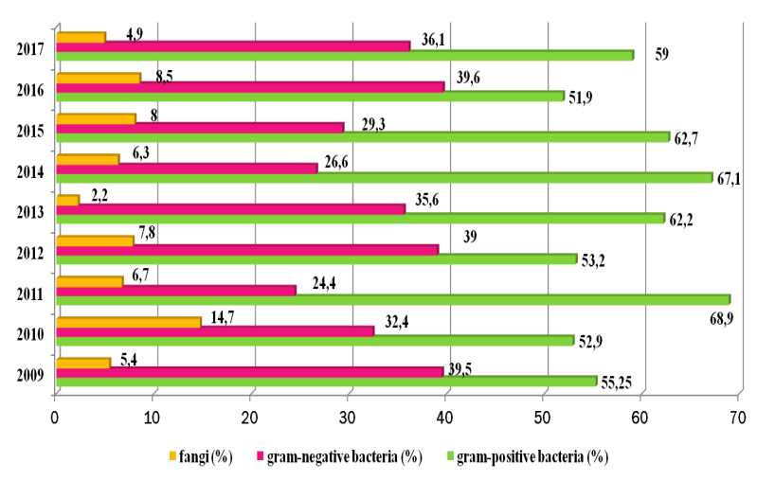
Recent Publications
- Deen J, Seidlein L, Andersen F, et al. (2012). Community-acquired bacterial blood stream infections in developing countries in south and Southeast Asia: a systematic review. Lancet infectious diseases. 12, 480-487.
- Bhandari P, Manandhar S, Shrestha B, Dulal N. (2016). Etiology of bloodstream infection and antibiotic susceptibility pattern of the isolates. Asian journal of medical sciences. 7(2), 71-75.
- Tufail S, Tikmani S, Ali A, et al. (2016). Frequency and etiology of community-acquired bloodstream infection in hospitalized febrile children. Journal of medical diagnostic methods. 5(3), doi.org/10.4172/2168-9784.1000217.
- Kaur A, Singh V. (2014). Bacterial isolates and their antibiotic sensitivity pattern in clinically suspected case of fever of unknown origin. Science. 16, 105–109.
- Laupland KB, Church DL. (2014). Population-based epidemiology and microbiology community-onset bloodstream infections. Clinical microbiology reviews. 27(4), 647–664.

Photograph

Biography
Dr Serhiyenka works at the Department of Children's Infectious Diseases from September 1, 2009 to the present. K. Serhiyenka has excelled throughout his career with many notable accomplishments. During this time, Katsiaryna Serhiyenka graduated from clinical residency at the department, she is actively engaged in clinical, practical and scientific work and she successfully defended her dissertation in 2013. The sphere of her professional interests is wide - this includes acute respiratory infections, herpetic infections, HIV infection, vaccine preventive maintenance of infectious diseases, sepsis, etc.
Email: Serhiyenka@yandex.com

Notes/Comments:

