Electronic water can reduce oxidative stress in cancer and diabetes patients for 3 weeks drinking.
Masahiro Onuma President of Trisguide ltd Japan

Oxidative stress means a state there is imbalance between the oxidizing action and the reducing action due to reactive oxygen species (ROS) in a living body, resulting in the oxidizing action becoming dominant. Oxidative stress arises as the balance between production and removal is disrupted through excessive production of ROS and impairment of the antioxidant system. Oxidative stress has been reported to be involved in the onset and progress of various diseases. Characteristics of Type 2 diabetes are insulin secretion failure and insulin resistance, but it seems that oxidative stress is greatly involved in insulin secretion failure.
Oxidative stress (OS) has received extensive attention in the last two decades, because of the discovery that abnormal oxidation status was related to patients with chronic diseases, such as diabetes, cardiovascular, polycystic ovary syndrome (PCOS), cancer, and neurological diseases. OS is considered as a potential inducing factor in the pathogenesis of PCOS, which is one of the most common complex endocrine disorders and a leading cause of female infertility, affecting 4%–12% of women in the world, as OS has close interactions with PCOS characteristics, just as insulin resistance (IR), hyperandrogenemia, and chronic inflammation. Electronic water, which was developed to generate electron in water, was consumed for three weeks, after meals, between meals and before sleeping 6 times a day, and according to the test subjects' possible time periods. The amount of drinking water was 750-1000 mL, and BAP and d-ROMs checks for all cases were carried out at 4:30 pm. The results of cancer patients and diabetes patients were seen as attached.
As a result, the d-ROMs value in the degree of oxidative stress has reduced, and the BAP value, which is an indicator of plasma antioxidant capacity, has improved significantly.

Image
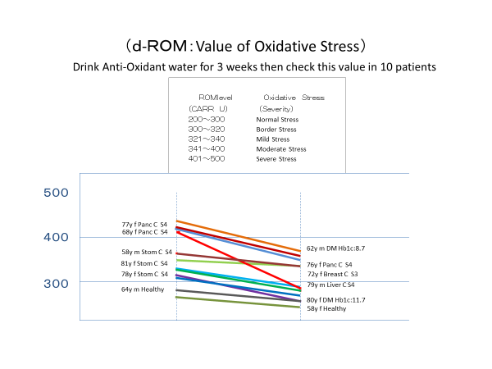
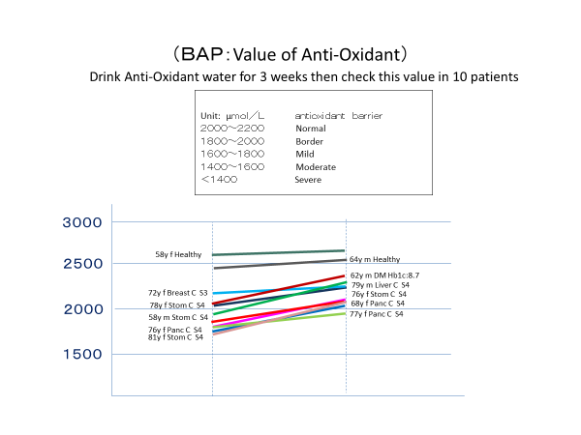

Recent Publications
Potential of Electronic Water as a Therapeutic Treatment for Oxidative Stress-Related Diseases Int J Diabetes Metab Disord, 2018 Volume 3 | Issue 2 | 1 of 4

 Masahiro Onuma has expertise in oxidative disease prevention to use non-medical product based on GSK’s experience of Allopurinol which is the strongest anti-oxidant efficacy in this world. He creates new indication of Allopurinol for stomatitis induced by cancer treatment which was approved by the Japanese Cancer treatment committee to propose new mechanism of Allopurinol for anti-oxidant. And now, there are so many new research papers of Allopurinol in the world.

Email: onuma@trisguide.com
Contact Information: +81-8040916

