Clinical Evaluation for the Decline of Serum Estradiol in PCOS Patients Treated with GnRH Antagonist Protocol During Controlled Ovarian Hyperstimulation
Li Jie, Yang Jing,Cheng Dan, Pang Xiangli
Reproductive Medical Center, Renmin Hospital of Wuhan University , China

The decline of serum estradiol (E₂) usually emerges in the process of controlled ovarian hyperstimulation with GnRH antagonist protocol, the study was to determine the impact of in the declining E₂ on the outcome of IVF-ET in PCOS patients treated with GnRH antagonist protocol. 120 PCOS patients including 58 cases with the decreased level of E₂ (study group) and 62 cases with continuously increased of E₂ (control group) were studied retrospectively in this research. The study group was also divided into 2 subgroups: the spontaneous decreased E₂ group (n=30) and the group with Gn alterations (n=28). The clinical data and outcomes of IVF-ET were analyzed. The three groups exhibited no significant differences in female age, infertility duration, basal sex hormone levels, the fertilization rate, 2PN cleavage rate, and the rate of high-quality embryo. The dosage of gonadotropin (Gn) in the decreased E₂ group with Gn alterations was significantly higher than that in the spontaneous decreased E₂ group and control group. Compared with that in Gn alterations group and the control group, the spontaneous group experienced a significant decrease in the clinical pregnancy rate. So, spontaneous decline of serum E₂ indicated the undesirable IVF outcomes in the PCOS patients treated with GnRH antagonist protocol during controlled ovarian hyperstimulation.

Recent Publications (minimum 5)
- J.Li, J.Yang, D. Cheng, S.-L. Shen, C.-L. Xiong(2015) New clues to identify proteins correlated with Attractin. Andrologia. 46(7):796-804.
- Li Jie, Yang Jing, Xu Wang-ming, Cheng Dan, Zou Yu-jie (2015)The Comparison of Perinatal Outcome of Twins After Assisted Reproductive Techniques and Natural Pregnancy. The Journal of Reproductive Medicine, 60(1-2):37-42.
- Jie LI, Shiqi WANG, Shiyun HUANG, Dan CHENG, Shiliang SHEN, Chengliang XIONG(2009) Attractin Gene Deficiency Contributes to Testis Vacuolization and Sperm Dysfunction in Male Mice，J Huazhong Univ Sci Technol［Med Sci］, 29(6):750-754.
- Yang Mu, Wen-jie Yan, Tai-lang Yin, Yan Zhang, Jie Li, Jing Yang (2017) Diet-induced obesity impairs spermatogenesis: a potential role for autophagy. Scientific Reports, 7 :43475.
- D. Cheng, C. Xiong, J.Li, C. Sui, S. Wang,H.Li and X. Jiang (2014) The effect of mahogunin gene mutant on reproduction in male mice: a new sight for infertility? Andrologia, 46(2):98-105.

Biography (150 word limit)
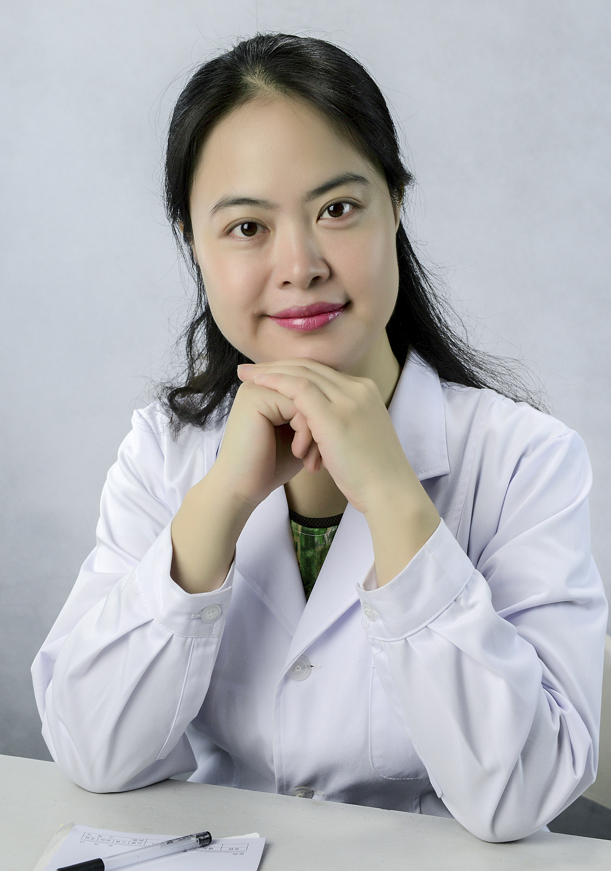
Li Jie,born in 1980, received M.D. from Wuhan University in 2004 and ph.D.from Huazhong University of Science and technology. After graduation, She became a doctor in Reproductive Medical Center in Renmin Hospital of Wuhan University. She is an excellent doctor in Obstetrics and Gynecology , Reproductive Endocrinology and Infertility. She has her expertise in evaluation and passion in improving the infertility of patient who suffers from Polycystic Ovarian Syndrome, She is experienced in therapy for IVF of POCS, The decline of E2 usually emerges in the process of controlled ovarian hyperstimulation with GnRH antagonist protocol in PCOS, this study illuminated the IVF outcomes in those patients.
Email: dr.lijie@163.com
Notes/Comments:
.

