

Title: Leukemic Infiltration Of The Gallbladder Manifesting As Cholecystitis: A Case Report
Author (s) Name: Lester Floyd D. Zamora, MD., Januario D. Veloso, MD.
National Kidney and Transplant Institute, Philippines

ABSTRACT
Acute Myeloid Leukemia is a hematologic malignancy that results from the clonal expansion of myeloid blasts in the peripheral blood, bone marrow, or other tissues. It is the most common form of leukemia in adults and may also be present in the form of extra-medullary disease. However, published cases of leukemic infiltration of the gallbladder is quite rare.

We present a rare case of leukemic infiltration of the gallbladder in a 60 year old, male, who presented with cholecystitis. The patient was just diagnosed with AML and had chemotherapy when a few days after discharge, he noted abdominal pain. Ultrasound findings showed gallbladder with pericholecystic fluid, slight wall thickening, multiple polyps and cholesterolosis.

Histologic examination of the gallbladder showed sheets of atypical mononuclear cells infiltrating the lamina propria and muscle layer. Review of the bone marrow flow cytometry study gated on the blast gate population showed a moderately bright CD45 expression with expression of the stem cell markers CD34 and HLA-DR; myeloid markers CD13, CD33 and CD117; myelomonocytic marker CD11c; cytoplasmic myeloid marker MPO. Immunohistochemistry studies done on the gallbladder showed positive expression for CD45, CD34 and MPO. These findings are in concordance with the bone marrow flow cytometry profile.

This case shows that AML can present with extramedullary manifestations in a form of leukemic infiltration of the gallbladder and present clinically as cholecystitis. Thus, a high index of suspicion should be given in any patient who has a history of leukemia despite the rarity of these manifestations.

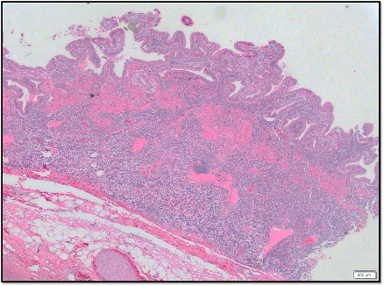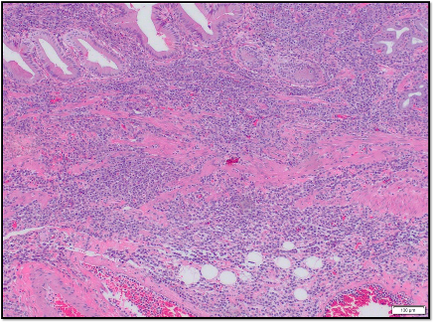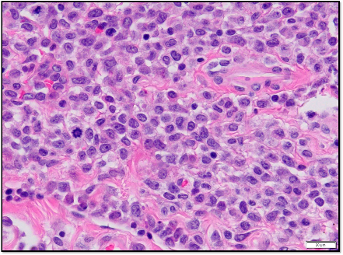

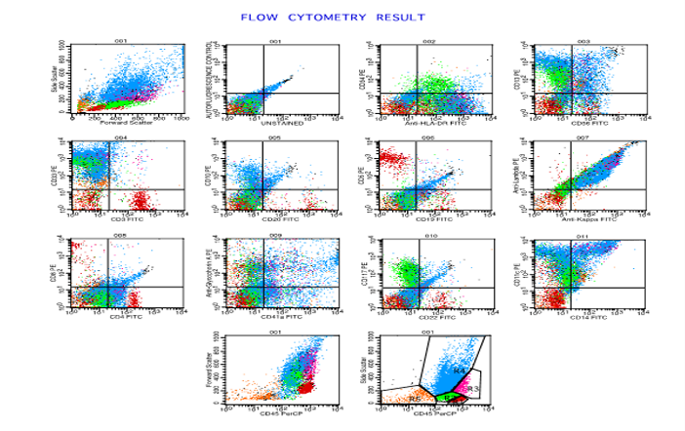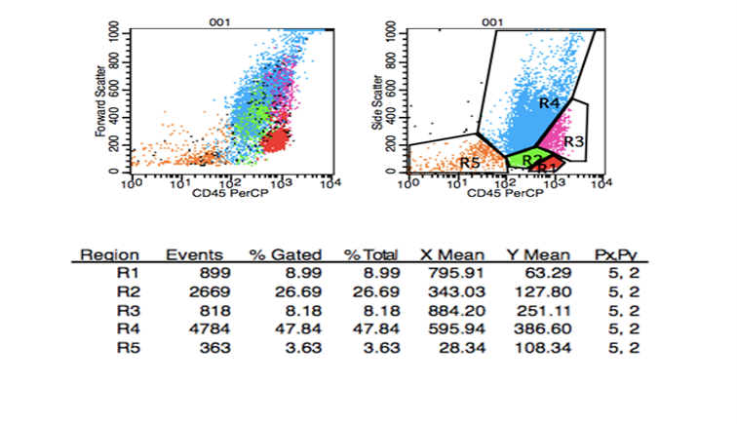

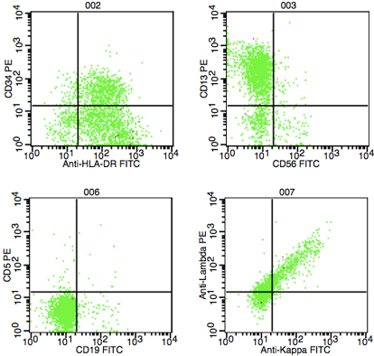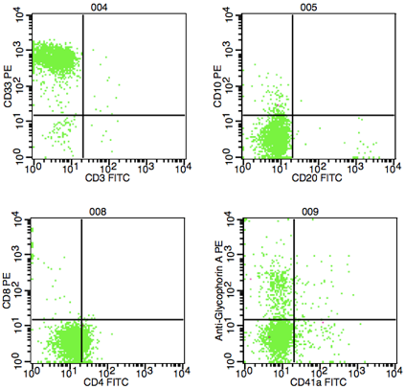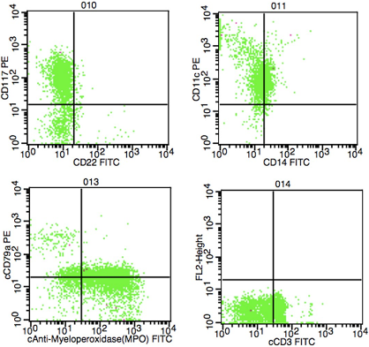

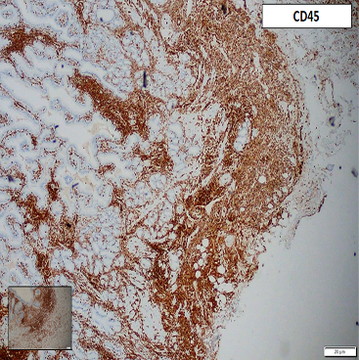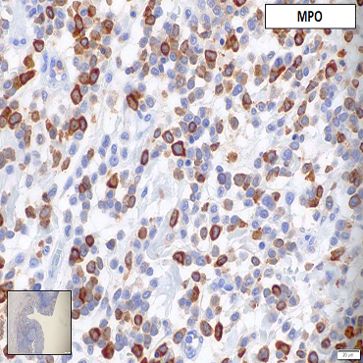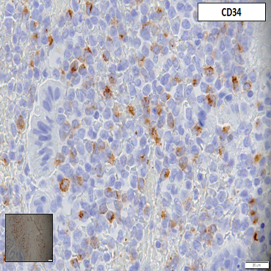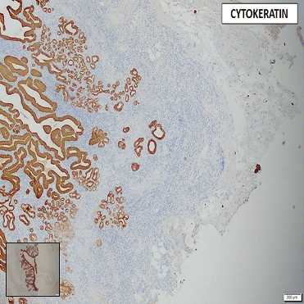

Biography

Dr. Lester Floyd Zamora has completed his medical training from the Cebu Institute of Medicine, Philippines. He is currently a fourth-year pathology resident at the National Kidney and Transplant Institute. He has been actively doing case reports during his residency and has ongoing retrospective research study in the field of hematopathology. Specific pathology specialty interests include hematopathology and uropathology.
Presenting author details
Full name: Lester Floyd D. Zamora
Contact number: +639954836119
Email id: lesterfloydzamora@gmail.com
Category: Poster presentation
Session name: Lester Zamora
Research interest: Hematopathology

PLEASE DO ACCEPT THIS REVISED EMAIL BASED ON YOUR TEMPLATE. I HAVE PREVIOUSLY EMAILED AN ABSTRACT NOT FOLLOWING THIS FORMAT. THANK YOU

